HOW TO INSTALL THE MICS GEOCODE PLUGIN

REQUIREMENTS
The MICS Geocode plugin works with QGIS 3 or above. Hence, it is required to have the QGIS 3 (or above) installed in advance and this tutorial will focus only on how to install the MICS Geocode plugin in QGIS. While updates to the plugin are expected over time, the installation steps will remain the same, as long as QGIS keeps its feature and steps unchanged.

Download the plugin
Download the latest version of the plugin from the MICS website, under Tools. Save the downloaded ZIP file (currently, “micsgeocodeplugin-1.x.zip”) in a folder where it easily can be located on the computer.
DO NOT UNZIP THE FILE.

INSTALLATION STEPS
- Open QGIS 3.x.
- Go to the Plugins menu and select Manage and Install Plugins….
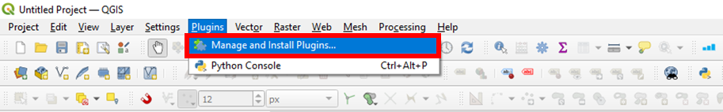

- Click Install from ZIP and then the icon to browse to the downloaded ZIP file plugin.
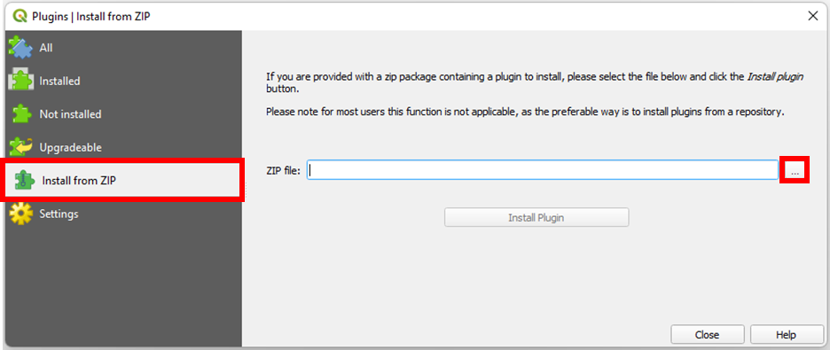

- Find the location of the downloaded ZIP file on your computer, select it and click Open.
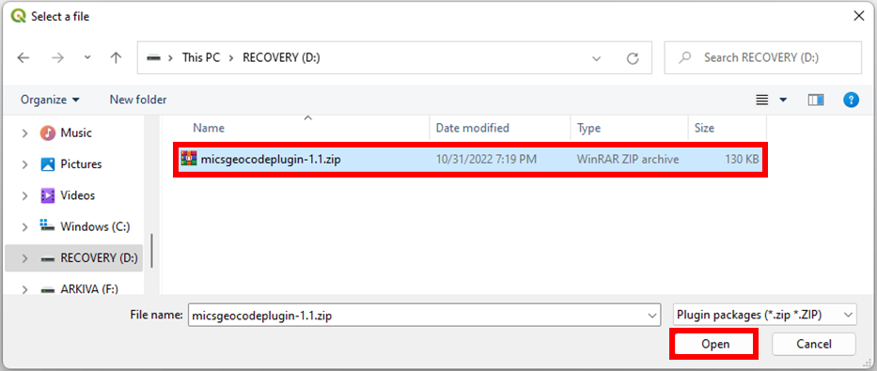

- Click Install Plugin.
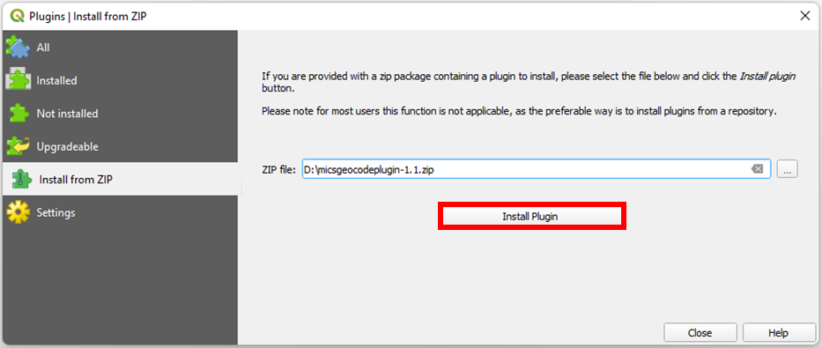

- A security warning message from QGIS will appear and ask if the source of the plugin can be trusted. Click Yes. If no warning appears, please skip this step.
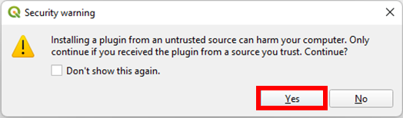

- Wait for a few seconds until the installation is complete.
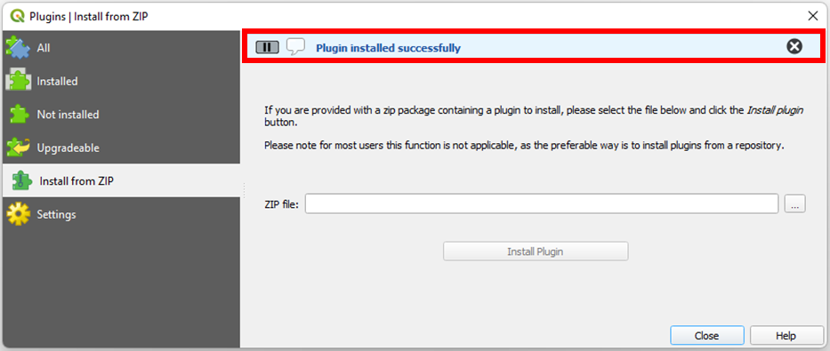

- Once the plugin has been installed successfully, close the window.
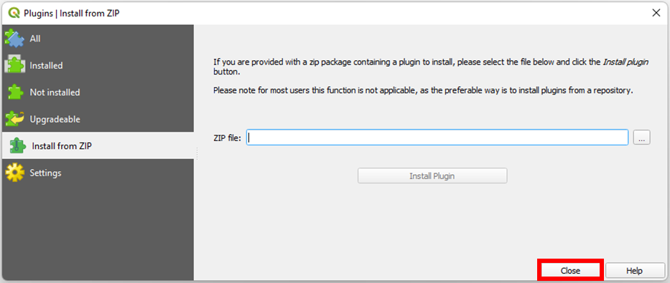

- Now go to the Plugins menu and open the window of MICS Geocode plugin by clicking MICS GIS MICS Geocode Plugin. Another way is to click the icon (top-right corner of the picture below). Note that this icon can be in a different location depending on computer.
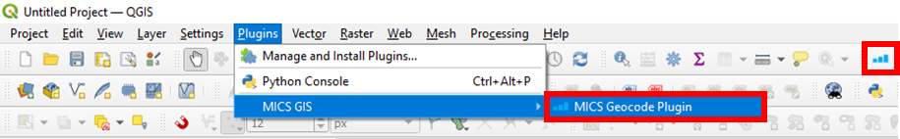

- The MICS Geocode Plugin will look like this when opened after successful installation.
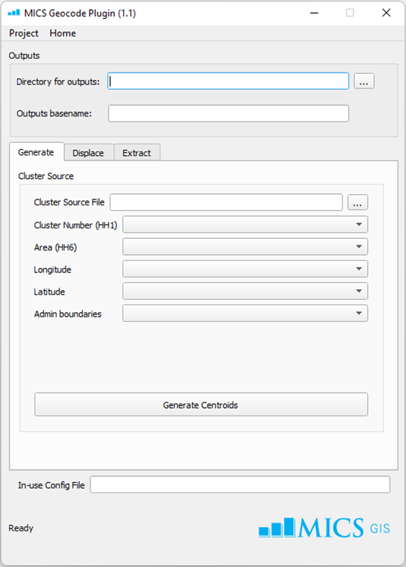

Please refer to the “How to use the MICS Geocode Plugin” manual for instructions on use of the plugin.

