GPS
Operator’s
Manual

Survey Coordinators:

Give a copy of this Manual to every operator. Translate into the local language, if necessary. Ensure that the information is appropriate to your survey.

Note that these Instructions require significant customisation if the survey is conducted using tablets / PDAs.

This present manual is designed to help the GPS Operator familiarise with his/her tasks in collecting GPS data in the field for the MICS survey.

Together with this manual, your GPS Coordinator will provide you with the following:
- GPS unit: Garmin eTrex 30
- 8 AA batteries (alkaline)
- Copies of the GPS Data Collection Form (one per cluster, plus spare copies)
Optional:
- Vehicle dashboard mount (if used for routing or collecting track log)
- Vehicle unit charger (if used for routing or collecting track log)
- MicroSD card (if collecting track log)
- 4 rechargeable (NimH) AA batteries and 1 charger

Your role as GPS Operator is essentially comprised of the following elements:
- Capture and record the GPS waypoint at the centre of the survey site.
- Complete the GPS data collection form, including the GPS waypoint number, latitude, longitude, elevation, and GPS unit number. As with the Cluster Control Sheet, only once the cluster is completed, the Form should be included in the bundle of questionnaires and transported to Headquarters.
- Communicate with the GPS Coordinator about any problems encountered in the field and follow his or her instructions.
- Ensure that the unit and accessories are handled properly during fieldwork. This includes maintaining battery level and transfer of data when the GPS Coordinator visits the team.

The above tasks will be covered in more detail throughout this document and, therefore, you are encouraged to take time to read it—together with the device’s accompanying Quick Start Manual—In order to collect good-quality GPS data and minimise errors.
The GPS Coordinator is there to manage all aspects of implementation of GPS Data Collection, and he/she is available to help with any questions or problems with the GPS units. If any issue arises, do not hesitate to ask for assistance.

Operating the Unit
The unit that your GPS Coordinator has provided you should already be set up for best performance, taking into account aspects that are particular to your country survey. With that in mind, please do not alter the settings of the device without consulting your GPS Coordinator. The unit should also be already loaded with the necessary maps and batteries in place.
This GPS device does not have touchscreen capability and is operated by the use of your fingers to press the keys and navigate with the Thumb Stick. Do not use something sharp, such as a pen, to press any button or the screen as it will wear out the unit.

Turning the Unit On and Off
The power button is located on the lower right-hand side of the unit. Press once and the device will turn on within a few seconds.
To turn it off, long-press the power button until the screen goes off.

Getting a GPS Satellite Signal
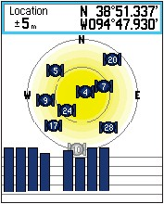When the unit is first turned on, it will automatically begin acquiring satellite signals until it locks a location. For this, it is important to have a clear view of the sky. Use the Thumb Stick to highlight the Satellite icon and press. From this page you can observe the satellite strength, and when the unit locks a signal, you will see the current location and error range of the signal.
The device has a very good GPS antennae and chip, and can often get a lock in conditions where it would be difficult for other receivers. Dense urban areas, tall buildings, tree canopy, and cloud cover typically are not a challenge. However, if the unit is not getting a lock in such situations, move to an open area to get an initial lock.
One thing to note is that it can be time consuming to get a lock from a moving vehicle. If you plan to record a track from a vehicle, get a good fix before starting to drive. You may want to make sure the GPS initially has a view of the sky not blocked by the roof. After this, the unit should be fine to record from inside the vehicle. Please aim to always have better than ± 5 meter precision.

Using the Map
GPS units come with a road map already installed which may also include cluster locations. Consult with the GPS Coordinator on what is available on the device to assist your navigation. Maps of roads may not be complete, and some locations might be in error, so GPS maps should not be relied on exclusively and existing resources such as cluster location maps and local knowledge are always useful.
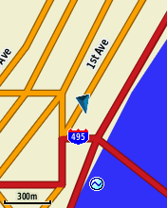To load the Map page, press on the Map icon. You may use the down and up arrow buttons located on the top left-hand side of the unit to zoom in and out respectively. Labels on point of interests are not always visible at a particular zoom level, or in crowded areas; increase the zoom to see more detail. You will find the current scale of the map in the lower left-hand corner of the screen.

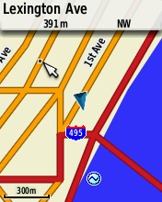

Use the Thumb Stick to pan the map; and as you do so, a pointer will appear along with a box at the top of the screen to indicate information on the spot that your pointer is on. To return the map to your current position, press the Back button located on the top right-hand side.

Finding Points
The map loaded onto your unit may enable you to search for cities and points of interest (POIs). To locate nearby POIs such as auto services and restaurants, do the following:
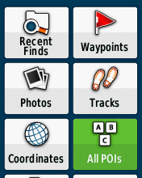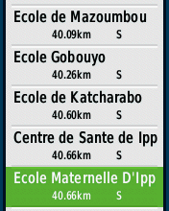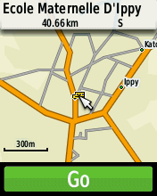
- Press on Where To?
- Select All POIs.
- Browse and press on your desired POI. Note that you may also search by typing the name of a POI. For that, press the Menu button located on the lower left-hand side of the unit, press on Spell Search, and begin typing using the Thumb Stick. If this POI exists in the map’s database, it will appear.
- Now press Go to navigate to that POI. Note that from the information page for this POI, you can pan the map using the Thumb Stick and zoom in and out using the down and up arrow buttons.
If you would like to navigate to a different kind of point (e.g. city, tide) on step 2 above select your desired icon (e.g. Cities, Tides) instead of All POIs.
In case you need to search for POIs near a different location than your current one, do the following:
- Press on Where To?
- Now press on the Menu key and select Search Near.
- Select A Map Point and press.
- Navigate the pointer to a desired location on the map using the Thumb Stick and then press.
- Now go to All POIs and the points of interest near the location you selected will appear.

GPS Cluster Centre Point Collection
The use of the GPS unit during the MICS survey is to record a single point (i.e. waypoint) near the centre of each cluster, and record this point on the form provided. Instructions on how to fill this form will follow.
Prior to marking and saving each waypoint, it is crucial that the GPS Operator follows these steps:
- Check the estimated accuracy of the reading to at least ± 5m.
- Make the reading near the centre of the cluster.
- Mark the waypoint.
- Rename the waypoint to match the cluster number.
- Save the waypoint.
Depending on the accessibility of the cluster centre, this point can be recorded by car or by foot. It helps to be as consistent as possible with how the point is collected.
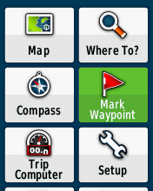Here is how to record a waypoint:
- Press on Mark Waypoint. Note that you can also simply long-press on the Thumb Stick from any page.
- 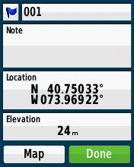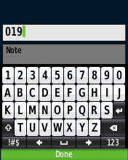Select the number at the top of the screen and press to rename this waypoint to match the cluster number (e.g. if you are in cluster #019, this waypoint should be renamed “019”). Now press Done at the bottom of the screen.

- Press again on Done to save the waypoint.
To view a saved waypoint on the device, go to Waypoint Manager and press on the waypoint you wish to view. You can edit any information related to a waypoint by highlighting and pressing on the information you wish to edit.

Data Handling
Periodically, the GPS Coordinator will meet with your survey team and download data from the device for further processing. Do not delete any data from the device or alter settings, unless in consultation with him/her.

Battery Handling
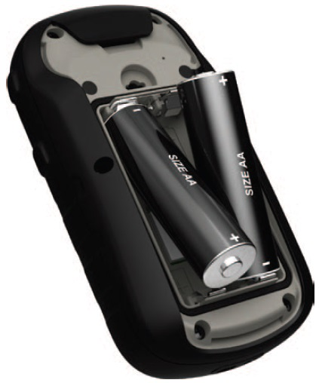As stated earlier, your GPS unit will be given to you with batteries installed, as well as extra batteries, some of which may be rechargeable. Batteries typically last for 2-3 days surveying when fully charged. Rechargeable NiMH batteries typically last longer than Alkaline, but either will work fine. The unit itself will display the estimated charge of the battery.
When plugged into the vehicle power cable, the GPS should be powered and charging rechargeable batteries (note that the battery-charging feature is not present with all power cables).
If you need to replace the batteries:
- Remove the battery cover on the rear of the GPS. Turn the ring counter-clockwise and pull off the cover.
- Insert the batteries. Be certain that the polarity of the batteries matches the diagram within the battery compartment.
- Place the battery cover back on, and turn the ring clockwise to close.

Filling the GPS Data Collection Form
This form accompanies the work of marking waypoints near the centre of clusters. As GPS Operator, you will fill out this form by pen for each waypoint marked (i.e. one form per cluster, depending on the requirements of your country survey). Once filled out, the form is to be placed together with the bundle of questionnaires and cluster control sheets associated with the cluster.
The form consists of an upper panel (GP1 to GP7), a central position checklist for you to review before marking each waypoint, and a lower panel (GP8 to GP11). The upper panel should be filled in before you begin the process of waypoint marking, as your supervisor will have provided the necessary information to you to fill it out entirely.

GP1. Cluster number
Enter the cluster number as instructed by your supervisor.
GP2. GPS unit number
Enter the GPS unit number. The GPS Coordinator has tagged your GPS unit with a sticker – this is your GPS unit number.
GP3. GPS operator’s name and number
Enter your own name and identification number provided to you at the time of training.
GP4. Supervisor’s name and number
Enter your supervisor’s name and number, if not already completed by your supervisor.
GP5. Day/Month/Year of reading
Enter the date of the reading as day, month and year.
GP6. Area
Circle the code for cluster area as instructed/provided by your supervisor. This will have been pre-determined; you will not be required to assess whether the cluster is in an urban or rural area.
GP7. Region
Circle the code for region as instructed/provided by your supervisor.
After GP1-GP7 has been filled out, ensure that the position checklist is followed before recording the reading (GP8-GP11) to the form.
GP8. Waypoint number
Enter the waypoint number as saved on your device. This waypoint number should be the same as the cluster number (GP1).
GP9. Elevation
If your device reports negative elevation, tick the box that says “tick if negative elevation.” If the device reports positive elevation, do not tick this box. Enter the elevation number in meters.
GP10. Latitude
Circle the appropriate letter (N or S if both are present on the form) under Direction, and enter latitude degrees. Keep five digits for decimal degrees.
GP11. Longitude
Circle the appropriate letter (E or W if both are present on the form) under Direction, and enter longitude degrees. Keep five digits for decimal degrees.

