Manual for Water QUality Testing

Survey Coordinators:

Translate this manual into the language(s) of field team members.

During water quality training ensure that this manual is provided to all field team members - measurers, interviewers and field supervisors.

Measurers should carry this manual with them at all times in the field.

it is important that only the equipment recommended by UNICEF is used during data collection. Please see the MICS Supply Procurement Instructions.

Delete this box as it is meant only for Survey Coordinators.

Note that these Instructions are designed for paper-based surveys and will require minor customization if the survey is conducted using tablets / PDAs.

Introduction to the Manual

This Manual is intended for all MICS field staff and outlines the required steps that need to be taken during MICS data collection in order to accurately assess drinking water quality. Measurers in particular should carry these instructions with them in the field and review them regularly to make sure they are always following the correct procedures. Supervisors should also frequently refer to this Manual in the field when observing the work of measurers.

Background on water quality testing

The objective of this water quality module is to obtain a nationally-representative view of the quality of water that people drink in their home and the quality of their drinking water source. In each cluster of the survey, a number of households will be randomly selected for E. coli testing. E. coli is a fecal indicator bacteria, meaning that it is likely to be present when faeces or raw sewage has entered the water supply. The presence of E. coli in drinking water does not necessarily mean that the person drinking it will become sick, but it indicates that over time the household is at a higher risk for waterborne diseases. The World Health Organization recommends as a guideline that there should be no E. coli present in a 100 mL sample of water.

Responsibilities of Field Team Members During the Collection of water quality measurements

Measurers will be responsible for conducting E. coli tests in the field, and for completing the water quality questionnaire. They will be responsible for maintaining the equipment and notifying Supervisors if equipment is faulty or short in supply.

Supervisors will complete the Water Quality Sample Household Selection Table and share this with the measurers after reaching each cluster on the day of survey. They will be responsible for coordinating the work of the measurer by making sure he/she knows where to find the households where samples are to be collected at the source and in the home. Supervisors will advise measurers when they should visit the household and provide bottled water for the blank test when needed. The supervisors will be responsible for ensuring that measurements are taken following the exact steps and procedures outlined in this Manual. In situations where measurers are routinely making errors in taking and/or reading measurement, or in reporting the information on the questionnaire, the supervisor should consult with the fieldwork director and/or survey coordinator about corrective actions.

General Precautions for Measurers

- Preventing contamination: aseptic technique
Care must be taken during sampling and testing to prevent contamination of the sample by bacteria in the environment or from previous water samples. Aseptic technique for field sampling can be summarized as follows:
- Always wash hands with soap or apply gel hand sanitizer before starting a new sample or touching equipment that will touch the sample.
- If using gloves, change to fresh gloves between each sample.
- Sanitize any equipment that comes in contact with the sample using alcohol before each new sample.
- Time management
The actual water quality test itself requires approximately 20-30 minutes. However, the measurer must also plan time to visit the household’s drinking water source and to read the sample results the next day. Results should be read within 24 – 48 hours of the time the test is started.
- Transport of samples
In some cases, it may be more convenient to collect a sample and process it for testing at another location. In this case, short transit times (up to 30 minutes) are acceptable provided samples are kept out of direct sunlight. If the unique requirements of the survey site will require longer transport times, then a cooler with ice should be used. Samples should be kept cool (less than 4 °C), never allowed to freeze, and should be analyzed within 6 hours of their collection.
- Sample incubation
To provide the right conditions for E. coli to grow into countable colonies, the Compact Dry plate must be kept at approximately 37 °C for 24 hours. If the temperature is too low for an extended period of time, the E. coli will grow too slowly to be visible and if the temperature is too high, the E. coli might be killed or overtaken by other bacteria suited for the hotter conditions. There are several ways to maintain this incubation temperature, including a simple belt worn around the body that keeps the plate close to body temperature (37 °C), portable battery-powered incubators or constant temperature ‘phase change’ incubators. It is recommended that incubation belts are used due to their low cost and simplicity as well as independence of reliable electricity.

Collection of samples

Household drinking water sampling
Since a main purpose of this part of the survey is to determine the quality of water as it is actually consumed, samples will be household drinking water taken from the point of consumption. The measurer will ask the survey respondent for “a glass of water that members of your household would drink” and the water samples of the household will be tested for E. coli. The water quality test can either be conducted in the household’s premises otherwise a sample can be collected using a Whirl-Pak bag for testing elsewhere.

Source sampling
The source should be determined based on the responses given by the household. The water quality test may be performed at the location of the source or the measurer may collect the sample in a sterilized Whirl Pak bag and then perform the test at a more convenient location. When water samples are collected from the source, water should be flushed for 30 seconds whenever this is feasible. For example, a tube-well should be pumped for 30 seconds minute, or a tap should be opened for 30 seconds, before collecting the sample. If the water is collected from the source by hand (as in an unprotected spring or dug well with bucket), flushing is not necessary. If the water is being collected from a spring, stream or a river, the sample should be collected by facing the mouth of the container/bag towards the opposite direction of the flow.

Blank test
Supervisors will provide Water Testers with water for the blank test. This will be a bottle of water known to be of high quality or distilled water. The water should be poured directly from the bottle when conducting the test.

Taking a sample with the Whirl-Pak Bag

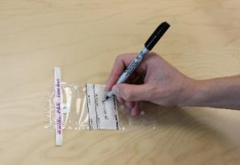  A. Write sample code on Whirl-Pak bag per instructions in questionnaire | B. Sanitize hands then  Open Whirl-Pak bag | 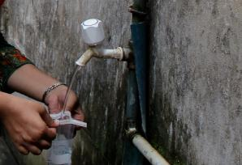  C. Collect water sample in Whirl Pak-bag (110 ml)
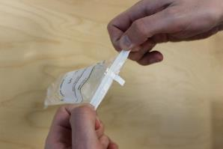  D. Close the Whirl-Pak bag by rolling over the white tab | E. Flip the Whirl-Pak 3 times | F. Fold white tabs closed to seal the Whirl-Pak

Water quality testing – E. coli
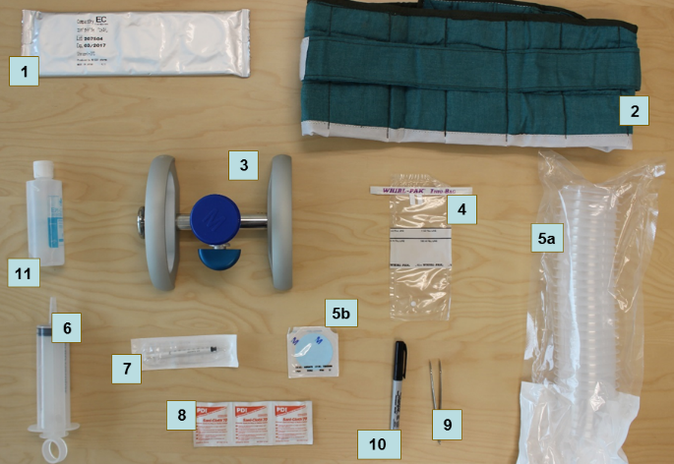
Figure 1: Equipment required for water quality testing

1. Compact Dry plates (E. coli)  2. Incubation belt  3. Membrane filtration manifold  4. Whirl Pak bags for sample collection  5a. Funnels  5b. Filter membrane (included in box  with Microfil Funnels)  6. Large syringe (100 mL)  7. 1 mL disposable syringe  8. Alcohol wipe  8. Incubation belt  9. Marker pen  10. Forceps (tweezers)  11. Hand sanitizer gel | Additional equipment:  - Bags for transporting the water testing kit  - Tissue paper  - Waste disposal bags  - Blank water bottles (or deionised water)  - Household bleach solution  - Bucket for disinfection  - Gloves for disinfection  Notes:  - Millipore membrane filtration manifold needs to be assembled prior to first use.  - Electric incubators may also be used where there is reliable electricity

Performing water quality tests

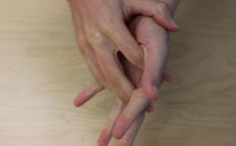  1. Sanitize hands | 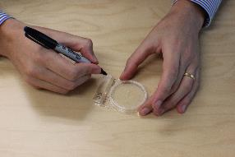  2. Use the Marker pen to label the a Compact Dry plate per instructions in Step 3 | 3. Labeling instructions  Example label:  H-012-03  Label codes:  1st letter: H = household sample, S = source sample,  B = blank test  Numbers: cluster + household

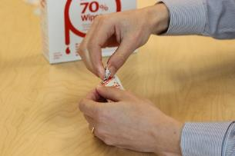  4. Tear open an alcohol wipe | 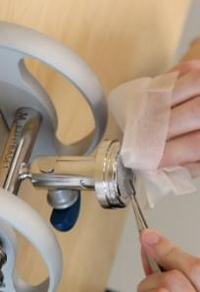  5. Use the alcohol wipe to sterilize the forceps and the top of the filtration stand and frit (use forceps to keep wipe from sticking to the rough surface) | 6. Place the forceps on top of an alcohol wipe to keep it sterile

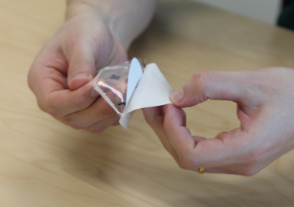  7. Remove one membrane filter from box | 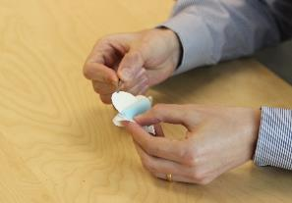  8. Remove the white gridded filter (discard the blue paper) – do not allow the filter to touch any other surfaces; if dropped accidentally, use a new one. | 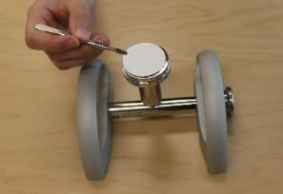  9. Place the filter, gridded side up, on top of the filtration stand

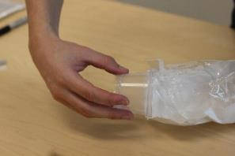  10. Remove funnel from the plastic sleeve; be careful not to touch the inside of the funnel | 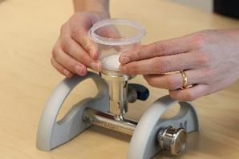  11. Lock the funnel onto the filtration stand, touching only the outside of the funnel | 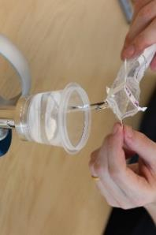  12. Fill the funnel with the water sample up to the 100 mL mark

Performing water quality tests (continued)

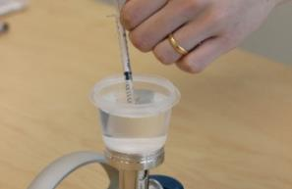  13. Open one sterile 1 mL disposable syringe and withdraw 1 mL of sample water | 14. Use the other hand to lift off the cover of the Compact Dry plate and add the 1 mL from the syringe | 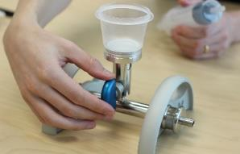 15. Switch the blue valve on the filtration stand into the open position (vertical)

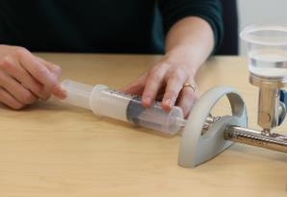16. Use the large syringe to pull the entire water sample through the filter; discard the water in the syringe | 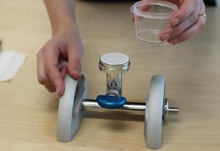  17. Carefully remove and discard the funnel, leaving the filter on the filtration stand | 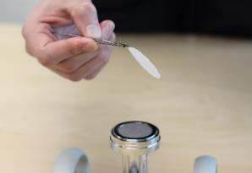  18. Use the sterile forceps to remove the filter from the filtration stand

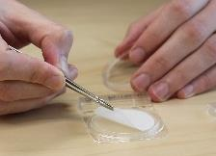  19. Place the filter, gridded side up, onto the plate | 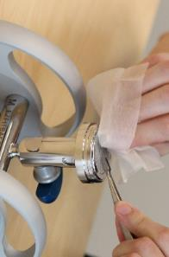20. Wipe down the surface of the filtration stand and allow any water still inside to drain out | 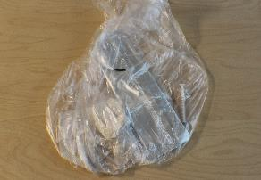  21. Collect all garbage and dispose of properly; show respect to households and do not leave behind any materials

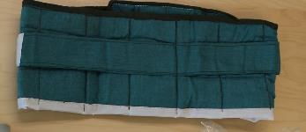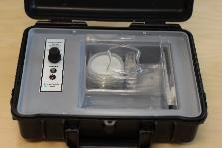  22. Place the Compact dry plate into the incubation belt or electric incubator. | 23. Incubate for 24-48 hours and then record result in water quality questionnaire.

Interpreting results

General guidelines for incubation and interpretation of Compact Dry Plate results:
- Keep temperature between 25 °C and 40 °C at all times.
- Read results between 24 and 48 hours after performing the water quality test.

Compact Dry plates contain a dried agar growth medium which is rehydrated by the sample. The medium contains a chemicals that can be used by only certain bacteria for growth (X-Gluc). When E. coli is present, it consumes the chemical, forming blue/green colonies.

Reading Results

All blue/green colonies should be counted, regardless of size. Other bacteria may grow and form colonies that are white, brown, yellow or pale blue, or some other color. These are not E. coli and should not be counted.

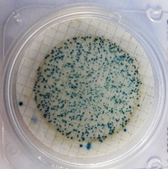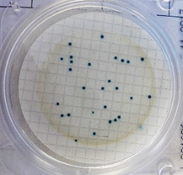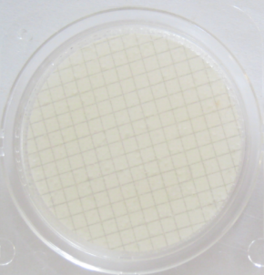

Figure 2: Compact Dry plates showing high numbers, moderate numbers, and no countable colonies in a 100 mL sample. Blue colonies are E. coli (EC).

In case there are many colonies on a plate, the number of colonies in one quarter of the plate may be counted, and this number multiplied by four. If there are more than one hundred colonies on the membrane, the result can simply be recorded as “101”. If the bacteria levels are very high, no individual colonies may be seen, but the entire plate may turn blue/green. In this case, the result should also be recorded as “101”.

If for any reason it is not possible to interpret the results or incubation could not be completed this should be recorded as “999”.

Number of E. coli colonies : 0 | Number of E. coli colonies : 101 | Number of E. coli colonies: 27
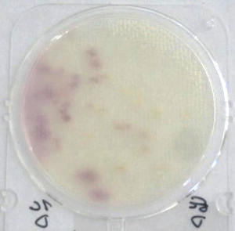 | 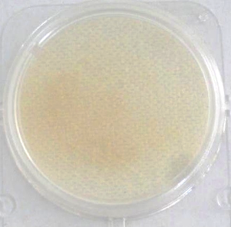 | 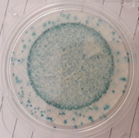
Diffuse colors do not signify contamination  Number of E. coli colonies : 0 | Brown color does not signal contamination.  Number of E. coli colonies : 0 | Blue color may indicate many, many colonies: ‘101’  Number of E. coli colonies : 101
Figure 3: Examples of different Compact Dry plate counts

disposal of used compact dry plates

The Compact Dry plates and other test consumables are not kept and transported back at the end of the survey, but are appropriately disposed of in the field. Water filtered during the test can simply be disposed of and does not have contamination. Most of components of the test will pose minimal risk and should be disposed of with other solid waste. After incubation, however, the Compact Dry Plates can contain high levels of E. coli and other bacteria, some of which could potentially be pathogenic, and must therefore be disposed of appropriately as they might otherwise come into contact with children for example. The Compact Dry Plates can be disinfected by adding a chlorine tablet and 1-2 mL of water. Alternatively, plates can be submerged in water to which an appropriate amount of household bleach has been added, for example 1 lid full for half a liter.

