GPS
Coordinator’s
Manual

SURVEY COORDINATORS:

Translate these instructions into the local language, if necessary. Ensure that the information is appropriate to your survey.

Note that these Instructions are applicable for GPS data collection during the Mapping & Listing Operation. The instructions will require significant customisation if the Mapping & Listing Operation is conducted using capi or if GPS data is collected during Main Fieldwork.

This manual gives details on the role and responsibility of the GPS Coordinator of the MICS. It is the role of the GPS Coordinator to manage all aspects of implementation of GPS data collection.

Each specific responsibility is listed below within the various phases of survey implementation, from the planning/design phase, through training, fieldwork, data processing, and reporting.

Obtaining Materials and Equipment
Once survey planning is near finalised and a draft of the survey plan is available which references the collection of GPS data, a large portion of the preparatory work can be completed. The critical input is knowledge of how many teams will be employed in the field.

Each field team/GPS Operator will need:
- GPS unit: UNICEF recommends the Garmin eTrex 32x. Instructions for ordering are described in the Supply Procurement Instructions for recommended equipment available at MICS Procurement instructions for recommended equipment
- 8 AA batteries (alkaline).
- Enough copies of the GPS Data Collection Questionnaire (one per cluster, plus spare copies)
Optional:
- Vehicle dashboard mount (if used for routing or collecting track log)
- Vehicle unit charger (if used for routing or collecting track log)
- MicroSD card (if collecting track log or if map files are extremely large)
- 4 rechargeable (NimH) AA batteries and 1 charger

Purchase 10-20% extra of all listed equipment to replace damaged or lost supplies.

The GPS Coordinator will need:
Hardware:
- A GPS Unit identical to the model used in the field
- USB to Micro-USB cable (supplied with units. Keep for replacement)
- Laptop for field monitoring and exporting data from units
- As units must be numbered, there may be need for stickers or similar (to be placed both on unit and under battery cover)
Software:
- GPS software to visualise and troubleshoot GPS waypoints. This could be BaseCamp (free) ,GPS Trackmaker (free), Garmin MapSource (free with unit purchase), or any other appropriate software already in use by implementing agency.
- Microsoft Excel to manually record GPS data from Questionnaires
- Garmin Express (available with registration of unit) to download and install latest firmware/software
Data:
- Map of sampled area, including cluster boundaries or waypoints if possible. Census maps are usually available and can be converted to the appropriate format, but map sections can alternatively be downloaded from: http://garmin.openstreetmap.nl/
Training/other field materials:
- Customise and provide copies of the GPS Data Collection Questionnaire – enough so that all survey clusters can be recorded and for training exercises. Instructions for customisation follow the standard customisation guidelines of MICS, but additional details are provided in the Questionnaire section below.
- Customise and copy (parts of) the GPS Operator’s Manual for each training participant.

Preparing the GPS Units
This should be done before training and field work:
- Tag each GPS unit with a number. This number should be recorded by the GPS data collectors on the GPS Data Collection Questionnaire under GP2. A simple sticker with a permanent marker is sufficient, although units may already have been tagged by UNICEF or others on arrival (this number can be used). It is recommended to also place a sticker with the tag number inside the battery cover.
- Insert the batteries and establish a connection between the laptop and the unit by means of the supplied cable in order to test the connection. Use this opportunity to register the unit, download the latest firmware, insert an SD Card (usually not necessary, see above), upload maps, etc.
- Ensure each unit has the appropriate settings. The below is necessary:

Map Setup

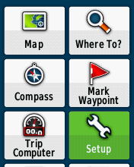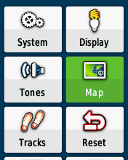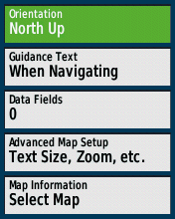

- Turn on your Garmin eTrex 32x by holding the Power key (on the lower right-hand side of the unit, named light).
- Use the Thumb Stick to navigate to the Setup icon and press.
- Navigate to the Map icon and press.
- Make sure Orientation is set to North Up.

Routing Setup

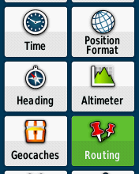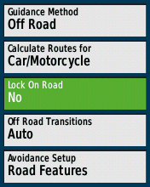

- Go to the Setup menu.
- Now navigate to Routing and press.
- Select Lock on Road and make sure it is set to No. Note that if Lock on Road is set to Yes, it would automatically align the tracklog with the nearest road already present in the map loaded into the GPS unit. By setting it to No, the device will record new data even in the presence of other roads.

System Setup

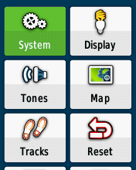

- Go to the Setup menu.
- Press on System.
- Make sure Satellite System is set to GPS + GLONASS.
- Navigate down to WAAS/EGNOS and make sure it is set to On. Note that WAAS/EGNOS provides greater accuracy in some parts of the world, but not all.
- Now down to Battery Type and select the right type of battery that your device is currently running on. Most rechargeable batteries are NiMH, while regular batteries are usually Alkaline. Note that the battery Type setting affects only the display of the battery charge level.

Time Setup

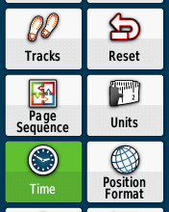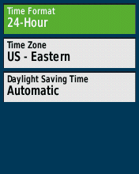

- Go to the Setup menu.
- Navigate to Time and press.
- Make sure Time Format is set to 24-Hour.
- Go down to Time Zone and select a city in your current time zone.

Units Setup

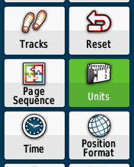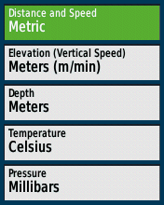

- Go to the Setup menu.
- Select Units and press.
- Make sure to set Distance and Speed to Metric, Elevation to Meters (m/min), and Depth to Meters.

Position Format Setup

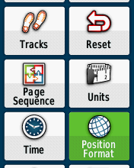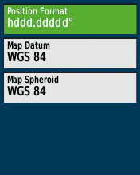

- Go to the Setup menu.
- Select Position Format and press.
- Make sure to set Position Format to hddd.ddddd° and Map Datum to WGS 84.

Altimeter Setup

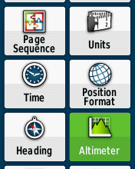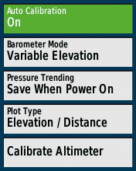

- Go to the Setup menu
- Select Altimeter
- Make sure that Auto Calibration is set to On and Barometer Mode is set to Variable Elevation.

Before you use the GPS unit in the field, it is essential that you first manually calibrate the Altimeter. In order to ensure maximum accuracy in elevation reading, we will use the known elevation level of a particular point. Below are steps to assist you (you may also use Google Earth, which also has an easy feature for finding elevation):

- Identify a point of reference in your area (e.g. a monument, an iconic building, a crossroad). Be as exact as possible.
- Go to the following website: mapcoordinates.net
- Using the map, find your identified point of reference, zoom on it, and then click on it. You may choose to click on Satellite on the top-right corner of the map to find your identified point more easily.
- A box will pop up giving you the elevation (sea level) of your selected point. In the image example below, the elevation is 326 m. 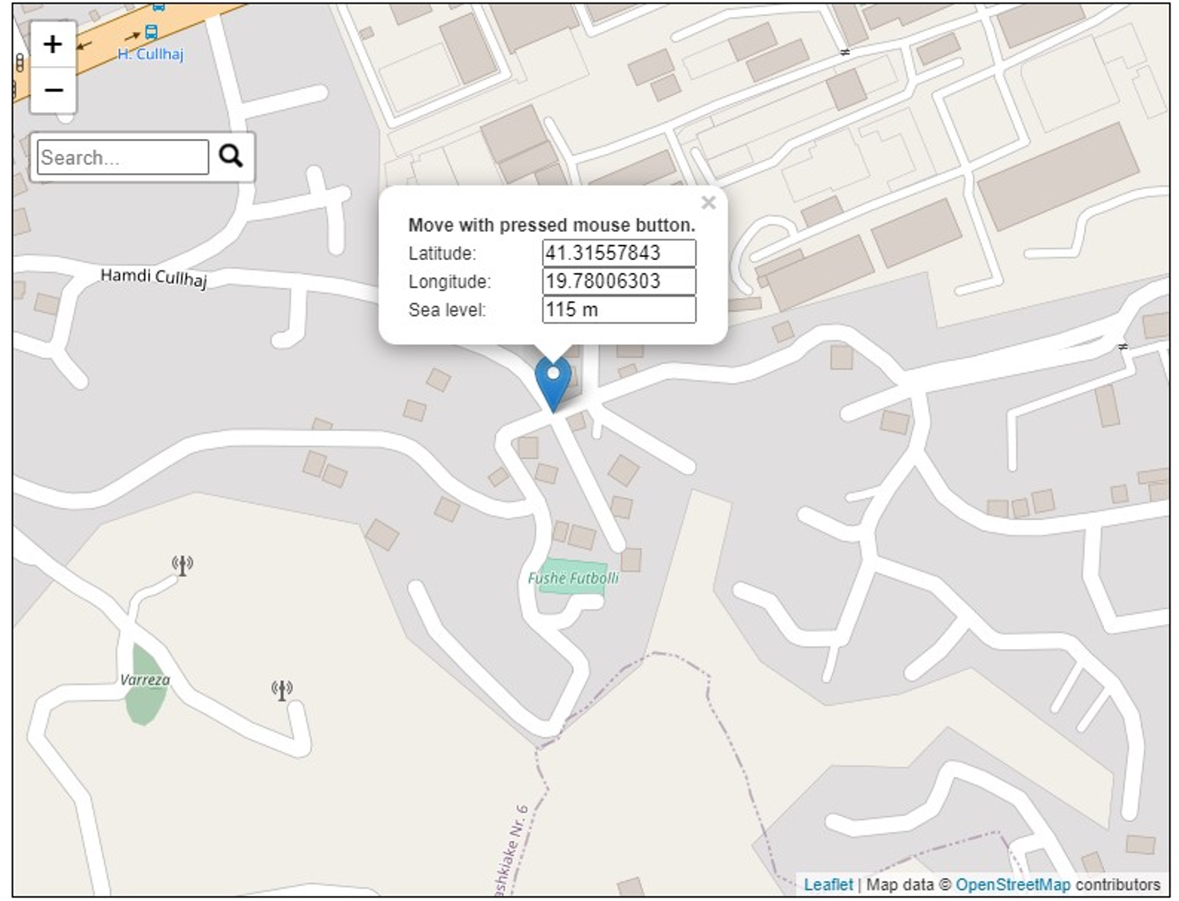
- Now that you know the elevation of a known point, go there and take the GPS unit with you.
- Place yourself on ground level outside (e.g., a sidewalk or a street). Be as exact as possible.
- Once you have achieved a good satellite lock (see GPS Operator’s Manual section Getting a GPS Satellite Signal) on the GPS unit, go to the Setup menu and select Altimeter.
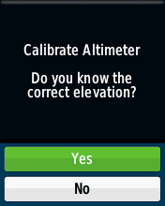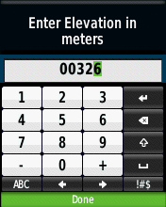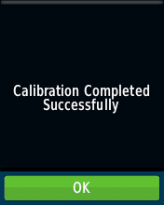
- Press on Calibrate Altimeter.
- You are now prompted by this message: “Do you know the correct elevation?” Choose Yes.
- Now use the Thumb Stick to correctly enter the elevation level from point 4 and then press Done.
- Calibration Completed Successfully. Press OK.

While performing your monitoring activities during GPS data collection, you should also check occasionally that the GPS units are collecting accurate elevation levels. If you notice discrepancies, it means the GPS unit needs to be recalibrated.

Loading a Map
Putting maps onto Garmin devices is straightforward, and Garmin files are in '.img' format. Consider the following steps to successfully load a map onto your GPS device:
- Download the appropriate map file to your computer.
- If the downloaded file is compressed, unzip it to extract a file called gmapsupp.img
- Connect your GPS unit to your computer with the accompanying USB cable. This will put the device in USB Mass Storage mode and will show up in your system as a drive.
- Unless it already exists, from your computer create a folder inside the device’s drive and name it Garmin.
- Copy the gmapsupp.img file over to the Garmin folder you just created. If that file already exists on your device, you may want to archive it either on the device or your computer.
- Disconnect the GPS device or press the power button to restart it.
- The map should now be available.

GPS Data Collection Questionnaire
As is standard in a MICS survey when it comes to customising materials according to the country context, this GPS Questionnaire will also require some adaptation. Please consider the following:
- Ensure that there is the correct number of digits available for the Cluster, GPS Unit, GPS Operator, and Waypoint IDs (GP1, GP2, GP3, and GP8, respectively).
- Ensure that GP9, GP10, and GP11 are customised for recording of data possible in the survey, e.g., only few countries can have both N and S Latitude recordings. For those that do have both, you may include instruction for operators to circle the appropriate letter. It is safe to delete both N/S and E/W if only one value for each is applicable in the survey. The directions can be automatically added to the data.
- Please also customise the number of meters and degrees appropriate to readings in your sample. Keep five digits for decimal degrees.

Training/Selection of GPS Operators
GPS data collection can almost always be done without hiring additional personnel. The set-up of roles and responsibilities may vary according to the survey and what data is already available. However, there should be a person on each Mapping & Listing team who is responsible for collection of the GPS points (the GPS Operator) and an overall GPS Coordinator at Headquarters.

Since the collection of GPS waypoints occurs during the Mapping & Listing Operation, UNICEF recommend that all mappers and listers are trained and the mapper on each team is responsible overall for GPS data collection.

The GPS Operators must be trained in the basics of the GPS units, point collection protocols, simple troubleshooting techniques, as well as how to fill out the GPS Questionnaire. This training should take about half a day. It is extremely important to give time during the training to practice GPS waypoint collection in a field or park where there is a clear view of the sky. This training must be conducted by the GPS Coordinator.

The responsibilities of the GPS Operators are as follows:
- Capture and record three GPS waypoints at the centre of the cluster. The distance between the three waypoints should be more than 20 meters and less than 200 meters from each other. To get adequate satellite signal power, the location of capture should be relatively open (in all directions), away from tall buildings, and out from under tree canopy.
- Complete the GPS Data Collection Questionnaire.
- Make a circle on the paper map (orthophoto, sketch map, etc.) of the place where each GPS waypoint was recorded.
- Once the cluster listing is completed, bundle the GPS Questionnaire with the full Mapping & Listing package for the cluster.
- Communicate with the GPS Coordinator about any problems encountered in the field and follow his or her instructions.
- Ensure that the unit and accessories are handled properly during fieldwork. This includes maintaining battery level and transfer of data when the GPS Coordinator visits the team.
- Never delete the collected waypoints from the GPS receiver during the whole fieldwork.

Data Collection/Monitoring
To ensure a flow of GPS data, the GPS Coordinator must establish a systematic and regular approach to the collection of GPS files. An opportune moment to collect files is when visiting the teams in the field carrying out the routine monitoring exercise. It is important to keep track of what has been collected, and for this reason it is recommended that the GPS Coordinator creates an Excel table with the first column containing all cluster numbers. This sheet will be extensively used for quality control as well.

The GPS Coordinator will make sure to fill out the row of the corresponding cluster number by adding the GPS Unit number, as well as whether the GPS files were collected. See below for a table example. This should be held against the information collected through the Questionnaires as recorded in headquarters on return of full cluster packages:

Example Monitoring Table

All Questionnaires must be checked to make sure they were filled out correctly and any discrepancy should be addressed immediately.

A further monitoring exercise includes random checks of the waypoints collected. The checklist on the GPS Questionnaire can be used as a guide. In fact, prior to marking and saving each waypoint, the GPS Operator must:
- Check the estimated accuracy of the reading to at least less than 5 metre.
- Make the reading near the centre of the cluster.
- Mark the waypoint.
- Rename the waypoint to Waypoint ID, which should contain Cluster and Reading number (XXX-Y). The cluster number is mentioned on GP1, while the reading number is the number of the waypoint of the same cluster. For example, the Waypoint ID of the third waypoint of cluster #179 should be “179-3”.
- Save the waypoint.

The GPS Coordinator should randomly test certain waypoints against the above list and compare the elevation, latitude, and longitude readings with those noted on the corresponding Questionnaire. When considerable discrepancies are found, feedback should be provided to the GPS Operator perhaps together with a reminding demonstration of how to operate the GPS unit for accurate reading.

The selected GIS computer software can be used also to monitor the accuracy of recorded waypoints. This can easily be done by entering the latitude and longitude coordinates of a waypoint into the GIS software.

Data Processing
Once fieldwork is over and all Questionnaires have been returned to headquarters, the GPS Coordinator will ensure that the monitoring sheet is finalised as well.

The Data Processing team will enter the data from the GPS Questionnaires and the GPS Coordinator must ensure that the CSPro data matches that of the monitoring sheet.

The Data Processing team will download waypoints from the GPS receivers using the GPS TrackMaker. The procedure to download the waypoints:
- Plug the GPS receiver into the computer with the USB cable.
- Turn on the GPS receiver.
- Open GPS TrackMaker and click on the GPS menu.
- Select Garmin Interface.
- On the pop-up box click the Capture button. If you receive a no data message, make sure your GPS receiver is turned on.
- Click the Waypoints button. The waypoints will be downloaded to your computer.
- Click the Exit button.
- The waypoints should appear on your screen. If they do not appear click on the view tab and check the waypoints selection.
- Go to File menu, and select Save File As.
- Browse to where you would like to save the file.
- Include the survey country, year, and GPS unit number (GP2) in the file name (e.g., Lao_2022_001.gtm).
- Select the file type: GPS TrackMaker File (*.gtm).
- Click Save.

Do the same for each GPS receiver.

