Multiple Indicator Cluster Surveys
Survey Findings Report & Statistical Snapshots
Customisation and Process Guidelines

SURVEY FINDINGS REPORT
The objective of the Survey Findings Report (SFR) is to present the results of the survey in tabular form and inform government agencies, non-governmental organizations, other multilaterals, the press, and the general public of the current situation of children and women. The SFR has limited standard text and even less text for customisation.

To facilitate the rapid production of the SFR, a report template is available at http://mics.unicef.org/tools#report-writing. The template is intended to:

- facilitate the efficient production of reports so survey team members responsible from drafting the report do not have to “reinvent the wheel” and spend time on the design of tables, indicator explanations, etc., enabling surveys to present a single, minimum compilation of survey documentation;
- ensure the production of comparable reports that can be used easily to draw comparisons between countries and MICS surveys; and
- increase confidence among users of the survey; MICS is a recognised household survey programme with an internationally accepted methodology.

Survey teams are expected to use the template for their SFRs and customise it in accordance with the contents of their surveys. In aid of that, UNICEF recommends the adoption of the following basic guidelines in the customisation of the SFR. These are all based on experience gathered from providing reviews and technical assistance to hundreds of such reports.

Note that this document contains two appendices with detailed guidance on:
- Transferring SPSS Excel exports to the SFR
- How to create bookmarks in the final SFR

Further guidance is found in the tabulation plan (http://mics.unicef.org/tools#analysis), syntax (http://mics.unicef.org/tools#data-processing), and the report template itself.

The SFR template is a package of independent Word documents for each chapter and for the appendices of the report.

Drafting of the report

Once tables are generated and finalised it should be quite straightforward to produce the report. The SFR should be drafted by the implementing agency and/or members of a stakeholder/technical committee, with assistance and feedback from the country and regional offices of UNICEF, as well as UNICEF Headquarters.

Chapters can be divided among different people. It is useful to include people familiar with subject matter. Experts in various fields should be consulted and asked to review tables in order that any significant or unusual findings are addressed and dealt with properly in the report and that technical terminology is appropriately used.

The template report is available at http://mics.unicef.org/tools#report-writing to help and guide the writers of the full report or the specific chapters.

Experience reveals that some chapters and most text can be customised in advance while awaiting the final tables. It is however not good practise to import tables before these have been through the review process. See below section “Minimum numbers of observations for proportions and percentages”.

Front cover

Survey teams are invited to keep the cover design according to the template design. This is of symbolic and practical importance – reports with similar designs from surveys around the world are expected to enhance the visibility of MICS, and emphasise that MICS is an internationally comparable survey, conducted within the context of a major global effort with quality assurance. Please visit the following web page for the MICS6 SFR cover templates in In-Design and PDF formats: http://mics.unicef.org/tools#report-writing.

The front cover of the report should explicitly display the name and logo of the implementing agency and other national agencies/governmental organizations participating in the survey. UNICEF’s name and logo may also be included, although this is not absolutely necessary. The same applies to other international agencies that have supported the survey. However, the MICS logo must be included on the front cover.

Please note that the templates were designed for MICS4 reports and that the MICS tagline has recently changed. This is not reflected on the cover templates, but details are available in the accompanying cover template instructions.

Customisation of content

Survey teams will customise the template SFR in accordance with the contents of their surveys, adding or deleting tables and sections as needed. It is recommended that survey teams plan the inclusion of additional topics and tables in advance (once the questionnaires are final and before the teams start data collection) so that the production of the report is not delayed. It is also important to note that the SFR is intended to show only the findings of the MICS survey; therefore, presentation of tables and analyses based on other data sources should be avoided, except where necessary to understand the findings of MICS.

In this context, trend analysis is also not recommended since such analysis requires a different analytical perspective and additional work. Trend analysis means that the quality and comparability of all data sources used in the analysis will be reviewed and ascertained (note that this also applies to using more than one MICS survey for trend analyses). Sampling errors of estimates from different data sources will need to be taken into account all at the same time. Separate, focused, and additional quality time is needed to undertake trend analyses, which can best be handled in a separate context.

Customisation – Summary Table of Survey Implementation and the Survey Population

This summary pulls together information from across the SFR and, as described below, requires a few minor calculations.

The table “Survey sample and implementation” requires information on sample, training, fieldwork and questionnaires, which should all be available in Chapter 2: Survey methodology, Chapter 4: Sample coverage and characteristics of respondents and in Appendix A: Sample design.

In the lower table, “Survey population”, the following is needed:
• “Average household size” is available in Table SR.3.1
• Percentages of population under age 5 and 18 are provided in Table SR.4.1
• “Percentage of women with a live birth in the last 2 years” is given in Table SR.5.1W
• Percentages of population living in urban and rural areas and in regions are not directly available from the standard tabulations. To generate these percentages, the numbers of household members in the last column of Table SR.2.3 need to be used for calculating percentages of total population.

Tables and table numbering

Tables are expected to be placed within the chapters, at the end of each applicable section.

As presented in Appendix I, tables should be run chapter by chapter, so that even the slightest update to syntax in one table will result in a new SPSS output exported to Excel with all the tables of one chapter, with each table in an independent sheet. This enables better control of the process. Please refer to Appendix I for guidelines on transferring tables from the Excel exports of SPSS through your customised tabulation plan and into to the report.

Table numbers in the text refer to the numbers used in the standard tabulation plan, which includes all standard MICS6 tables. Survey teams may choose to re-number the tables to be sequential throughout each chapter and section, keeping the two letters and one number denoting the chapter and section to which the tables belong, depending on the tables included in the report. For example, in a country where the malaria questions have not been included, section TC.6 will not appear in the report. In this example, Sections TC.7-TC.11 should be renumbered as TC.6-TC.10. In another example, if a survey that did include malaria also included additional questions on the topic, these should be placed within Section TC.7 and sequentially numbered, from TC.6.14 onwards. Renumbering should happen at the very last stage, i.e. after the UNICEF HQ review of the Final Report. This is to ensure that a common reference is maintained between syntax names and table names in order to facilitate more efficient reviews.

Survey-specific questions/modules and indicators

Additional topics covered by the survey that are not part of the standard MICS6 topics should be inserted where appropriate, either within existing chapters or as independent chapters. It is important to describe such survey specific additions also in Chapter 2: Survey Methodology.

When certain results represent indicators added to the survey, these should be added to the list of indicators in Chapter 3: Indicators and definitions. They should be placed within the appropriate topic. Please use a numbering system of XX.S1, XX.S2, etc., where XX is the topic code from the MICS Indicator List.

Figures

No figures are recommended for the SFR. Graphical representation of results is included in the MICS Statistical Snapshots. These should be produced at the same time as the SFR (see Statistical Snapshots section below).

Template text

Nearly all text in the report template is standard description of indicators and methodology. Where text is in red, customisation is needed.

In a few instances, additional text is needed to present aspects directly related to policy and programming specific to each country. Instructions on this is also presented in red in the template report.

Any additional citations – provided in footnotes – should be inserted as needed. The citation style in the SFR follows a slightly modified “Chicago” style. Citations can be automatically generated here: http://www.citationmachine.net/chicago, which can be used for anything but reports and special documents, where it is recommended to use Word’s citation function for harmonisation purposes.

Missing cases and ‘don’t know’ responses

Missing cases and ‘don’t know’ responses are not shown in the template tables, apart from those tables that include percentage distributions of responses to a question where ‘Don’t know’ responses were explicitly allowed in the questionnaire; in such cases, ‘Don’t know’ categories are shown. In general, however, missing cases and ‘don’t know’ responses should be included in the actual tabulations as separate categories. If the total of ‘missing’ and ‘don’t know’ is less than 5 percent of the denominator, these two categories should be combined into a single category and denoted as ‘Don’t Know/Missing’. For cases when the combination of these two categories is more than 5 percent, each category should be shown on separate columns (or row if denominator allows), and caution should be exercised in the interpretation of the results. These apply to both row (usually background) variables and column (usually indicator) variables.

Minimum numbers of observations for proportions and percentages

For proportions or percentages, the recommended minimum size of the denominator is 25 unweighted cases. A percentage based on an unweighted denominator of fewer than 25 cases should not be shown in the table, while a percentage based on fewer than 50 cases, but at least 25 cases (25-49) should be shown in parentheses. If a percentage is based on fewer than 25 unweighted cases for any category of an indicator or background variable, the category should be kept and ‘(*)’ should be put in place of the percentages. A simplified example is provided below, presenting only a selected number of cells from a table.

Please note that to be able to do this, you will have to run the tabulations both weighted and unweighted in order to determine whether the unweighted denominators are smaller than 25 or 50 cases.

Table TC.7.1: Initial breastfeeding
Percentage of last live-born children in the last two years who were ever breastfed, breastfed within one hour of birth and within one day of birth and percentage who received a prelacteal feed, by type of feed, Survey name, Year
 | Percentage who were ever breastfed¹ | Percentage of children who were first breastfed: |  | Number of last live-born children in the last two years
 |  | Within one hour of birth² | Within one day of birth
Mother’s education
None | (98.4) | (58.4) | (86.0) | 24
Primary | 97.9 | 67.2 | 90.0 | 122
Secondary+ | 97.2 | 62.3 | 86.4 | 1,040
Don’t know/Missing | (*) | (*) | (*) | 11
¹ MICS indicator TC.30 - Children ever breastfed
² MICS indicator TC.31 - Early initiation of breastfeeding
^{A} Children receiving a prelacteal feed are those ever breastfed who consumed something other than breastmilk in the first 3 days of life.
( ) Figures that are based on 25-49 unweighted cases
(*) Figures that are based on fewer than 25 unweighted cases

Alternatively, if a specific category is required to be suppressed consistently in many tables because of the low number of cases, the category might be excluded altogether from the tables; in this case, a footnote must be inserted for that variable, indicating that category X has been suppressed from the table due to a small number of unweighted cases.

Using the same example as above, if “Don’t know/Missing” is consistently presented with (*) in applicable tables, i.e. based on the denominator of “Number of last live born children in the last two years”, the row can be deleted, a reference inserted on “Mother’s education” and the following note inserted: ^{B} The category of “Don’t know/Missing” in the background characteristic of “Mother’s education” has been suppressed from the table due to a small number of unweighted cases.

The result would look as below section:

Mother’s education^{B}
None | (98.4) | (58.4) | (86.0) | 24
Primary | 97.9 | 67.2 | 90.0 | 122
Secondary+ | 97.2 | 62.3 | 86.4 | 1,040
¹ MICS indicator TC.30 - Children ever breastfed
² MICS indicator TC.31 - Early initiation of breastfeeding
^{A} Children receiving a prelacteal feed are those ever breastfed who consumed something other than breastmilk in the first 3 days of life.
^{B} The category of “Don’t know/Missing” in the background characteristic of “Mother’s education” has been suppressed from the table due to small number of unweighted cases.
( ) Figures that are based on 25-49 unweighted cases

There is no need to suppress any cells in Tables SR.2.1 through SR.5.3 as the percentages are based on the total number of households, household members, women, men and under-five and 5-17-year-old children. The weighted and unweighted numbers of cases in some of these tables are presented in rows for descriptive purposes.

A special note applies to the few indicators that are calculated as rates, probabilities, ratios, and proportions. The rules for adequate number of cases are explained in the individual tables, in the standard tabulation plan. Consult with the UNICEF Regional MICS Coordinator.

Also note that “results” based on 0 unweighted cases should be presented using a dash ‘-‘ when it is required to present the entire row, e.g. in tables where there are more than one denominator or where removing a category would be confusing (such as a region or a quintile).

In percentage distributions the total of 100.0 percent should not be suppressed, as this is a given “result”.

Sampling Error Tables

In cases when the value of an indicator is equal to 0.0000 or 1.0000, provided that the number of unweighted cases that the indicator is based on at least 50, then the sampling error values for this indicator should be set as follows:

Standard Error: 0.0000
Coefficient of Variation: 0.000
Design effect = na
Square Root of Design Effect = na

‘na’ stands for “not applicable” (please insert this as a note to tables where appropriate). The confidence limits would be calculated automatically by the template as 0.000 – 0.000 and 1.000 – 1.000 respectively for indicators with values 0.000 and 1.000.

Similar to above description of minimum number of observations, if values are calculated based on fewer than 25 unweighted cases (i.e. “unweighted count” is smaller than 25), then replace all values with ‘(*)’. Use parentheses around values based on 25-49 cases. In both cases the MICS and SDG references, as well as the weighted and unweighted counts should be retained.

Compiling the report

Once each individual chapter is in final draft, the chapters should be merged into a single document. It is advisable to leave out the Appendix containing questionnaires and keep this separate until the very end, as the content becomes very large and stresses most computers when tracked changes and comments are inserted in the review process.

Please review the compiled report in its entirety as different authors may have used slightly different approaches. Such review will improve harmonisation.

At this stage, an automated table of contents can also be included, replacing the “manual” version in the template, which is included for illustrative purposes. It is also recommended to wait until this stage to insert the indicator values in Chapter 3: Indicators and definitions, as some tables may have changed over the course of compiling the report.

STATISTICAL SNAPSHOTS
The statistical snapshots are visual representations of the results in the SFR. They contain graphs, figures, tables and boxes for key messages on key thematic areas in the SFR. There are currently more than 20 statistical snapshot templates.

Survey teams should develop only those snapshots that are most important to their situation. The snapshots are fully customisable. For example, colours can be changed to reflect preference and high-resolution pictures may be included (if space permits). Behind each graph/figure/chart in the snapshots, there is an Excel worksheet with detailed instructions on where to find the data and how to customise them. The worksheet is accessed from within PowerPoint (Chart Tools-Design-Edit Data).

Further, any graphs/figures/charts that are not applicable for your country can be removed and replaced with other relevant survey specific indicators, if available. The PowerPoint files can be saved as pdf files and sent for printing.

Graphs/Figures/Charts should follow the same convention as the SFR for minimum numbers of observations for proportions and percentages (see above).

Tutorial videos on how to customise statistical snapshots are available here: http://mics.unicef.org/tools#reporting. It is highly recommended to watch these four short videos.

Generally, values are shown without decimal digits. For values in charts and tables below 1%, it is recommended to manually insert “<1” or “<1%”, where applicable.

THE REVIEW PROCESS
Once the survey team is satisfied with the draft SFR and Statistical Snapshots, please share with the UNICEF Regional MICS Coordinator for review as described in the MICS Technical Collaboration (TC) framework. This review may require several draft versions being produced and revised. To minimise the time required for this review process it is highly recommended that the survey team reviews each version before submitting for review. More eyes conducting a thorough review is known to increase the quality of the report and thus minimise the review iterations and comments.

After this stage is completed, the report and statistical snapshots can be prepared for print. Specifically for the SFR, please carefully review and also share the print ready version for a last review with the Regional MICS Coordinator as also presented in the TC framework. This last review is necessary based on numerous instances of mistakes being introduced in this last phase, either by designers or by the software itself.

Please note that “month, year published” on the SFR’s front matter cover page should refer to the time the report was made available to the public. It is therefore natural that this can change during the review, design and printing process.

Final version for online sharing

Please ensure that the printer/designer provides the original files (created in the design software) to the survey team and UNICEF, as well as the pdf files for upload. In order to provide reports easily accessible for download and online browsing, the SFR pdf file should not exceed 5 MB.

Please refer to Appendix II in this document for instructions on how to create the pdf version of the SFR to be shared on the MICS website, mics.unicef.org/surveys, as well as a list of bookmarks that should be added to the pdf version for easy browsing.

APPENDIX I: Transferring SPSS Excel exports to the SFR

Each table in MICS comes with a tabulation syntax that should be customised to the survey (or deleted if not used). If any table for a survey specific topic is added, the syntax as well as the corresponding tabulation plan template should be created by the survey team.

In turn, Chapters 4-11 and Appendices C and D each come with a tabulation plan that should also have been customised for the survey. A syntax (MICS6 - 00 - All Tables in Sheets.sps) is available (for customisation) that produces one Excel workbook for each chapter, with each table in independent sheets. Experience tells us that the safest procedure to handle any update to the tabulation syntax of any table, is to run this syntax (MICS6 - 00 - All Tables in Sheets.sps) to produce a new set of Excel files. This creates a full set of tables, all dated the same date. If tables are independently run and manually exported or outputs copied (which is of course possible), you very quickly run the risk of losing overview of what is final and what is not.

The below steps describe how to transfer these SPSS Excel exports into the SFR.

Step 1 – Customising the Tabulation Plan template Excel files

Open and customise (if not already customised) all relevant tables in the Tabulation Plan template Excel files (have a backup of the template tabulation plan Excel files as you will be making changes to these).

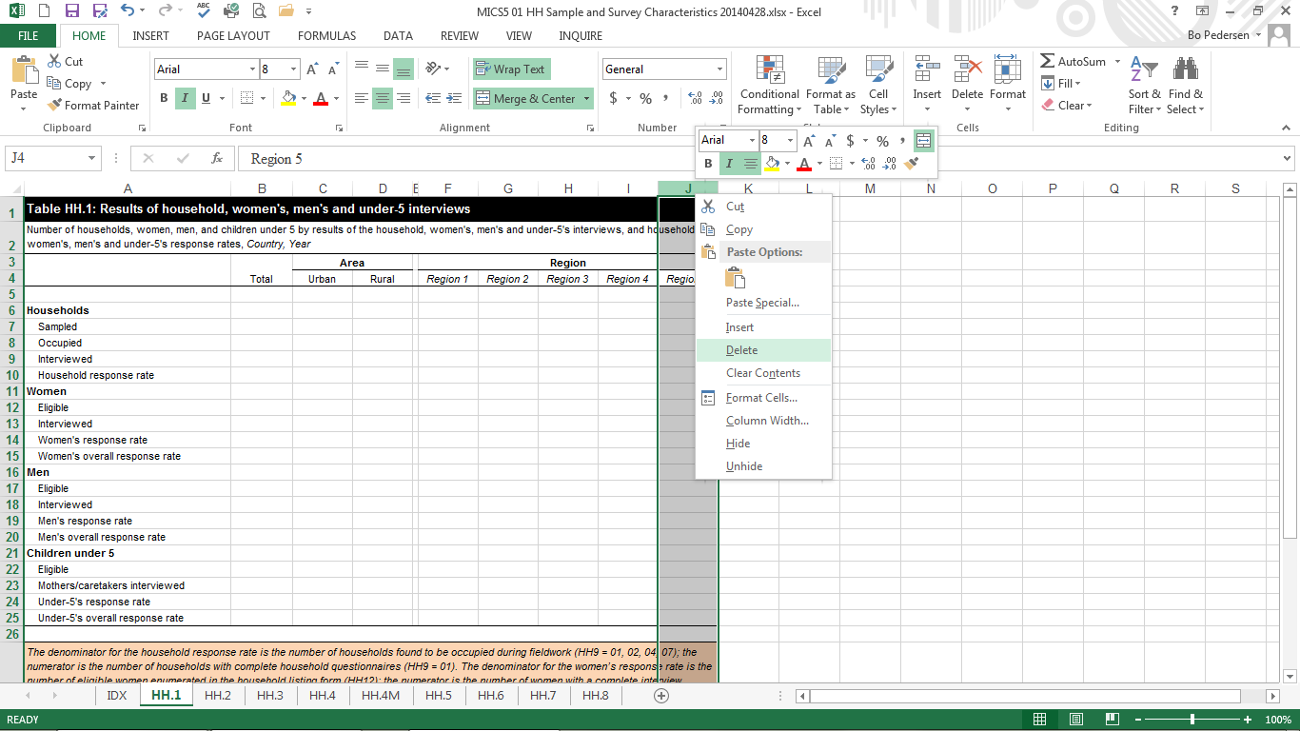

The customisation need for the table in template files may be very simple for some tables while very difficult for others. You may need to add or delete some rows or columns to correspond the categories of your indicators. For example, you may need to insert rows for your regions or you may need to insert an additional column in a percentage distribution table to show the ‘missing/don’t know’ category.

Step 2 – From the SPSS Excel export files to the customised Tabulation Plan Excel files

Select an area to copy from the SPSS Excel export worksheet with the data for the template file.

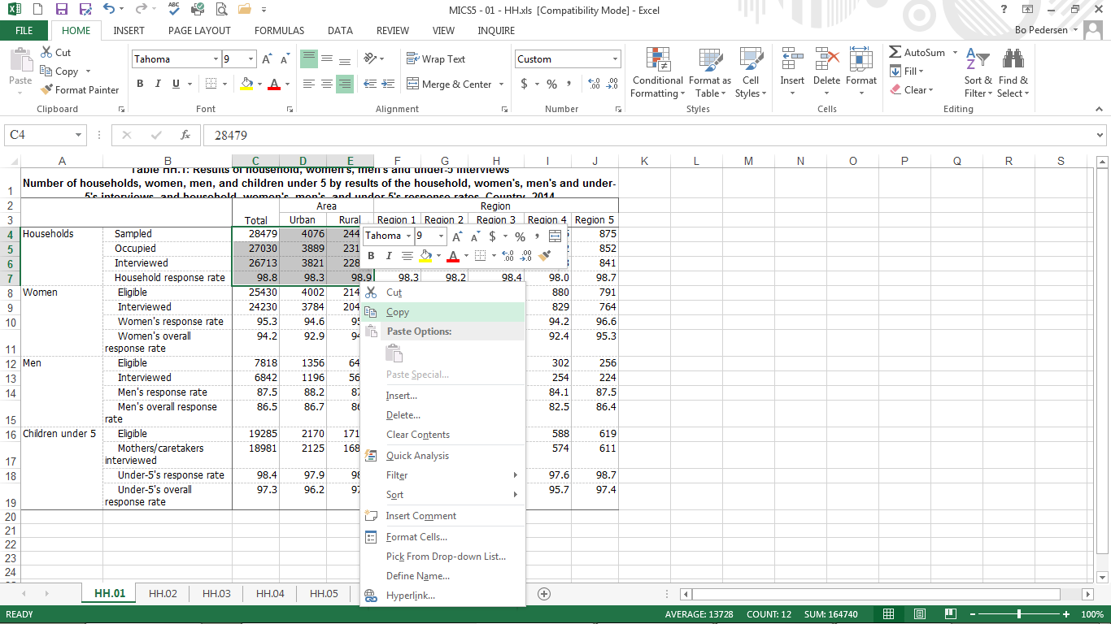

As the template table is differently formatted than the SPSS Excel export table, you need to copy and paste groups of cells several times.

Now, go to the Excel template file and right-click and paste your selection in appropriate cell (here B7).

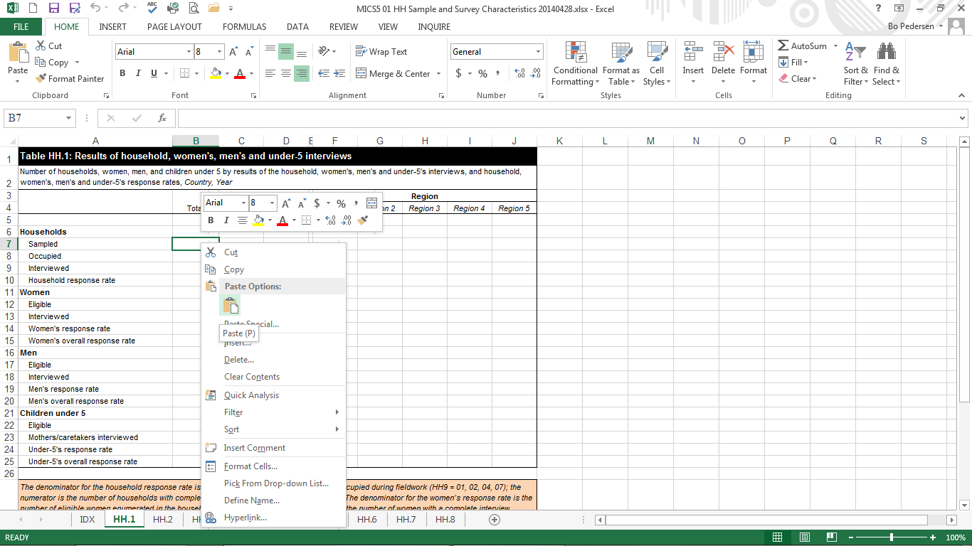

Please note that the area of percentages/numbers that you ‘copy’ might not correspond fully to the area to where you ‘paste’. In this example, because of the additional rows (i.e., the row ‘Households’ and columns (the column between Rural and Region 1) in the template file, you need do this copy-paste operation multiple times.

TIP: You can also use ‘Paste Special… No Borders’, which sometimes reduce the formatting work.
Repeat this step for other parts of the table.

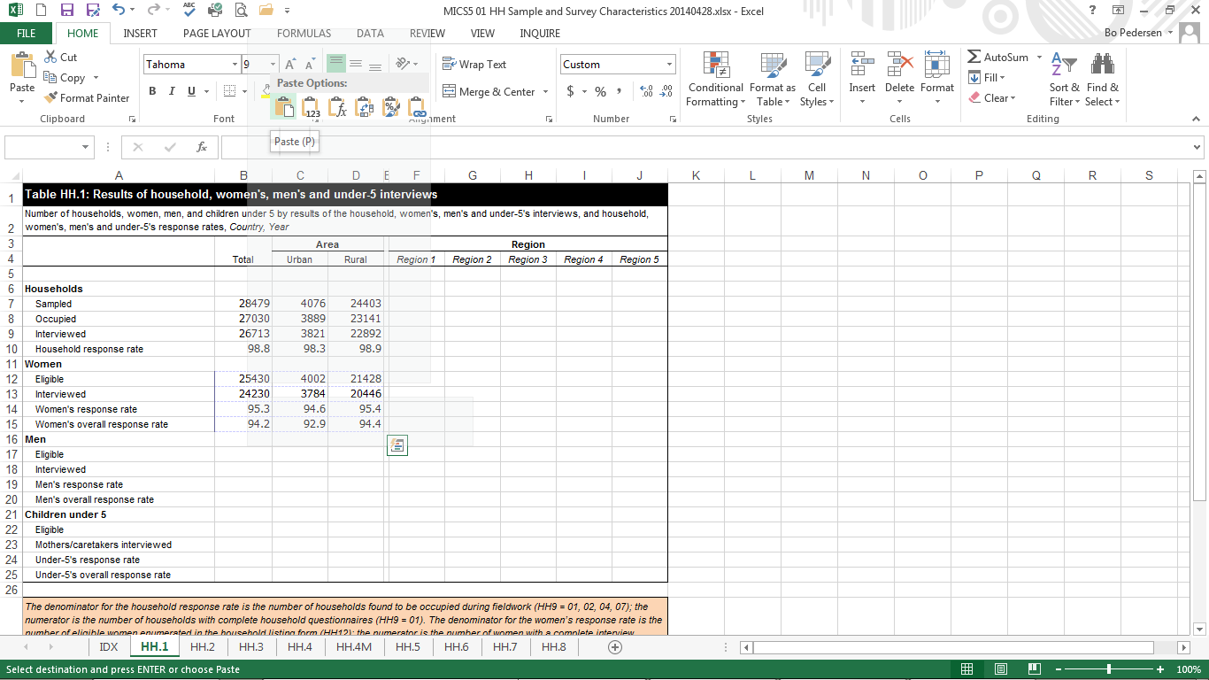

Step 3 – Formatting the customised table

At the end of this series of copy-paste operations, the tabulation plan Excel sheet will look similar to this.

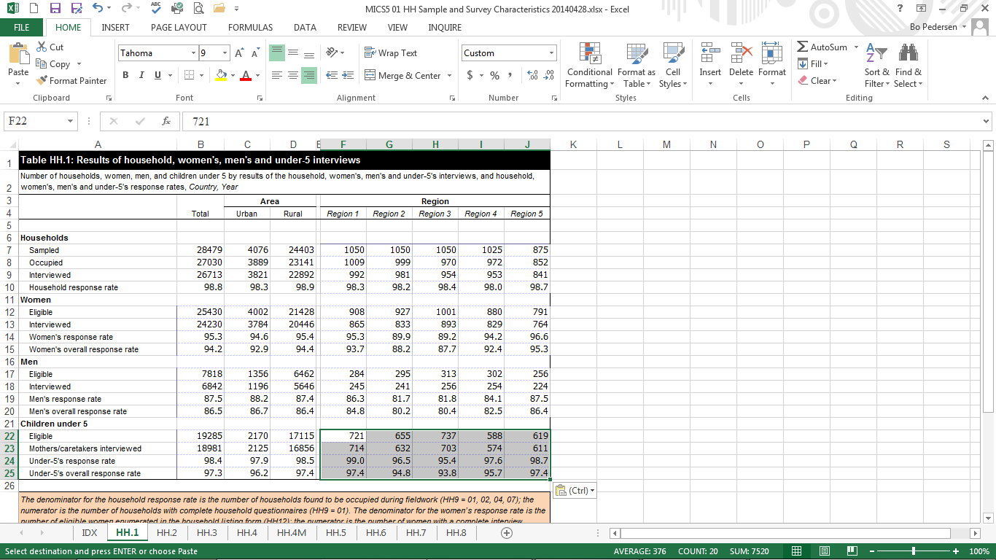

Some formatting will be needed.

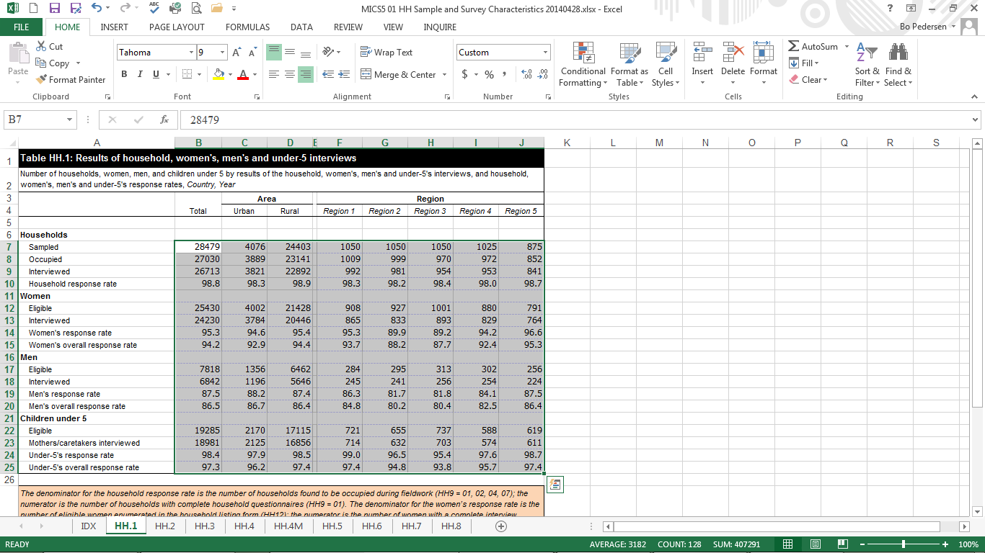

Select the area in which you have copied your percentages and numbers. You usually need to a) change font to Arial, b) set the font size to 8, c) remove the borders and d) set all copied cells to “Number format”.

Depending of the country-specific preferences, you may also need to add a 1000-separator. This is recommended for ease of reading.

Leading zeros are also recommended, but this should be automatic when setting to “Number Format”. You may also need to adjust the number of decimal digits: Always 0 (no decimal) for denominator columns, always 1 decimal for percentages, and differently, depending on indicator, in columns presenting rates (see tabulation plan). Only the tables in Appendix C: Estimates of sampling errors are designed differently as indicated in the tabulation plan.

Further formatting of borders is necessary.

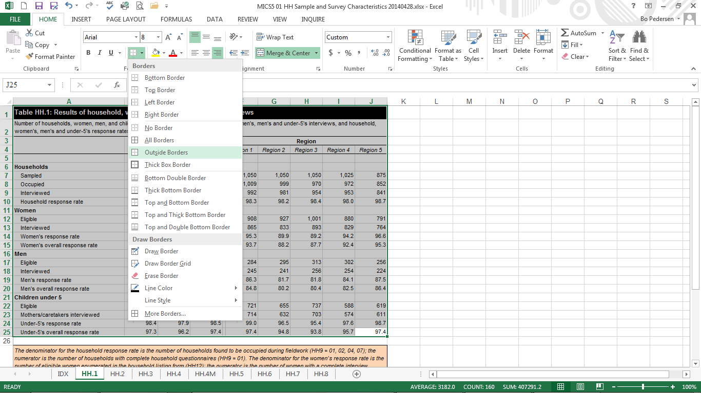

Now the table is ready to copy from the customised tabulation plan to the SFR Word file.

TIP: It is highly recommended that you save the now formatted Excel template file at this point. Some tables will most likely require updating as a result of changes to data or syntax files at a later stage. By saving now, you will already be prepared for such issues and avoid copy-pasting of the tables that are not affected.

Step 4 – Copying from Excel to Word

Select the table in Excel template file and copy. Paste it to the relevant part of the SFR.

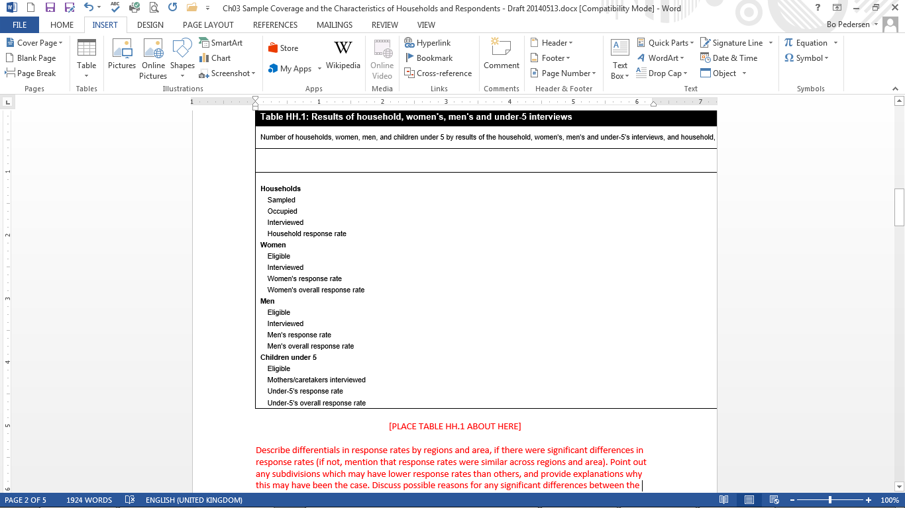

There is no need to copy the comments in the orange boxes below the tables. However, when there are table notes or indicator references, please ensure to copy these as well.

Step 5 – Word formatting

For most tables, some fitting is required (as in the example). Select the table by pointing to the upper left corner of the table and then right-click. Then select Auto Fit, AutoFit to Window.

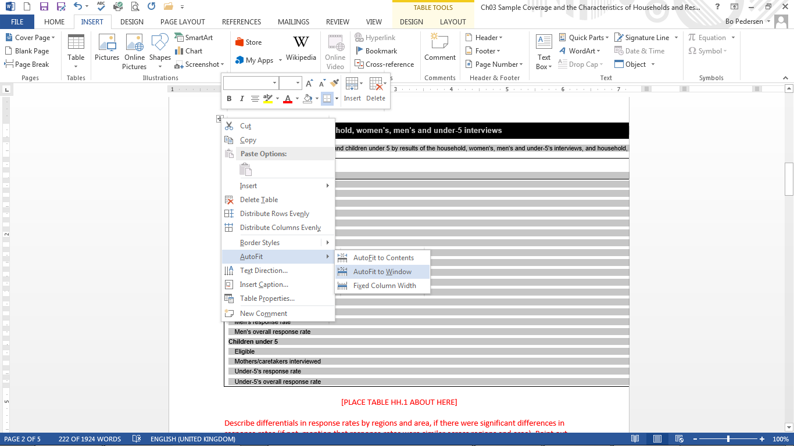

Step 6 – Additional formatting

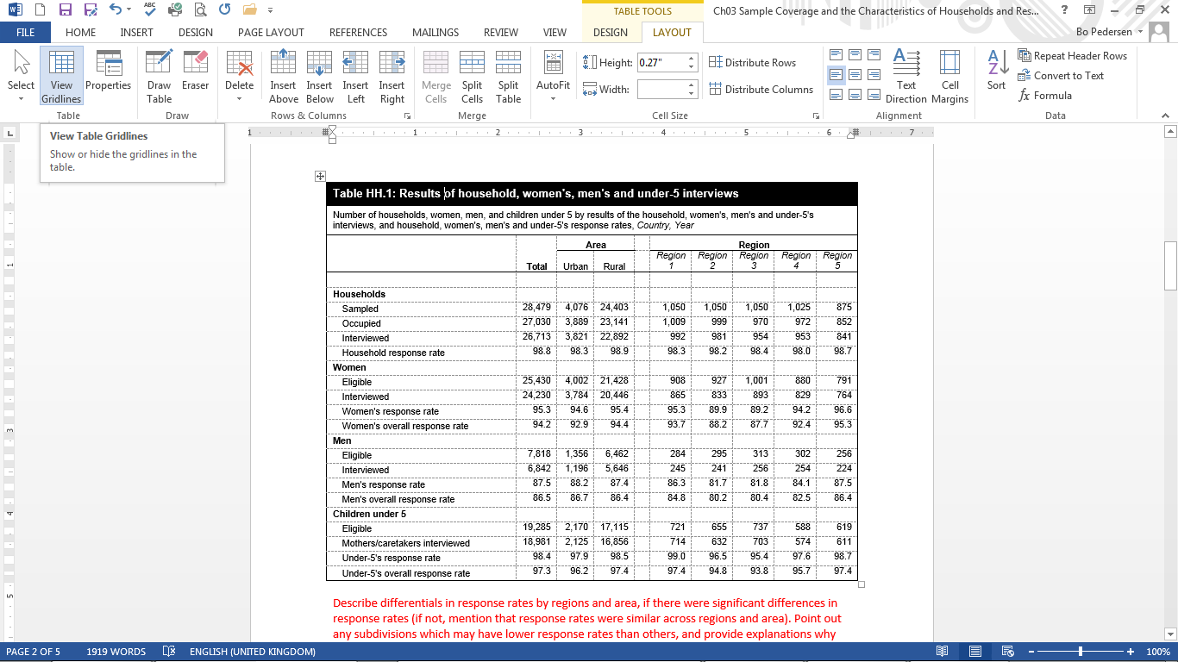

After fitting to window, most tables will have a look that require no more formatting. For larger tables with many columns, further customisation will be necessary.

Below are some tips for fitting the table contents into a portrait document. Keeping the document layout as portrait is recommended whenever possible. However, if preferred and provided that the experts preparing the SFR are capable of handling mixed layout documents with portrait and landscape pages in the same document, customisation can be made to fit large tables into landscape pages.

First you should view the tables with gridlines (see above). This gives a good overview of what may be possible.

One way of customising is to squeeze the cell contents by selecting the cells you would like to format, right-click, Table Properties, Cell, Options, unselect ‘Same as the whole table’, decrease the margins for ‘left’ and ‘right’.

Another option is to change the text direction of some columns (from horizontal to vertical). In order to do so, select the columns that require change of text direction, right-click and select Text Direction, change the orientation to vertical. You may further need to move these table columns by squeezing them manually using the ‘ruler’ so that, if there are any, the columns with vertical text direction are narrower. You may also need to increase the size of the row containing these labels and change the justification of the text.

APPENDIX II: Creating bookmarks in the SFR

The following describes how to ensure that the desired bookmarks appear in the pdf version of the final SFR document. Bookmarks make viewing and referencing a large document, such as a MICS report, much more user-friendly. Please note that regardless of procedure, some bookmarks must be inserted manually (as indicated in list).

In Word documents:

There are variations of how to include bookmarks. Below are those most useful in the context of this particular task, i.e. creating, from Word alone, a final pdf version for sharing.
Automatic approach:
- Word can generate bookmarks when saving in pdf format using the headers indicated in the report. As the report already should contain an automatic table of content based on headings in the report this is the easiest approach. It may however create unnecessarily many bookmarks, which then could be removed using the approach described under the pdf guide below.
- Simply click ‘Save As’ and choose pdf under ‘Save as type:’.
- Click ‘More options’.
- Retain the setting of ‘Standard’ under ‘Optimize for:’, but open the ‘Options’ dialog box and tick the box labelled ‘Create bookmarks using:’ and the setting of ‘Headings’. Click ‘Ok’ to close the ‘Options’ dialog box and then ‘Save’. The pdf document will automatically open for your review.
Manual approach:
- Similarly, Word can generate bookmarks when saving in pdf format using bookmarks manually added to the report. The manual approach is sometimes easier (depending on your Word file), as you will not need to delete any bookmarks added to the pdf file (which requires a pdf editor).
- Once you have added the necessary bookmarks (see below), simply click ‘Save As’ and choose pdf under ‘Save as type:’.
- Click ‘More options…’.
- Retain the setting of ‘Standard’ under ‘Optimize for:’, but open the ‘Options’ dialog box and tick the box labelled ‘Create bookmarks using:’ and change the setting to ‘Word Bookmarks’. Click ‘Ok’ to close the ‘Options’ dialog box and then ‘Save’. The pdf document will automatically open for your review.
- To manually add such bookmarks, the following routine should be completed for each necessary bookmark (the list of bookmarks is added below):
  - In the SFR, using the cursor, highlight a position for bookmarking. A “position” should be the chapter/section headings according to the list of recommended bookmarks given at the end of this appendix, e.g. “1 Introduction”. Click copy.
  - From the ‘Insert’ menu click ‘Bookmark’. The ‘Bookmark’ dialog box will open.
  - Paste the copied text, e.g. “1 Introduction” in the ‘Name’ box. Note that this will not work with all headers. Some do not appear in the report and most have multiple words. Word does not accept multiple words, as a bookmark must start with a letter and cannot contain spaces, but you can use the underscore character to separate words.
  - Click ‘Add’.
  - Please ensure that all (as appropriate) headers from the below list are bookmarked one at a time.
Additionally:
- To return to the bookmark location open the ‘Bookmark’ dialog box from the ‘Insert’ menu, highlight the name of the bookmark, and then click ‘Go To’. The bookmarks are not visible in the finished document.
- To delete a bookmark, return to the Bookmark dialog box and click ‘Delete’.

In pdf documents:

A pdf editing software is required to add/edit bookmarks. The below is based on Adobe Acrobat; slightly different approaches would apply to other software. Note that some software, including Acrobat, can automatically add bookmarks based on the document structure and existing tags.
- Click the Bookmarks button on the left to open the Bookmarks panel.
- Open the page where you want the bookmark to link to, e.g. navigate to first page of the “1 Introduction” chapter.
- Use the Select tool to drag across the text you want to bookmark, e.g. “1 Introduction”. The selected text becomes the label of the new bookmark. You can edit the label.
- Select the bookmark under which you want to place the new bookmark. If you don’t select a bookmark, the new bookmark is automatically added at the end of the list.
- Choose ‘Tools’, then ‘Edit PDF’ – ‘More’ and finally ‘Add Bookmark’.
- Repeat for each bookmark you want to create.
- Some bookmarks should be “nested”, i.e. section headers should be “nested” under Chapter headers: Drag the Section bookmarks directly underneath the appropriate Chapter bookmark.
- In the Bookmarks panel you can edit the name of or delete bookmarks.
Additionally:

- Once bookmarks are created, before saving the pdf document, go to ‘File’ and click ‘Properties’ and tick ‘Enable Bookmarks Panel and Page’ under ‘Initial View’ and ‘Navigation tab’. This step ensures that the bookmarks are seen as soon as the document is opened without having to change any settings.

Headers/Positions for bookmarking:

Please ensure that the following headers/positions are bookmarked in the pdf file to allow easy browsing for users:

Title page (insert manually)
Citation page (insert manually)
Summary Table of Survey Implementation and the Survey Population
Table of Contents
List of Abbreviations
Acknowledgements

- Introduction
  - Background
  - Survey objectives
- Survey methodology
  - Sample design
  - Questionnaires
  - Ethical protocol
  - Data collection method
  - Training
  - Fieldwork
  - Fieldwork quality control measures
  - Data management, editing and analysis
  - Data sharing
- Indicators and definitions
- Sample coverage and characteristics of respondents
  - Results of interviews
  - Housing and household characteristics
  - Household composition
  - Age structure of household population
  - Respondents’ background characteristics
  - Literacy
  - Migratory status
  - Adult functioning
  - Mass media and ICT
  - Tobacco and alcohol use
  - Children’s living arrangements
- Survive
- Thrive – Reproductive and maternal health
  - Fertility
  - Early childbearing
  - Contraception
  - Antenatal care
  - Neonatal tetanus
  - Delivery care
  - Birthweight
  - Postnatal care
  - Adult and maternal mortality
  - Sexual behaviour
  - HIV
  - Male Circumcision
- Thrive – Child health, nutrition and development
  - Immunisation
  - Disease episodes
  - Diarrhoea
  - Household energy use
  - Symptoms of acute respiratory infection
  - Malaria
  - Infant and young child feeding
  - Malnutrition
  - Salt iodisation
  - Early childhood development
  - Early child development index
- Learn
  - Early childhood education
  - Attendance
  - Parental involvement
  - Foundational learning skills
- Protected from violence and exploitation
  - Birth registration
  - Child discipline
  - Child labour
  - Child marriage
  - Female genital mutilation
  - Victimisation
  - Feelings of safety
  - Attitudes towards domestic violence
- Live in a safe and clean environment
  - Drinking water
  - Handwashing
  - Sanitation
  - Menstrual hygiene
- Equitable chance in life
  - Child functioning
  - Social transfers
  - Discrimination and harassment
  - Subjective well-being
Appendix A Sample design
A.1 Sample size and sample allocation
A.2 Selection of enumeration areas (clusters)
A.3 Listing activities
A.4 Selection of households
A.5 Calculation of sample weights
Appendix B List of personnel involved in the survey
Appendix C Estimates of sampling errors
Appendix D Data quality
D.1 Age distribution
D.2 Birth date reporting
D.3 Completeness and measurements
D.4 Observations
D.5 School attendance
D.6 Birth history
D.7 Siblings
Appendix E Survey name questionnaires
E.1 Household questionnaire (insert manually)
E.2 Water quality testing questionnaire (insert manually)
E.3 Questionnaire for individual women (insert manually)
E.4 Questionnaire for individual men (insert manually)
E.5 Questionnaire for children under five (insert manually)
E.6 Questionnaire form for vaccination records at health facility (insert manually)
E.7 Questionnaire for children age 5-17 (insert manually)

The instructions and screenshots in this section were developed during MICS5 and have been edited for MICS6. Note, however, that the example table and file has changed slightly, without consequence.

