Procurement instructions for recommended equipment AND SOFTWARE

This is a list of some of the recommended equipment and software needed for implementation of the Base Questionnaire of a MICS survey. It describes the major items, including those that must be procured through UNICEF Supply Division (by the UNICEF Country Office) which require orders to be placed months in advance.
Please see the ‘MICS Listing and Fieldwork Duration, Staff and Supply Estimates Template’ for estimating number of units needed.
Before proceeding with any purchase, kindly request confirmation from the Regional MICS Coordinator.

Measuring boards
The size of the required measuring board depends on whether the survey intends to only measure children under 5 years or if the survey also includes measurement of children age 5-9 years. Only one size should be ordered, as the survey will measure children under 5 on the same board used for children age 5-9 years, if included.
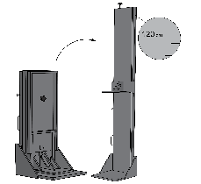
If only measuring children under 5:
Portable baby/child length/height measuring board, made of wood, 2 boards packed in a carton box. 120 cm. UNICEF Supply Catalogue material number S0114530). Stock item. Boards are packed by two in a carton to save shipping costs. Price for 2 units (one carton): USD 169.35 (indicative price in UNICEF Supply Catalogue, March 2023).
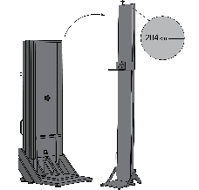
If both measuring children under 5 and age 5-9 years:
Portable baby/child/adult length/height measuring board made of wood, 2 boards packed in a carton box. 204 cm. UNICEF Supply Catalogue material number S0114540). Stock item. Boards are packed by two in a carton to save shipping costs. Price for 2 units (one carton): USD 258.63 (indicative price in UNICEF Supply Catalogue, March 2023).
Other measuring boards and devices are available in the Supply Catalogue. Note that the MICS Programme expects to change its recommendation to a digital board as soon as available. Please communicate with Regional MICS Coordinators for guidance on options and latest information.
Please try to plan as early as possible and order at least 3 months before the scheduled start of the fieldwork/pre-test training. Shipping time will vary depending on mode of shipment, but order processing alone is at least 6 weeks.

Scales
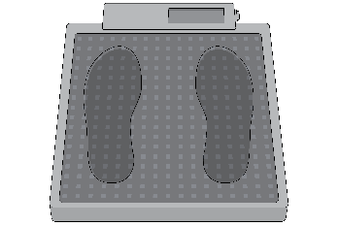
Scale, mother/child, maximum 150 kg – UNICEF Supply Catalogue material number S0141025). Stock item. Price each: USD 107.14 (indicative price in UNICEF Supply Catalogue, March 2023). Scales require six alkaline AA batteries (supplied with the scale) which can conduct a minimum 5,000 measurements per battery set.
Other scales are available in the Supply Catalogue as are options for solar charge versions and other add-ons. Note that the MICS Programme expects to change its recommendation to a scale with additional functionality when available. Please communicate with Regional MICS Coordinators for guidance on options and latest information.
Please try to plan as early as possible and order at least 3 months before the scheduled start of the fieldwork/pre-test training. Shipping time will vary depending on mode of shipment, but order processing alone is at least 6 weeks.

Water quality testing equipment and consumables
Water testing for Escherichia coli (E. coli) requires both items that can be procured locally and items that must be ordered through UNICEF Supply Division in Copenhagen. Use the “Water Quality Supplies” sheet of ’MICS Listing and Fieldwork Duration Staff and Supply Estimates Template‘ to calculate the number of each item that will be needed.
The below picture and table reference the hardware and consumables needed for water quality testing. The cost of the kit’s hardware is approximately USD 1,500 per team and on top of this, each test costs about USD 2.50. The cost of water testing equipment and supplies will vary depending on number of households in which water quality testing will be done according to sample design and field team composition.
Please try to plan as early as possible and order supplies required to be ordered from UNICEF Supply Division at least 3 months before the scheduled start of the pre-test training. Items for local procurement should be purchased at least a month in advance of the pre-test training.
For technical advice on water quality testing and for assistance with placing orders for water testing equipment, please e-mail the Global MICS Team (mics@unicef.org) and copy the WHO/UNICEF Joint Monitoring Programme team (info@washdata.org) and the Regional MICS Coordinator.
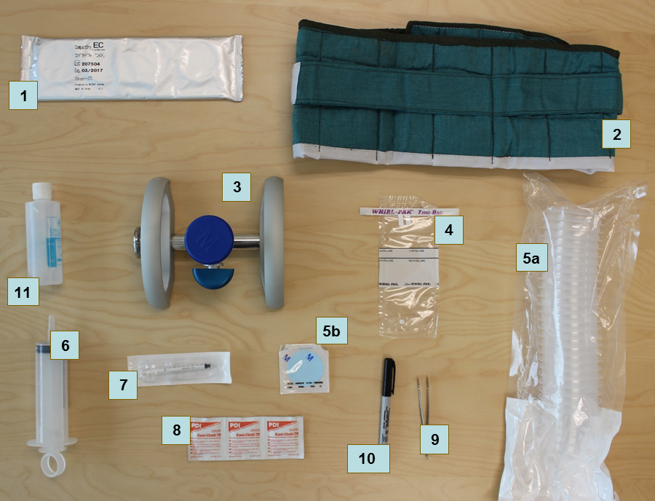
# | Item | Material number
UNICEF Supply Division
1 | Nissui CompactDry ECO plates | S0000579
2 | Incubation belt^{A} | S0000593
3 | Membrane filtration manifold | S5006120
4 | WhirlPak sample collection bag | S0000543
5 | Membrane and funnels | S5006125
6 | Reusable syringe, 100 mL | S0000545
7 | Disposable sterile syringe, 1 mL | S0782203
8 | Alcohol swabs | S0000540
9 | Metal forceps | S0000513
- | Chlorine tablet, 8.5 mg | S1588350
Local procurement
10 | Permanent marker | *
11 | Hand sanitiser | *
- | Storage Bag for consumables^{B} | *
- | Testing Bag for Measurer^{B} | *
- | Trash bags | *
- | Ziploc bags | *
- | Kitchen paper towels
- | Bottled water^{C}
- | Laminated instructions for Measurer
- | Water quality information leaflet (optional)
 | Tray for water quality testing (optional)
^{A} An optional portable electric incubator (S0000597) can be used in countries where electricity is reliable during the evenings, as teams can use vehicle 12V sockets during the day. Incubation belts are still needed as back up in countries planning to use electric incubators. USD 573.42 (indicative price in UNICEF Supply Catalogue, March 2023)
^{B} To store and transport the water testing supplies, each team requires a water quality testing bag to carry equipment and a small amount of consumables and a larger bag to store materials in the vehicle. These can be procured locally or from UNICEF Supply Division (e.g., S5001100, S5001000).
^{C} Bottles of water for the “blank test” (100 to 250 mL) are needed to ensure that testing is performed correctly throughout the fieldwork. These should be identified as high quality water and known to be free of E. coli contamination. This may need to be distilled water.
* These items can be ordered from UNICEF Supply Division, but local procurement is likely to be lower cost and offer a wider range of options.

GPS units
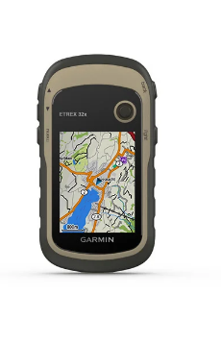
The standard Memorandum of Understanding specifies that MICS data should be geocoded, with a minimum of one cluster centre point available per cluster.
The MICS Programme recommends that GPS data is collected (or validated if already existing) in the mapping & household listing operation. GPS Data Collection is done using stand-alone GPS units, with specific functionality and precision. Validation of existing GPS data may be possible without stand-alone units. Please consult with the Global MICS Team (mics@unicef.org) and copy the Regional MICS Coordinator for immediate advice.
GPS units and accessories may be available through UNICEF’s Direct Ordering Scheme or UNICEF Supply Catalogue, otherwise through local procurement.
Manual and other tools are available based on a recommended unit: Garmin eTrex 32x. There are many other appropriate units available on the market. Altimeter and Mapping capability are highly recommended features. Please alert the Regional MICS Coordinator if the recommended unit is not available.
The unit runs on two AA batteries. Purchase 8 AA alkaline batteries per unit. In case of very high or low temperatures, 4 AA lithium batteries per unit are suggested. Alkaline batteries can rupture at high temperatures and significantly decrease in performance at low temperatures. Purchase 10-20% extra to replace damaged or lost units.

Tablets for data collection
Both Windows and Android devices can be used for data collection.
Minimum configuration:
Windows tablets: Microsoft Windows 7 or higher.
Android tablets: Android 8.0 or higher.
Suggested configuration: Microsoft Windows 10 or 11, or Android 10, 11, 12, or 13, with SD card, Bluetooth, and USB port and the following accessories: Individual charger, vehicle charger (1 per team), protective case, screen protector, and spare stylus.
Windows RT or iOS Operating Systems are not supported.
Note that desktop or laptop computers are required for processing and analysing data. Tablets used for data collection cannot be used for such purposes.
When planning to purchase new or deciding to reuse tablets from a previous survey, please contact the Global MICS Team (mics@unicef.org) and copy the Regional MICS Coordinator for advice. Note that a large order of specific tablets can be difficult to fulfil locally. Plan and order well in advance.

CSPro software
CSPro is used for data collection in MICS. It is a public domain software, developed by the U.S. Census Bureau and ICF International, used for entering, editing, tabulating, and disseminating census and survey data. It supports data collection on both Windows and Android devices and enables intelligent data transfer from field to a central office.
The CSPro version 7.7 installation program will be provided to MICS implementing agencies during the MICS Data Processing Workshop, or earlier on request. Free download of the installation program is also available, upon required registration, on the US Census Bureau website (link: CSPro).
Note that due to potentially significant changes between relatively frequent updates to the software, it is important that only version 7.7 is used, unless changes are communicated from the Global MICS Team.
For synchronisation of data from the field to the central office, a central server is required. The MICS data collection system supports two types of servers: CSWeb and FTP (File Transfer Protocol).
- CSWeb is a web server running the CSPro synchronisation server software. The CSWeb service is configured on the servers of UNICEF Headquarters and offered to implementing agencies as part of the MICS Technical Collaboration Framework for data synchronisation purposes. If implementing agencies are interested in installing the CSWeb server locally, free installation packages and instructions are available here. Setting up and maintaining a server for CSWeb requires expertise in web server maintenance and cybersecurity. Therefore, it is recommended to either use the existing CSWeb service configured on UNICEF Headquarters’ server or a local FTP.
- FTP: CSPro synchronisation can also be used with an FTP server. The MICS Programme suggests using FTP in situations where such is already established in implementing agencies and when there are no plans to rely on the CSWeb service set up on UNICEF Headquarters’ servers or to install a CSWeb service locally.

SPSS Statistics software
For MICS data analysis, it is recommended to use SPSS Statistics, a statistical software produced by IBM for advanced analytics and data management. One licence for SPSS Statistics 28 will be provided to the agency implementing MICS by the Global MICS Team. All MICS tabulation programs are provided as SPSS syntax files for customisation based on survey content.
Modules: Statistics Base, Complex Samples, Custom Tables.
Link: SPSS Statistics

