MANUAL FOR
MAPPING AND HOUSEHOLD LISTING

October 2013

Introduction

Multiple Indicator Cluster Surveys (MICS) are household sample surveys designed to provide up-to-date information on the situation of children, women and men, and to measure key indicators that allow countries to monitor progress towards the Millennium Development Goals (MDGs) and other internationally agreed-upon goals, targets and indicators.

Four sets of questionnaires are used in a typical MICS survey:
- A Household Questionnaire which is used to collect information on all de jure household members (usual residents), the household, and the dwelling;
- A Questionnaire for Individual Women administered to all women age 15-49 years living in the household;
- A Questionnaire for Individual Men administered to all men age 15-49 years living in the household; and
- A Questionnaire for Children Under Five administered to mothers or caretakers of all children under the age of 5 years living in the household.

Women and men interviewed in MICS surveys live in residential households that are randomly selected from a set of sample points called clusters. A cluster may correspond to a locality (e.g. village), a census Enumeration Area (EA), or a group of EAs, or a portion of an EA. Prior to interviewing, all households located in the sampled clusters will need to be listed. The main objective of the household listing operation is to create a complete and updated list of households for all selected clusters, so that the sampled households can represent the total population. This list will then serve as a sampling frame for the final selection of households to be included in the MICS sample. During the household listing operation, each selected cluster will be visited to:
- Update the existing map of the cluster by drawing a location map of the cluster as well as a sketch map of the structures in the cluster, and
- Record on listing forms a description of every structure together with the names of the heads of the households found in the structure.

The listing operation represents an appreciable field cost, but there is no reliable method by which it can be avoided. The listing exercise is one of the most important bias correction procedures in the survey, especially when the sampling frame is out-of-date. It provides complete and recent information on the number of households for each selected cluster. Selecting the sample households from the updated listing for each sample segment will ensure that the MICS sample represents the current population of the country.

The MICS programme recommends that the household listing be carried out by field staff other than interviewers, as a separate field operation conducted in all clusters before the survey starts. Household listing as a separate exercise is more expensive but also more reliable. The expense is incurred because each cluster must be visited twice, once during the household listing and then again during interviews. It is more reliable because listing staff who are specifically trained and devoted to listing are less likely to bias the sample by excluding households that are harder to reach. Also, with a separate listing the random selection of households can be done from lists in a single central location using reliable and uniform procedures.

Household listing must be undertaken unless the sample frame or available household listing is very recent (1 year at most).

This manual provides general guidelines for carrying out the household listing operation in the field along with the responsibilities of the listing staff, and the definition of terms used. It also describes the selection of households to be included in the MICS survey. However, this manual should be customized to adapt to a country's specific conditions.

Definition of Key Terms

The definitions of key terms used in this manual are provided below.

An Enumeration Area (EA) is the smallest geographical statistical unit created for a housing and population census. For example, an EA can be a city block, a village or part of a village, or a group of small villages. The EA should have well-defined boundaries identified on a map. The number of households per EA is generally small enough to be covered by one enumerator during the census. The size of the EAs is fairly uniform, although there is some variability in the number of households by EA. In some countries, the average size of EAs is different for urban and rural areas.

A cluster in MICS surveys is the smallest geographical area comprised of a number of adjacent households. A cluster may correspond to an EA or a segment of a large EA with well-defined boundaries.

A base map is a reference map that describes the geographical location and boundaries of an EA.

A location map is a map produced during the household listing operation that shows the location of the cluster along with its boundaries. It also includes instructions on how to get to the cluster and any information that can be used to find the cluster and its boundaries.

A sketch map is a map produced during the household listing operation that shows all of the structures found in the cluster during the listing operation. It also contains features such as landmarks (river, roads), public buildings (e.g. park, school, or temple) and streets or roads which helps the interviewer to find the selected households.

A dwelling unit is a room or a group of rooms normally intended as a place of residence for one household (e.g., a single house, an apartment, or a group of rooms in a house). However, a dwelling unit can also be shared by more than one household.

A structure is a free-standing building that can have one or more dwellings for residential or commercial use. Residential structures can have one or more dwelling units (e.g., a single house or an apartment building).

A household consists of a person or a group of related or unrelated persons, who live together in the same dwelling unit, who share common living arrangements, who acknowledge the same person as the household head, who eat together and are considered as one unit.

The head of household is defined as a usual resident member of the household who is acknowledged by the other members of the household as the household head.

Households are found in dwellings, dwellings in structures and structures in clusters.

In some cases, one may find a group of people living together in the same dwelling, but each person has separate eating arrangements and incomes. In such cases, each person constitutes a one-person household. Collective living arrangements (sometimes also called institutional households) such as messes, hotels, residential hotels, rescue homes, homes for the elderly, orphanages, jails, army camps, workers’ hostels and boarding schools are not considered as households and therefore, are excluded from the survey.

Note, however, that domestic servants and other workers living and eating in the same household should be included as household members.

For the overall majority of cases, defining or identifying a household is straightforward, but this is by no means an easy task all the time.

It is important that this manual is customised to reflect the most precise definition possible. This is defined in the census. The census documentation will typically also have a set of appropriate examples that can be replicated here.

Regardless, of precise definition and examples, there will be some difficult cases coming up and you should consult your supervisor.

Responsibilities of the Listing Staff

The household listing operation will be carried out in each selected cluster by a household listing team prior to the main survey. Each team consists of two persons: one will work as the mapper while the other will be the lister. Supervisors will be overseeing teams, while the overall household listing operation will be monitored by a listing coordinator.

Responsibilities of the supervisor
- Obtain base maps for all clusters selected for the survey;
- Assign clusters to teams;
- Ensure that all listing materials (Manual for Mapping and Household Listing, mapping and listing forms) are obtained before going to the field;
- Plan and organize fieldwork logistics (e.g. arranging for transport, identifying and contacting local officials and village elders in each cluster to inform them about the listing operation and to obtain their cooperation);
- Receive and review duly completed listing forms and maps and ensure that they are safely stored at the central office;
- Ensure that each cluster has been fully covered and listed;
- Monitor and verify that the quality of work is acceptable.

Responsibilities of the listing team
- Identify the boundaries of the clusters;
- Draw a detailed sketch map showing the location of the cluster and of all the structures it contains;
- List all the structures and households in the cluster in a systematic manner;
- Complete all listing forms including Segmentation Form if required;
- Transfer all completed forms to the supervisor or to the central office;
- When possible mark the structure number on the door frame of the structures within the clusters;
- Communicate to the supervisor problems encountered in the field and follow his/her instructions.

The mapper and the lister should work together at the same time in the same area. They will first identify the cluster boundaries together, and then the mapper prepares the location and sketch map while the lister does the household listing. The sketch map and the household listing form must be prepared in tandem. The following materials are needed for the household listing operation:
- Manual for Mapping and Household Listing
- Felt-tipped pen (marker or chalk) to be used in numbering structures
- A note book
- Pencils and erasers
- Base maps of the selected clusters
- Cluster Information form
- Household Listing form
- Segmentation Form

Steps in Mapping and Household Listing

The household listing operation involves three main steps: locating each cluster, preparing the location and sketch maps of each cluster, and the listing of all households found in each cluster. In some cases, segmentation is required and will be described later in this manual.

Step 1: Locating the Cluster

The supervisor will provide the listing team with a base map containing the cluster assigned to the team. Upon arrival in a cluster, the team should first tour the cluster to identify its boundaries and create the location map of the cluster (described below). This should be done with the assistance of the local authorities where the cluster is located. During this first tour of the cluster, the listing team should determine an efficient route of travel for listing all structures in the cluster.

In most cases, the cluster boundaries are recognizable natural features such as streams or rivers, or features such as roads or railroads. However, in some cases such as in rural areas where the cluster boundaries may not be marked with visible features, particular attention should be paid to the information provided on the base map. In such cases, assistance from local authorities will be particularly helpful.

Following the identification of the cluster boundaries, the listing team will tour the cluster a second time to create the listing and draw the sketch map of the cluster. A sketch map is a detailed map of the cluster showing all its structures and features such as roads.

Step 2: Preparing Location and Sketch Maps

The mapping of the cluster and the listing of the households should be done in a systematic manner so that there are no omissions or duplications. The cluster should be divided into parts if possible, and a part can be a block of structures. The team should finish each block before going to the adjacent one. Within each block, start at one corner of the block and move clockwise around the block. In rural areas where structures are found in small groups, the team should work in one group at a time. In each group, start from the centre and move clockwise around it.

Location map
During the first tour of the cluster, using the Cluster Information Form, the mapper will:
- First enter the identification information of the cluster on page 1. This information is provided by the supervisor.
- Using page 1, the mapper will then prepare a location map of the cluster. This involves drawing a map that shows the location of the cluster along with its boundaries and the boundaries of the parts that comprise the cluster. This location map should include all instructions on how to get to the cluster and any information that can be used to find the cluster and its boundaries.

Sketch map
During the second tour of the cluster, using page 2 of the Cluster Information Form, the mapper will draw a sketch map of all structures found in the cluster as follows:
- Marking the starting point with a large ‘X’, identify on the map each structure by a small square at the spot where it is located in the cluster. Non-residential structures should be identified by their use (e.g. school, shop, or factory).
- Number all structures in sequential order beginning with “1”. Whenever there is a break in the numbering of structures (e.g. when moving from one block to another), use an arrow to indicate how the numbers proceed from one set of structures to another. Although it may be difficult to pinpoint the exact location of the structure on the map, even an approximate location is useful for finding the structure in the future.
- Add to the sketch map landmarks, public buildings (e.g. park, school, or temple) and streets or roads. Sometimes it is useful to add to the sketch map landmarks that are found outside the cluster boundaries, if they are helpful in identifying other structures inside the cluster.
- With permission, use the marker to write on the door or frame of the entrance to the structure the number that has been assigned to the structure on the sketch map. Note that this is the serial number of the structure that will be assigned on the household listing form. In order to distinguish the MICS number from other numbers that may exist already on the door/frame of the structure, write MICS in front of the structure number, for example MICS/60 for structure number 60.
- Ensure that all of the structures within the cluster boundaries are covered.

The listing team should be careful to locate hidden structures. In some areas, structures have been built so haphazardly that they can easily be missed. If there is a pathway leading from the listed structure, check to see if the pathway goes to another structure. People living in the area may help in identifying any hidden structures.

Step 3: Listing of Households

Using the Household Listing Form, the Lister will record all structures and households found in the cluster as follows:

- Begin by entering the identification information of the cluster.
- Leave blank the first two columns which are reserved for office use.
- Column (1) [Serial Number of Structure]: Record for each structure the same structure serial number that the mapper enters on the sketch map.
- Column (2) [Address/description of structure]: Provide the street address of the structure or any description of the structure that helps to locate it.
- Column (3) [Residence (Yes/No)]: Indicate whether the structure is used for residential purposes (eating and sleeping) by circling Y for “Yes”. In cases where a structure is used for commercial or other purposes, circle N for “No”. Structures used for both residential and commercial purposes (for example a combination of store and home), should be classified as residential (i.e. circle Y in column 3). Make sure to list any dwelling unit found in a non-residential structure (for example, a guard living inside a factory or in a church).
All structures must be listed, including vacant structures and structures under construction, as well as structures where the household members refuse to co-operate, or are not at home at the time of listing.
- Column (4) [Serial Number of Household in the structure]: This is the serial number assigned to each household found in the structure. There can be more than one household in a structure. The first household in the structure will always have number “01”. If there is a second household in the structure, then this household should be recorded on the next line, and “02” is recorded in column 4. If the structure is an apartment building, assign one serial number to the entire structure (only one square with one number appears on the sketch map), but complete columns 4 through 7 for each apartment in the building individually.
- Column (5) [Name of the Head of Household]: Write the name of the head of the household. There can only be one head per household.
- Column (6) [Households with children under 5]: Indicate whether the household includes children under age 5. Note that this column is optional and is used when households with children under 5 are to be oversampled such as in countries with low fertility rates. The column should be deleted if not applicable.
- Column (7) [Status of dwelling]: Circle “1” if occupied. If a dwelling is unoccupied, observations or information from neighbours will advise the appropriate code to circle. Under special circumstances where an unoccupied dwelling cannot be classified as vacant “2” or with the household temporarily absent “3”, “Other” should be circled and accompanied by the specifics of the situation in column (8).
- Column (8) [Observations]: Record any special information about the household or structure (e.g. non-residential structure, under construction, or household refusal).

Segmentation of Large Enumeration Areas

The complete listing of large EAs is not cost effective. For that reason, large EAs should be subdivided into smaller segments of which only one will be selected and listed. Upon arrival in a large EA that may need segmentation, the listing team should first tour the EA and do a quick count to get the estimated number of households in the EA. As a standard, MICS recommends that each EA with 300 or more households should be subdivided into an appropriate number of segments. If possible, the segments should be roughly of equal size and ideally around 100-200 households each. However, it is critical to adopt segment boundaries that are easily identifiable. This condition must take precedence over secondary considerations of roughly same size, i.e. not all EAs with 300 or more households can be segmented due to lack of clearly identifiable boundaries.

Each team should carry a number of Segmentation Forms to the field each with a random number printed in the appropriate space on the Form.

Segmentation and selection of a sample segment will be carried out as follows:
- Draw a location map of the entire EA as described above;
- Using clear boundaries such as roads or rivers, divide the EA into segments of roughly equal size in terms of the number of households;
- Show on the location map of the EA the boundaries of the newly created segments;
- Number the segments sequentially;
- For each segment, do a quick count of the number of dwellings;
- Using the Segmentation Form, record the identification information of the EA, the segment number, and the size of each segment in the appropriate columns (number of dwellings, percentage and cumulative percentage);
- Compare the cumulative percentage with the random number provided on the Segmentation Form;
- Select the first segment for which the cumulative percentage is greater than or equal to the random number;
- Draw a sketch map of the selected segment and list all the households found in the selected segment. The selected segment corresponds to the cluster for the MICS survey.

Household Selection

The household selection will be done at the central office once all the listing forms are completed for all clusters. To obtain the sample of households to be interviewed for the MICS survey, the following steps are required.

Step 1: In column “HH number”, starting with “1”, assign sequentially a number to all households listed in the Cluster meeting one of the three following criteria:
- Occupied residential dwellings;
- Households that refused to cooperate during household listing;
- Households whose occupants were temporarily absent during household listing.

Leave the cell blank if the dwelling unit is not occupied (Column 7 = 2) or the structure is not a residential structure. For each cluster, the number assigned to the last household listed that meets one the above 3 criteria, corresponds to the total number of households for that cluster.

Step 2: After sequentially numbering of all households listed in each cluster, record the total number of households in the customised Excel spreadsheet used for household selection (MICS Household Selection Template). For each cluster, record also the percentage that the selected segment represents in the EA that was segmented in the column “Proportion of the selected segment”. The percentage to record is in the selected segment row of the “Percent of total” column on the Segmentation Form of the EA. If no segmentation was carried out, leave the value of “1” in the column (Proportion of the selected segment).

Step 3: The Excel spreadsheet used for household selection will automatically generate the household numbers for households to be interviewed in the survey. The selected households should be indicated on the Household Listing Form by circling the corresponding number in the HH Number column. The Excel file also allows for the selection of a sub-sample of households for a male survey as needed. The selected sub-sample of households should be indicated in the first column (HH selected for men) of the Household Listing Form by an X or a tick. The column can be deleted if not applicable.

Annexes

Mapping and Household Listing Forms

CLUSTER INFORMATIOn
name of survey
IDENTIFICATION
Enumeration Area number: | Region:  Region 1 1  Region 2 2  Region 3 3  Region 4 4  Region 5 5  Region 6 6
___ ___ ___ ___ ___ ___ ___ ___ ___ ___
Locality name and code:
Name _________________________ ___ ___
MICS Cluster number: ___ ___ ___
Mapper’s name and number: | Lister’s name and number:
Name _________________________ ___ ___ | Name ____________________________ ___ ___

Observations
Location Map
MICS Cluster number: ___ ___ ___
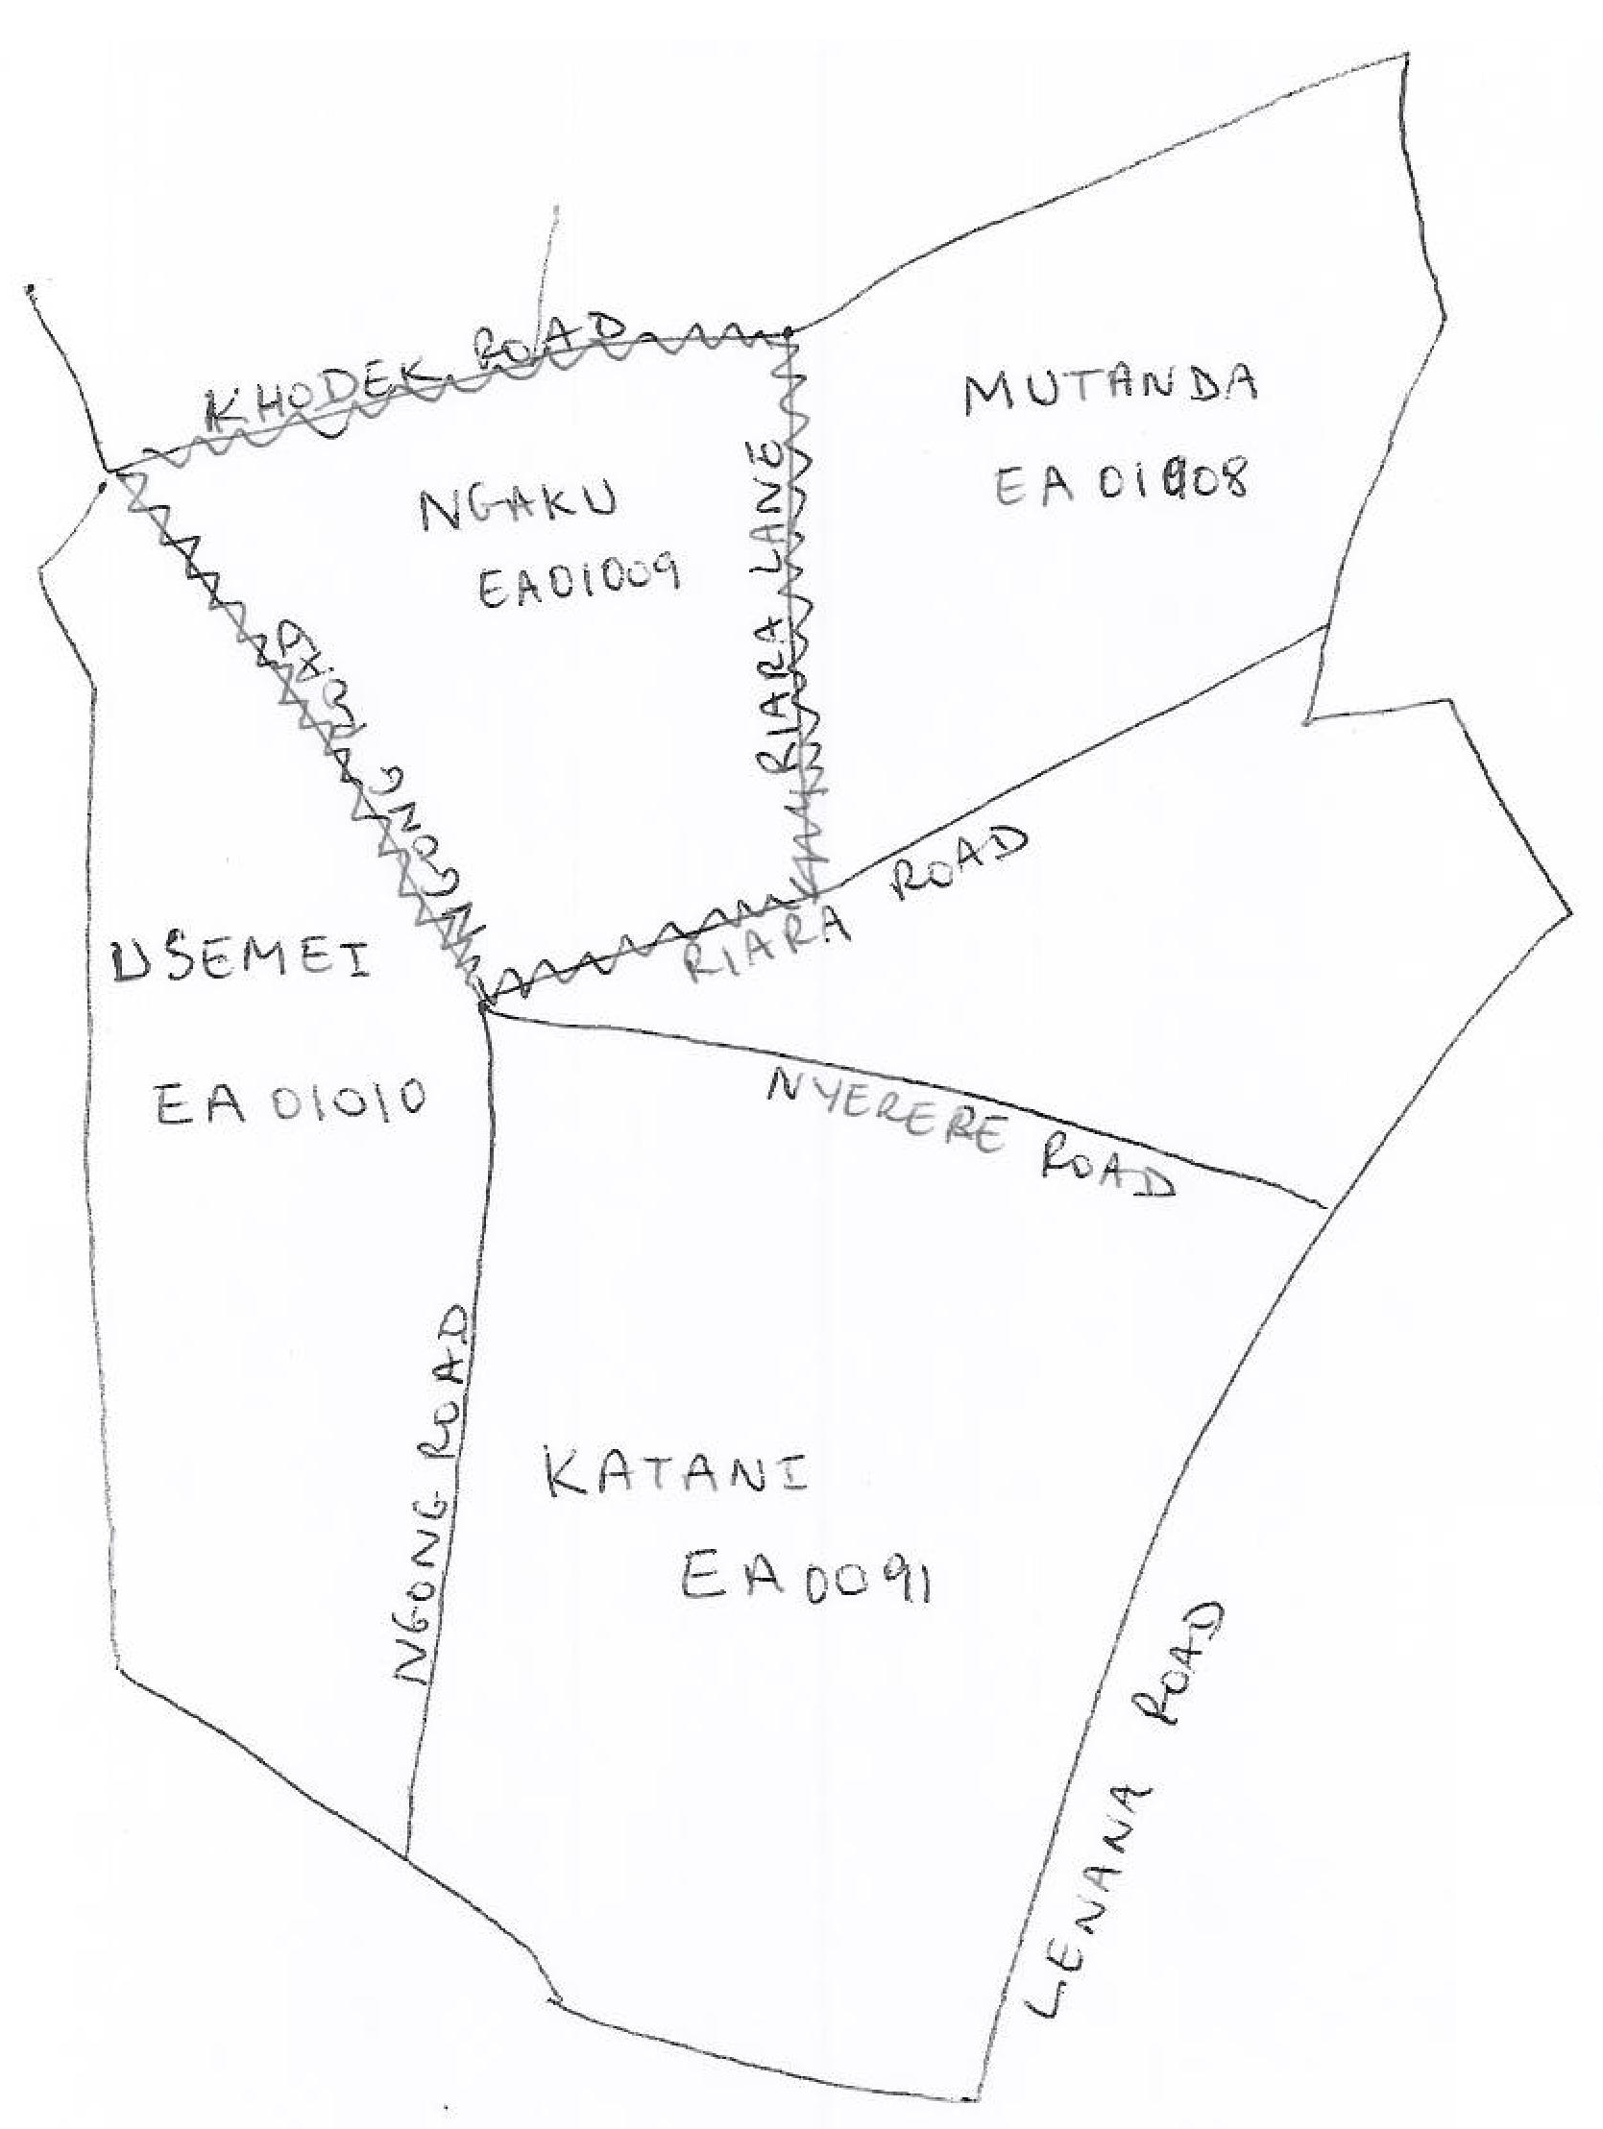

Sketch Map
MICS Cluster number: ___ ___ ___
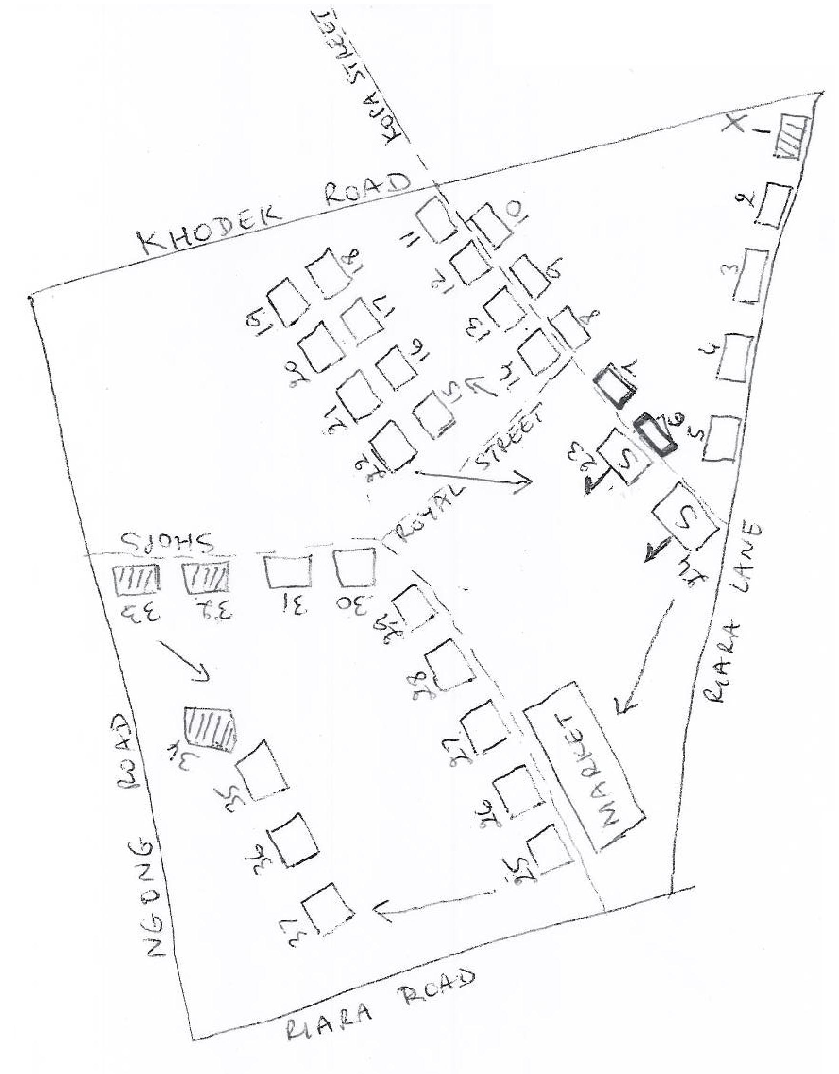

Segmentation form
name of survey
IDENTIFICATION
Enumeration Area number: | Region:  Region 1 1  Region 2 2  Region 3 3  Region 4 4  Region 5 5  Region 6 6
___ ___ ___ ___ ___ ___ ___ ___ ___ ___
Locality name and code:
Name _________________________ ___ ___
MICS Cluster number: ___ ___ ___
Mapper’s name and number: | Lister’s name and number:
Name _________________________ ___ ___ | Name ____________________________ ___ ___

Number of segments to be created: ___ | Random number between 1 and 100: X X X

Segment number | Number of dwellings | Percent of total | Cumulative percent of total
1 | ___ ___ ___ | ___ ___ | ___ ___
2 | ___ ___ ___ | ___ ___ | ___ ___
3 | ___ ___ ___ | ___ ___ | ___ ___
4 | ___ ___ ___ | ___ ___ | ___ ___
5 | ___ ___ ___ | ___ ___ | ___ ___
Total | ___ ___ ___ |  | 1 0 0
 |  | Segment selected: | ___

Household listing form
name of survey
IDENTIFICATION
Enumeration Area number: |  |  |  | Region:  Region 1 1  Region 2 2  Region 3 3  Region 4 4  Region 5 5  Region 6 6 |  |  |  |  | Mapper’s name and number:
___ ___ ___ ___ ___ ___ ___ ___ ___ ___ |  |  |  |  |  |  |  |  | Name __________________________ ___ ___
Locality name and code: |  |  |  |  |  |  |  |  | Lister’s name and number:
Name ______________________________ ___ ___ |  |  |  |  |  |  |  |  | Name __________________________ ___ ___
MICS Cluster number: ___ ___ ___ |  |  |  |  |  |  |  |  | Page no.: ___ ___ |  |  | Total no. of pages: ___ ___
Leave blank |  | Serial number of structure | Address/Description of Structure |  | Residence?  Y / N  If no, record observations or proceed to next structure |  | Serial number of HH in structure | Name of head of household  Record the name at the time of listing |  | Children under 5 in household?  Y / N |  | Status of dwelling  1 Occupied  2 Vacant  3 Temp. absent  6 Other (Specify) |  |  |  |  |  | Observations
HH selected for men | HH number
 |  | 1 | 2 |  | 3 |  | 4 | 5 |  | 6 |  | 7 |  |  |  |  |  | 8
 |  | ___ ___ |  |  | Y | N | ___ ___ |  |  | Y | N | 1 | 2 |  | 3 |  | 6
 |  | ___ ___ |  |  | Y | N | ___ ___ |  |  | Y | N | 1 | 2 | 3 |  | 6
 |  | ___ ___ |  |  | Y | N | ___ ___ |  |  | Y | N | 1 | 2 | 3 |  | 6
 |  | ___ ___ |  |  | Y | N | ___ ___ |  |  | Y | N | 1 | 2 | 3 |  | 6
 |  | ___ ___ |  |  | Y | N | ___ ___ |  |  | Y | N | 1 | 2 | 3 |  | 6
 |  | ___ ___ |  |  | Y | N | ___ ___ |  |  | Y | N | 1 | 2 | 3 |  | 6
 |  | ___ ___ |  |  | Y | N | ___ ___ |  |  | Y | N | 1 | 2 | 3 |  | 6
 |  | ___ ___ |  |  | Y | N | ___ ___ |  |  | Y | N | 1 | 2 | 3 |  | 6
 |  | ___ ___ |  |  | Y | N | ___ ___ |  |  | Y | N | 1 | 2 | 3 |  | 6
 |  | ___ ___ |  |  | Y | N | ___ ___ |  |  | Y | N | 1 | 2 | 3 |  | 6

In some surveys, a sub-sample of households is selected for the administration of the men’s questionnaire.

