Procurement instructions for recommended equipment

This is a list of some of the recommended equipment needed for implementation of MICS surveys. It describes the major items, including those that must be procured through UNICEF Supply Division (by the UNICEF Country Office) which require orders to be placed months in advance.

Please see the ‘MICS Listing and Fieldwork Duration, Staff and Supply Estimates Template’ for estimating number of units needed.

Before proceeding with any purchase, kindly request confirmation from the Regional MICS Coordinator.

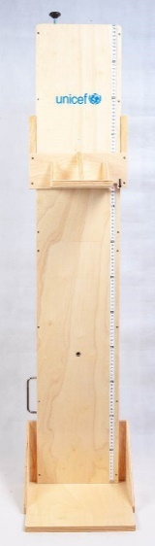
Measuring boards
Portable baby/infant length-height measuring system, made out of wood. UNICEF Supply Catalogue material number S0114530). Stock item. Boards are packed by two in a carton in order to save shipping costs. Price for 2 units (one carton): USD 181.21 (indicative price in UNICEF Supply Catalogue, June 2021).

Other measuring boards and devices are available in the Supply Catalogue. Note that the MICS Programme expects to change its recommendation to a digital board as soon as available. Please communicate with Regional MICS Coordinators for guidance on options and latest information.

Orders should be placed a minimum of 6 weeks before the required shipping date. Shipping time will vary depending on mode of shipment. Please try to plan as early as possible and order at least 3 months before the scheduled start of the fieldwork/pre-test training.

Scales
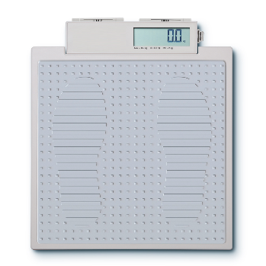
Scale, mother/child, 150 kg – UNICEF Supply Catalogue material number S0141025). Stock item. Price each: USD 119.47 (indicative price in UNICEF Supply Catalogue, June 2021). Scales require 6 alkaline AA batteries (supplied with the scale) which can conduct a minimum 5,000 measurements per battery set.

Other scales are available in the Supply Catalogue as are options for solar charge versions and other add-ons. Note that the MICS Programme expects to change its recommendation to a scale with additional functionality when available. Please communicate with Regional MICS Coordinators for on options and latest information.

Orders should be placed a minimum of 6 weeks before the required shipping date. Shipping time will vary depending on mode of shipment. Please try to plan as early as possible and order at least 3 months before the scheduled start of the fieldwork/pre-test training.

Salt test kits
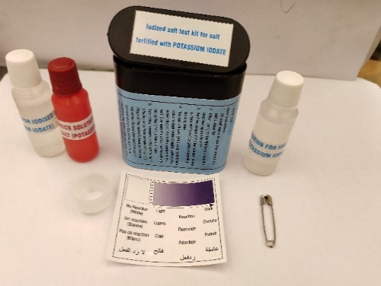
Since mid-2019, UNICEF Supply Division has made improved salt test kits available that determines only presence/absence of iodine, as opposed to the previous version that was used to determine three levels of iodine content. The previous version was phased out by the end of 2019. Please see UNICEF Supply Division Technical Bulletin no. 26 (July 2019) for details.

Salt test kits testing for potassium iodate (KIO₃) presence in salt: order UNICEF Supply Catalogue material number S0003195. Price is USD 0.45 per kit (indicative price in UNICEF Supply Catalogue, June 2021).

If salt test kits for measuring iodine presence of salt iodised/fortified with potassium iodide (KI) are needed, Sales Order should be raised using UNICEF Supply Catalogue material number S0003005. Price is USD 0.45 per kit (indicative price in UNICEF Supply Catalogue, June 2021).

See ‘Guidelines for the Customisation of MICS6 Questionnaires’ for details on which kit to order and communicate with the Regional MICS Coordinator for additional guidance.

Each kit can be used for at least 50 tests. Calculate your total need based on this estimate of 50 but also add extra kits per interviewer and for fieldwork training use, piloting, loss or damage.

It usually takes at least 4 weeks to produce the kits once the order is complete and reaches the producer (applies for orders below 50,000 units). Please try to plan as early as possible and order at least 2 months before the scheduled start of the fieldwork/pre-test training.

Water quality testing equipment and supplies
Water testing for E. coli requires both items that can be procured locally and items that must be ordered through UNICEF Supply Division in Copenhagen. Use the “Water Quality Supplies” sheet of ’MICS Listing and Fieldwork Duration Staff and Supply Estimates Template‘ to calculate the number of each item that will be needed.

The below picture and table reference the hardware and consumables needed for water quality testing. The cost of the kit’s hardware is approximately USD 1,500 per team and on top of this, each test costs about USD 2.50. These calculations will vary depending on sample design and survey implementation.

Please try to plan as early as possible and order supplies required to be ordered from UNICEF Supply Division at least 3 months before the scheduled start of the pre-test training. Items for local procurement should be purchased at least a month in advance of the pre-test training.

For technical advice on water quality testing and for assistance with placing orders for water testing equipment, please e-mail the MICS team (mics@unicef.org) and copy the WHO/UNICEF JMP team (info@washdata.org).
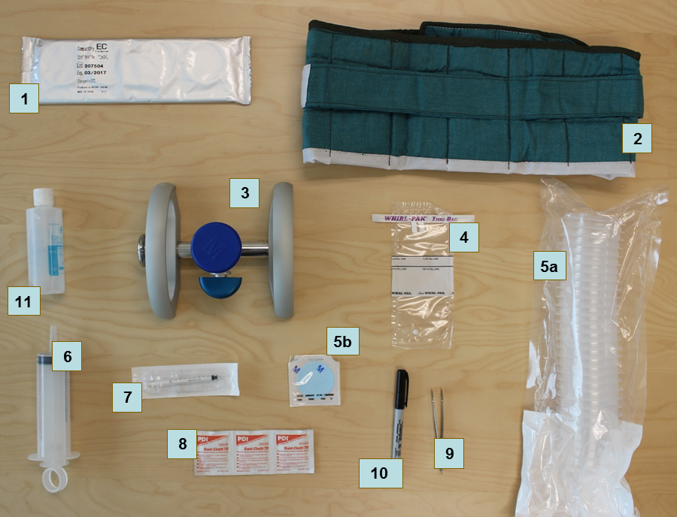
# | Item | Material number
UNICEF Supply Division
1 | Nissui compact dry EC plates | S0000579
2 | Incubation belt^{A} | S0000593
3 | Manifold | S5006120
4 | WhirlPak sample collection bag | S0000543
5 | Membrane and funnels | S5006119
6 | Reusable syringe, 100 mL | S0000545
7 | Disposable sterile syringe, 1 mL | S0000541
8 | Alcohol swabs | S0000540
9 | Metal forceps | S0000513
- | Chlorine tablet, 8.5 mg | S1588350
Local procurement
10 | Permanent marker | *
11 | Hand sanitizer | *
- | Storage Bag for consumables^{B} | *
- | Testing Bag for Measurer^{B} | *
- | Trash bags | *
- | Ziploc bags | *
- | Kitchen paper towels
- | Bottled water^{C}
- | Laminated instructions for Measurer
- | Water quality information leaflet (optional)
- | Tray for water quality testing (optional)
^{A} An optional portable electric incubator (S0000597) can be used in countries where electricity is reliable during the evenings, as teams can use vehicle 12V sockets during the day. Incubation belts are still needed as back up in countries planning to use electric incubators.
^{B} To store and transport the water testing supplies, each team requires a water quality testing bag to carry equipment and a small amount of consumables and a larger bag to store materials in the vehicle. These can be procured locally or from UNICEF Supply Division (e.g., S5001100, S5001000).
^{C} Bottles of water for the “blank test” (100 to 250 mL) are needed to ensure that testing is performed correctly throughout the fieldwork. These should be identified as high quality water and known to be free of E. coli contamination. This may need to be distilled water.
* These items can be ordered from UNICEF Supply Division, but local procurement is likely at less cost and with more options.

GPS units
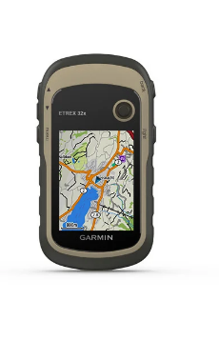
The standard Memorandum of Understanding specifies that MICS data should be geocoded, with minimum a cluster centre point available.

The MICS Programme recommends that GIS data is collected (or verified if already existing) in the mapping & household listing operation, which is increasingly done using a CAPI application. The need for stand-alone GPS units will depend on whether mapping & listing is done on CAPI and whether the CAPI devices have internal GPS units and the specific functionality, precision and circumstances of the survey.

External GPS units are recommended if the CAPI devices do not have GPS functionality. Any location availability in tablets without GPS is not appropriate as the required precision is not guaranteed.

GPS units and accessories may be available through UNICEF’s Direct Ordering Scheme or UNICEF Supply Catalogue, otherwise through local procurement.

Manual and other tools are produced based on a recommended unit: Garmin eTrex 30x series. Link: Garmin eTrex 32x. There are many other appropriate units available on the market. Altimeter and Mapping capability are highly recommended features.

Depending on the needs of the survey, certain additional parts may be useful: Rechargeable NiMH battery kit, dashboard mount, vehicle power cable, external antenna, etc.

Please consult with the Global MICS Team at UNICEF HQ, on mics@unicef.org for immediate advice and access to draft data collection manual and associated tools.

Tablets for data collection
Minimum configuration: Microsoft Windows 7 or higher.

Suggested configuration: Microsoft Windows 10, SD card, Bluetooth and USB port with the following accessories: Individual charger, vehicle charger (1 per team), protective case, screen protector and spare stylus.

Windows RT, Android, or iOS Operating Systems are not supported.

Note that desktop or laptop computers are required for processing and analysing data. Tablets used for data collection cannot be used for such purposes.

When planning to purchase new or deciding to reuse tablets from a previous survey, please contact the Global MICS Team at UNICEF HQ, on mics@unicef.org for advice. Note that a large order of specific tablets can be difficult to fulfil locally. Plan and order well in advance.

CSPro software
Will be provided to MICS implementing agencies during the MICS Data Processing Workshop or earlier on request.

Is also available for free downloading from the US Bureau of Census website (registration required). Link: CSPro.

Note that due to potentially significant changes between relatively frequent updates to the software, it is important that only version 6.3 is used, unless changes are communicated from UNICEF RO/HQ.

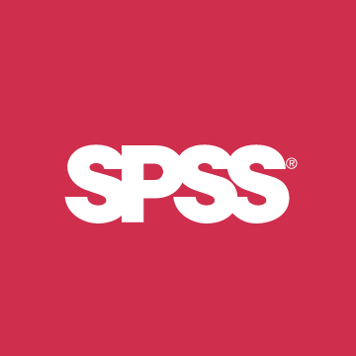
SPSS Statistics software
One license to SPSS Statistics 24 will be provided to MICS implementing agencies by UNICEF HQ.

Modules: Statistics Base, Complex Samples, Custom Tables.

Link: SPSS Statistics.

DDI Metadata Editor (Nesstar Publisher)
The archiving software recommended by International Household Survey Network and UNICEF.

Will be provided to MICS implementing agencies during the MICS Data Processing Workshop.

Is also available for free downloading from the International Household Survey Network website (registration required). Link: DDI Metadata Editor.

