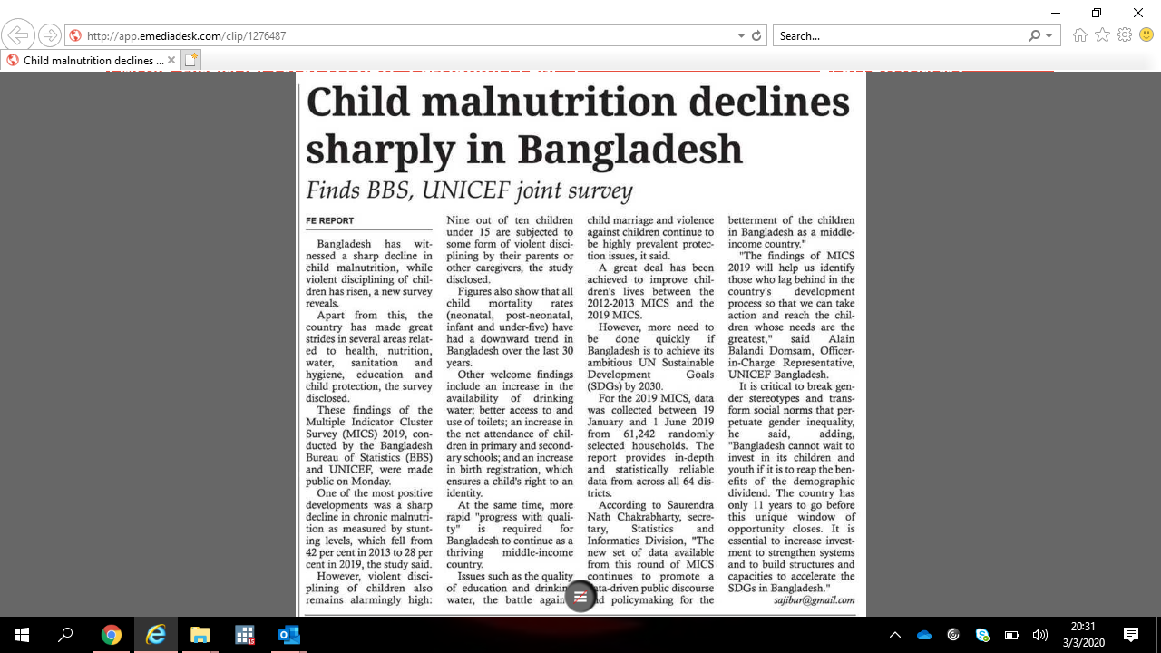

**Media: Financial Express | Date: 25-Feb-2020 | Page: 3**

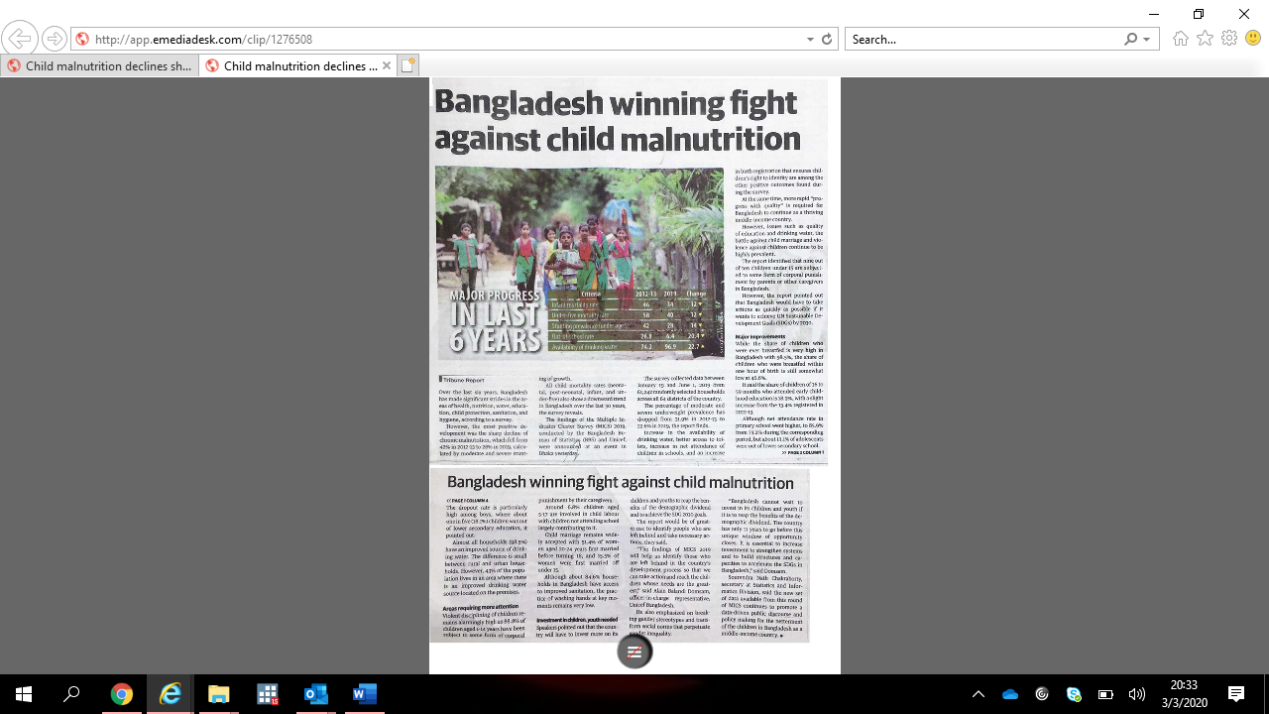 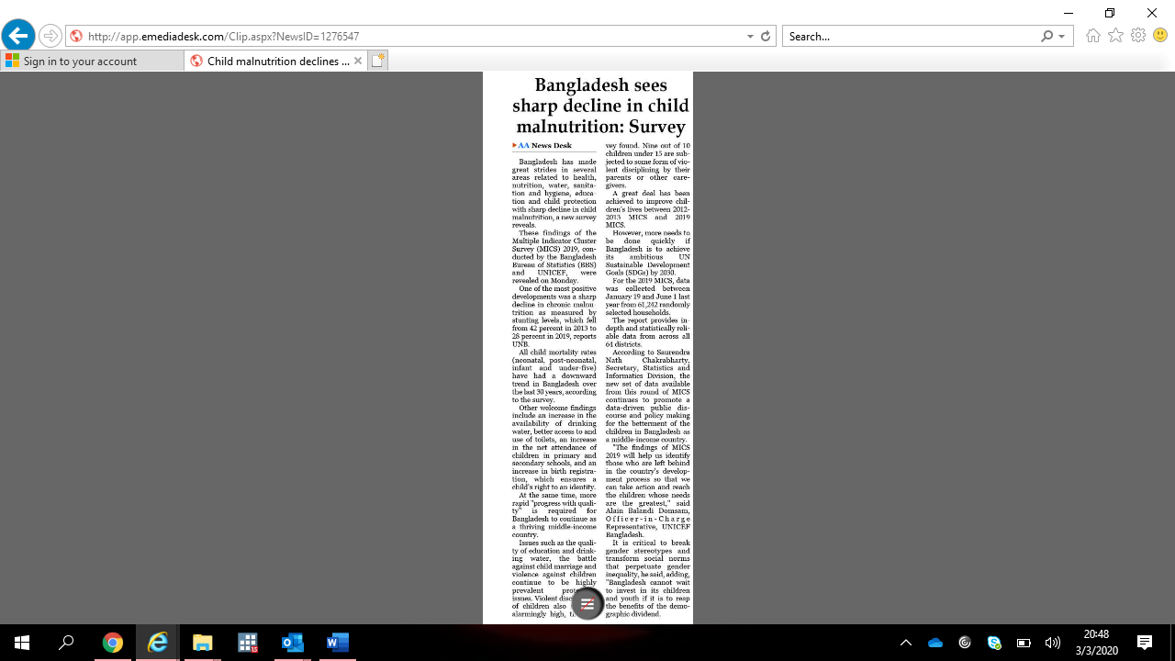

|  |
| --- |
| **01.UNICEF Mentioned News Reports** |
| **Press Release** |
| |  |  | | --- | --- | |  | [Child malnutrition declines sharply in Bangladesh](http://www.dailynayadiganta.com/city/483183/পারিবারিক-সহিংসতার-শিকার-৮৮.৮-শতাংশ-শিশু) 25 February, 2020  Type: Report  [Naya Diganta(03)](http://app.emediadesk.com/clip/1276568) | [Bangladesh Protidin(BP)](http://app.emediadesk.com/clip/1276525) | [Banik Barta(02)](http://app.emediadesk.com/clip/1276601) | [Daily Star(FP)](http://app.emediadesk.com/clip/1276470) | [Daily Sun(FP)](http://app.emediadesk.com/clip/1276467) | [Dhaka Tribune(FP)](http://app.emediadesk.com/clip/1276508) | [Financial Express(3)](http://app.emediadesk.com/clip/1276487) | [Independent(BP)](http://app.emediadesk.com/clip/1276592) | [Inqilab(BP)](http://app.emediadesk.com/clip/1276499) | [Jai Jai Din(BP)](http://app.emediadesk.com/clip/1276596) | [Janakantha(FP)](http://app.emediadesk.com/clip/1276594) | [Jugantor(02)](http://app.emediadesk.com/clip/1276553) | [Kaler Kantha(19)](http://app.emediadesk.com/clip/1276474) | [News Today(03)](http://app.emediadesk.com/clip/1276504) | [Observer(FP)](http://app.emediadesk.com/clip/1276532) | [Prothom Alo(FP)](http://app.emediadesk.com/clip/1276496) | [The Asian Age(FP)](http://app.emediadesk.com/clip/1276545) | [The Asian Age(03)](http://app.emediadesk.com/clip/1276547) | [The Business Standard(03)](http://app.emediadesk.com/clip/1276445) | [Alokito Bangladesh(03)](http://app.emediadesk.com/clip/1276574) | | Bangladesh has witnessed a sharp decline in child malnutrition, while violent disciplining of children has risen, a new survey reveals. Apart from this, the country has made great strides in several areas related to health, nutrition, water, sanitation and hygiene, education and child protection, the survey disclosed. These findings of the Multiple Indicator Cluster Survey (MICS) 2019, conducted by the Bangladesh Bureau of Statistics (BBS) and UNICEF, were made public on Monday. One of the most positive developments was a sharp decline in chronic malnutrition as measured by stunting levels, which fell from 42 per cent in 2013 to 28 per cent in 2019, the study said. However, violent disciplining of children also remains alarmingly high: Nine out of ten children under 15 are subjected to some form of violent disciplining by their parents or other caregivers, the study disclosed. | | |

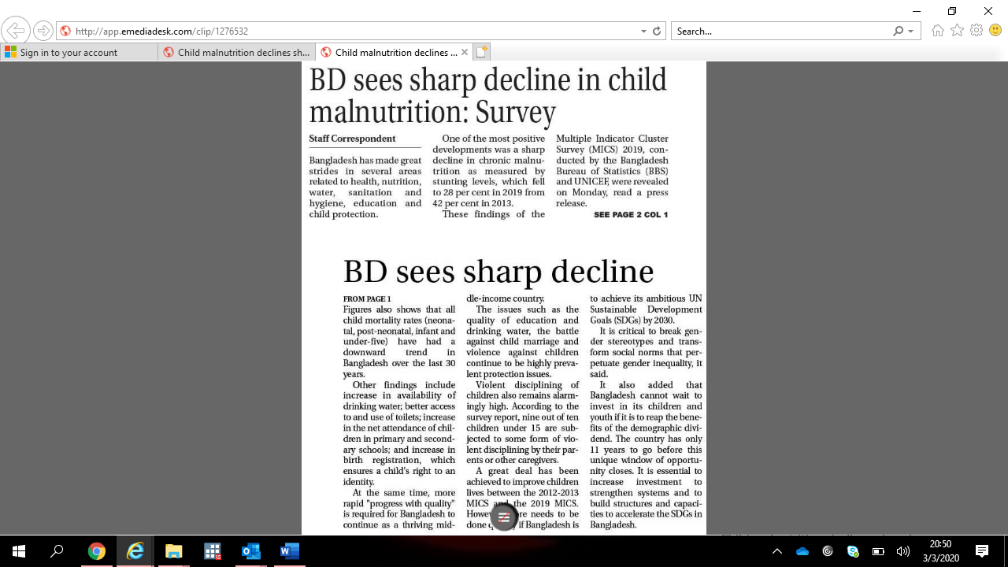

**Media: Observer | Date: 25-Feb-2020 | Page: FP**

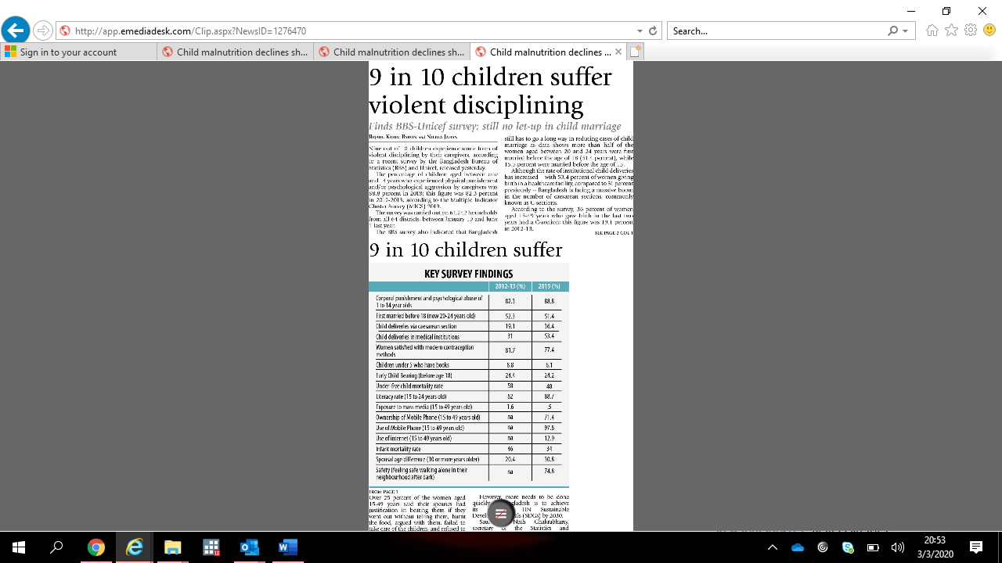

**Media: Daily Star | Date: 25-Feb-2020 | Page: FP**

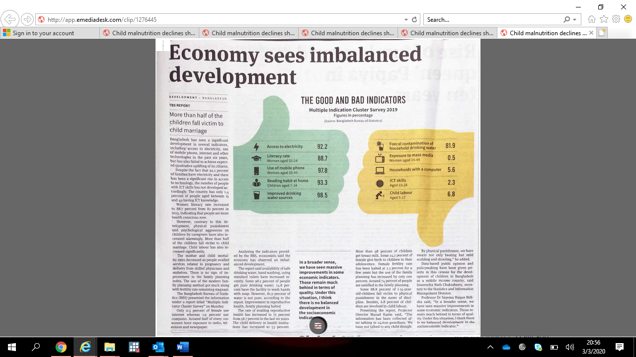

**The Business Standard | Date: 25-Feb-2020 | Page: 03**