Equipment for MICS surveys – procurement instructions

This is a list of equipment needed for MICS surveys. It describes the major items, including those that must be procured through UNICEF Supply.

Please see the ‘MICS Listing and Fieldwork Duration, Staff and Supply Estimates Template’ for estimating number of units needed.

Kindly inform the Regional MICS Coordinators of your plans and purchases.

Measuring boards
- Baby/infant board, made out of wood. UNICEF Supply Catalogue; (search for item# S0114530). Stock item. Boards are packed by two in a carton in order to save shipping costs. Price for 2 units (one carton): USD 164.65 (as provided by UNICEF Supply Division, October 2016).

Standard lead time for stock items is a minimum of 6 weeks for picking and packing. Shipping time is additional and depends on mode of shipment. Please note lead time also depends on the size of the order. For orders above 400 boards (i.e. 200 cartons) it is suggested to contact Supply Division to consult lead time and delivery options.

Scales
- Electronic scale, mother/child. Manufactured by seca. Model: “seca 874 U”. UNICEF Supply Catalogue; (search for item# S0141021). Stock item. Price each: USD 129.17 (as provided by UNICEF Supply Division, October 2016). Scales require 6 alkaline AA batteries (supplied with the scale) which approximately can conduct 3000 measurements per battery set.

Standard lead time for stock items is a minimum of 6 weeks for picking and packing. Shipping time is additional and depends on mode of shipment. Please note lead time also depends on the size of the order. For orders above 500 scales it is suggested to contact Supply Division to consult lead time and delivery options.

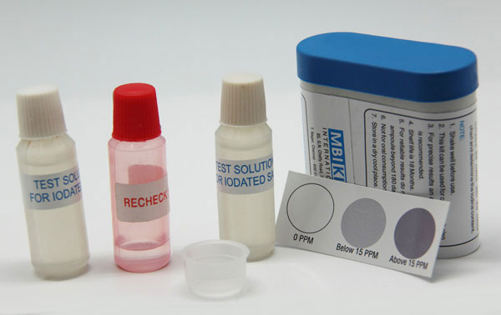
Salt test kits
- Salt test kits testing for potassium iodate (KIO₃) content in salt: order from MBI Kits International through UNICEF’s Direct Ordering Scheme. See UNICEF Intranet. UNICEF Supply LTA NO. 42200458, valid until 24.05.2018, material number S0008193.
- If salt test kits for measuring iodine content of salt iodised/fortified with potassium iodide (KI) are needed, Supply Order should be raised using material number S0008194 (using same LTA as above).
S0008193 Salt test kit, salt fortified w/IODATE | S0008194 Salt test kit, salt fortified w/IODIDE
Indicative Price: USD 0.38 | Indicative Price: USD 0.38
General Description:  Improved Iodised salt test kit, for measuring iodine content of salt iodised/fortified with potassium iodate (KIO3). | General Description:  Improved Iodised salt test kit, for measuring iodine content of salt iodised/fortified with potassium iodide (KI).
Presentation:  Test solutions, 10 ml ampoules/vials (white cap) - 2  Recheck solution for identifying false negatives (for alkaline samples),  10 ml ampoules/vials (red cap) - 1  Salt holder (standardized plastic measuring sample) - 1  Instruction leaflet - 1 | Presentation:  Test solutions, 10 ml ampoules/vials (white cap) - 2  Recheck solution for identifying false negatives (for alkaline samples),  10 ml ampoules/vials (red cap) - 1  Salt holder (standardized plastic measuring sample) - 1  Instruction leaflet - 1
Packing/labelling:  The contents should be packed together in a high quality plastic container, preferably opaque, with tight screw cap, to prevent leakage during transport and be easily squeezable. It should be clearly labelled "Improved iodized salt tests kit", 0 ppm, 1-14 ppm and equal or more than 15 ppm for testing salt fortified with potassium iodate only. The colour chart must be displayed on the label. The label should clearly indicate the "shelf life" (a minimum of 18 months), with the date of manufacture and expiry date. | Packing/labelling:  The contents should be packed together in a high quality plastic container, preferably opaque, with tight screw cap, to prevent leakage during transport and be easily squeezable. It should be clearly labelled "Improved iodized salt tests kit", 0 ppm, 1-14 ppm and equal or more than 15 ppm for testing salt fortified with potassium iodide only. The colour chart must be displayed on the label. The label should clearly indicate the "shelf life" (a minimum of 18 months), with the date of manufacture and expiry date.
Colour chart:  Rapid salt test kits should be able to distinguish iodine concentration of salt at three different levels by comparing the colour reaction of the salt after addition of the test solution and a reference colour. The colour should be stable for a few minutes (not less than 1-2 minutes), i.e. with an end point of 1-2 minutes. Colour chart should have clear and uniform indication of ppm scale i.e. 0 ppm, 1-14 ppm and equal or more than 15 ppm. | Colour chart:  Rapid salt test kits should be able to distinguish iodine concentration of salt at three different levels by comparing the colour reaction of the salt after addition of the test solution and a reference colour. The colour should be stable for a few minutes (not less than 1-2 minutes), i.e. with an end point of 1-2 minutes. Colour chart should have clear and uniform indication of ppm scale i.e. 0 ppm, 1-14 ppm and equal or more than 15 ppm.

- Ensure that correct kits are ordered or available if not using the LTA provided above. The manufacturer produces a variety of kits. The MICS Indicator requires testing of 0, 1-14, and 15+ ppm. In an effort to ensure correct purchases, please keep the Regional MICS Coordinator informed of orders.
- Each kit can be used for about 50 tests (or slightly higher depending on use). Calculate your total need based on this estimate but also add extra kits per interviewer and for fieldwork training use and piloting.
- It usually takes at least 4 weeks to produce the kits once the order is complete and reaches the producer (applies for orders below 50,000 units). Please try to plan as early as possible and order at least 2 months before the scheduled start of the fieldwork/pre-test training.
Water quality test
- Water testing for E. coli requires items that are procured locally and items that can be ordered through UNICEF’s Supply Division in Copenhagen. Use the “Water Quality Supplies” sheet of “MICS Listing and Fieldwork Duration Staff and Supply Estimates Template” to calculate the number of each item that will be needed. The cost is approximately USD 1,500 per team and USD 2.50 per test.
- Please try to plan as early as possible and order international supplies at least 3 months before the scheduled start of the pre-test training.
- Please consult with Robert Bain, Statistics Specialist, UNICEF HQ, on rbain@unicef.org for advice on water testing and to request a sample water testing incubation belt.
- Please consult Lauren Large, Procurement Assistant, UNICEF Supply Division, on llarge@unicef.org for assistance with placing orders for water testing equipment.

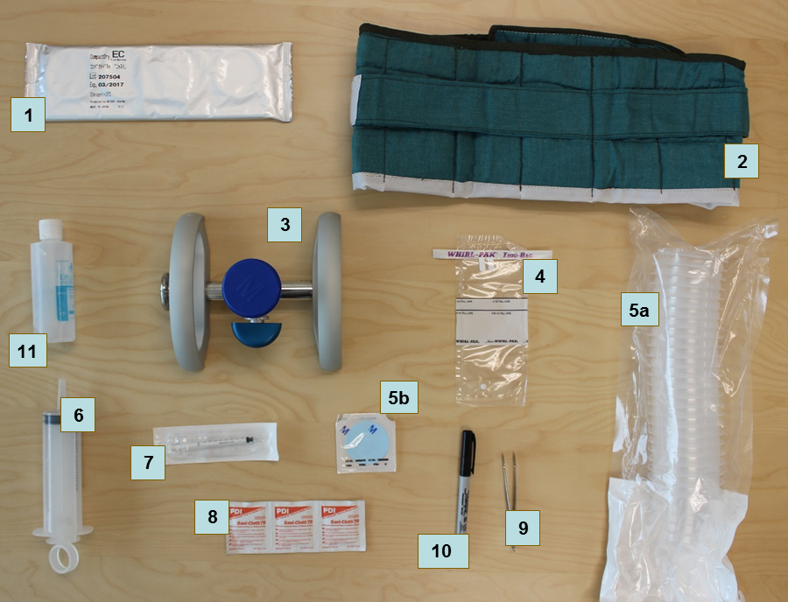
# | Item | Code | Quantity
1 | CompactDry plates E. coli only | S0000579 | Box of 1,404
2 | Incubation belt | S0000593 | Each
3 | Manifold | S5006120 | Each
4 | Sample collection bags | S0000543 | Box of 500
5 | Filter and funnel | S5006119 | Box of 150
6 | Syringe, 100 mL | S0000545 | Box of 50
7 | Disposable syringe, 1 mL | S0000541 | Box of 120
8 | Alcohol wipes | S0000540 | Box of 100
9 | Forceps | S0000513 | Each
10 | Permanent marker | S0000576 | Box of 10-25
11 | Hand sanitizer | - | -
Note: An optional portable electric incubator (S0000597) can be used in countries where electricity is reliable during the evenings, as teams can use vehicle 12V sockets during the day. Incubation belts are still needed as back up in countries using an electric incubator.

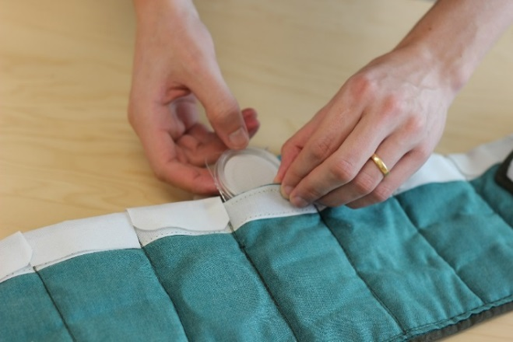
- Local procurement for water testing should be done at least a month in advance of fieldwork/pre-test training.
Incubation belt
- Incubation belts should be manufactured locally and can be based on a sample belt.
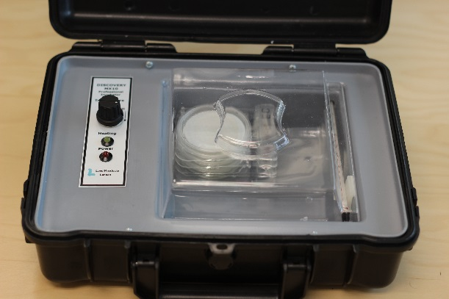
- Bottles of water for the “blank test” (100 to 250 mL) are needed to ensure that the test is performed correctly. These should be identified as high quality water and known to be free of E. coli contamination. This may need to be distilled water.
Electric incubator
- The following items are also needed: hand sanitizer (250 mL bottle of gel), trash bags (1 per cluster) and 8.5 mg NaDCC chlorine tablets (1 per test).
- To store and transport the water testing supplies, each team requires a water quality testing bag to carry equipment and a small amount of consumables and a larger bag to store materials in the vehicle. These can be procured locally or from UNICEF Supply Division (e.g. S5001100, S5001000).

CSPro software
- Will be provided to MICS implementing agencies during the MICS Data Processing Workshop.
- Is also available for free downloading from the US Bureau of Census website (registration required). Link: CSPro.
- Note that due to potentially significant changes between relatively frequent updates to the software, it is important that only version 6.3 is used, unless changes are communicated from UNICEF RO/HQ.

SPSS Statistics software
- One license to SPSS Statistics 23 will be provided to MICS implementing agencies by UNICEF HQ.
- Modules: Statistics Base, Complex Samples, Custom Tables.
- Link: SPSS Statistics.

DDI Metadata Editor (Nesstar Publisher)
- The archiving software recommended by International Household Survey Network and UNICEF.
- Will be provided to MICS implementing agencies during the MICS Data Processing Workshop.
- Is also available for free downloading from the International Household Survey Network website (registration required). Link: DDI Metadata Editor.

GPS units
- The need for stand-alone GPS units will depend on content and objective of individual surveys, as well as availability of existing GIS data. If household level GIS data is collected during the listing exercise, the use of stand-alone units is required, as the built-in GPS units in tablets may not precise enough for this level of detail.
- External units are still recommended if the tablets used for the survey do not have GPS functionality. Any location availability in tablets without GPS is not appropriate as the required precision is not guaranteed.
- GPS units and accessories are available through UNICEF’s Direct Ordering Scheme. See UNICEF Intranet. UNICEF Supply LTA NO. 42200394, valid until 31.05.2016.
- Manual and other tools will be produced based on the recommended unit: Garmin eTrex 30x, material number S0006025. Unit price: USD 182.99. Link: Garmin eTrex 30x.
- Accessories are also available on the LTA. Depending on the needs of the survey, certain parts are highly recommended: Rechargeable NiMH battery kit (010-11343-00/ USD 13.89), dashboard mount (010-11602-00/ EUR 20.87), vehicle power cable (010-10851-11/ EUR 13.89), external antenna, etc.
- Please consult with Ivana Bjelic, Statistics Specialist, UNICEF HQ, on ibjelic@unicef.org for immediate advice and access to draft tools.

Tablets for data collection (and listing)
- Minimum configuration: Microsoft Windows 7 or higher.
- Suggested configuration: Microsoft Windows 10, SD card, Bluetooth and USB port with the following accessories: Spare battery, vehicle charger (1 per team), protective case, screen protector and spare stylus
- Windows RT, Android, or iOS Operating Systems are not supported.
- Note that Desktops/Laptops are still required for processing and analysing data.
- If you are planning purchase new or reuse Tablets from a previous survey, please contact Ivana Bjelic, Statistics Specialist, UNICEF HQ, on ibjelic@unicef.org for advice.

