MICS from north to south
In the midst of data collection I am writing this story to give a snapshot about the Viet Nam Multiple Indicator Cluster Survey (MICS). I was thinking to find one angle, one edge, but the diversity is so prominent in Viet Nam that it naturally became a subject. The variety of landscapes, peoples, and even means of transportation are part of the data collection experiences which the surveying teams live every day. 30 in total, the teams are currently collecting data in all provinces of Viet Nam, from the north mountainous Ha Giang to the south waters of Ca Mau.
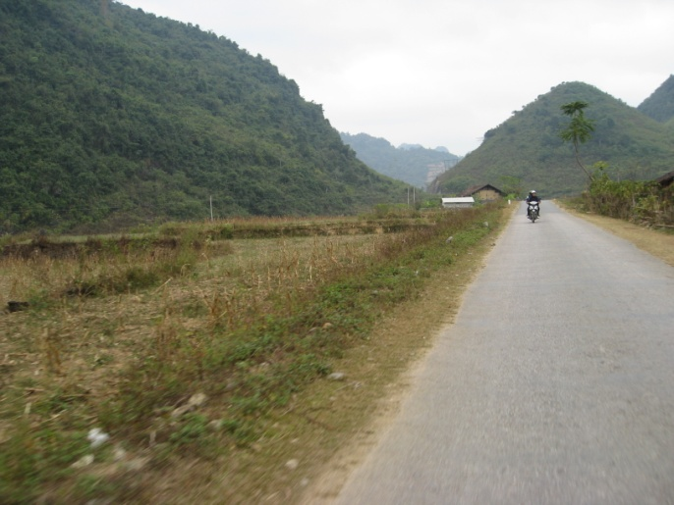
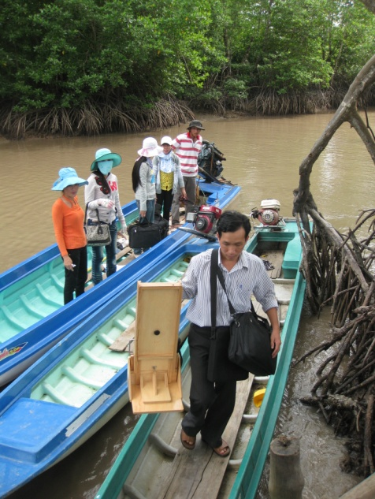
After a 3-hour boat ride in the immense Mekong delta we are in Dat Mui, the southern tip of Viet Nam. The chairman and delegates from the People’s Committee warmly welcomed us to the Commune. In the torrid sun the icy drinks from the table were quickly savored while the team leader explained the purpose of MICS field work in this selected area. We embarked on the narrow boats and in no time found ourselves navigating through spectacular streams abound in fairy-like mangroves. This village in the distant waters of Mekong is rarely visited by unknown people let alone foreign looking faces, and for two days the MICS team became the main focus in the community. Everyone wanted to see, talk and even feed us. In this overwhelming atmosphere extra effort was needed to ensure privacy during interviews. Using boats was the only way we could reach from one household to the next. “In this village the water streams are like the roads in Hanoi”, said Mr. Tri, the local guide.
Boats are essential for field work in Dat Mui, Ca Mau province
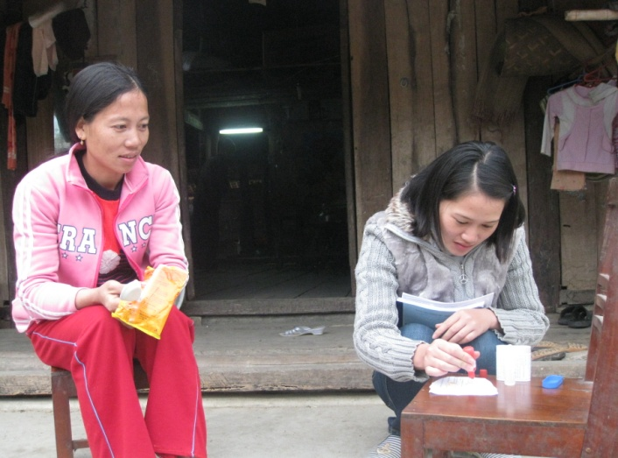
It looks and feels differently in Cao Bang province. The motorbike ride to Ban Co village opened up its splendid pyramid-shaped mountains from the distance. The road was gently curving leading to new stunning views with every hill we would leave behind. Not only did the village head welcome the team to the community, he helped us locate the selected households, hosted the team in his own home and made sure we stay warm over the night. A largely Tay ethnic settlement, the interviews became so memorable as Ms. Thao and Ms. Duyen used their mother tongue for the first time during MICS. The completion of interviews in this village brought a sense of achievement in the team’s hearts; this was the 4th accomplished area. But it also meant the team needed to commute to the next province, about 4 hours away by motorbike in the misty winds.
Fascinating road to Ban Co village, Cao Bang province
Interviewer Thao performing iodized salt testing and respondent curiously watching, Ban Co, Cao Bang

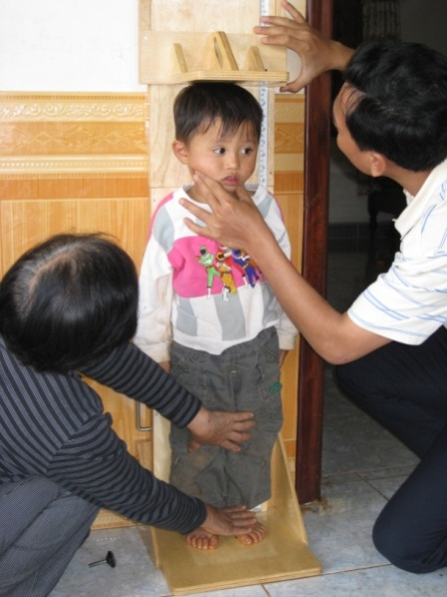
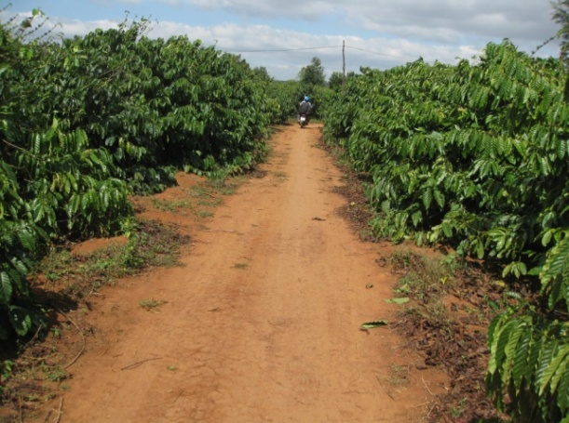
Away from the curving roads of the northern mountains and water streams of the southern delta, in Bo Ngoong village it seemed like stepping in an enormous coffee land. The households are widely spread on the plateau and hidden in the coffee fields. The pathways endlessly weave through the coffee plantations making us wonder how one can know where the next household is. What seemed impossible for us was so easy to Mr. Tien, a coffee grower who moved to the central highlands two decades ago. With his help the team completed the MICS data collection in the village in a shorter time than expected. Of course we could not leave without a strong coffee made from the locally grown beans.
This is not the last turn to reach the household, Bo Ngoong village, Gia Lai province
It is about its coast, its deltas, its highlands, its islands, the busy HCM city and Hanoi; all together define the landscape of Viet Nam and MICS. Every region, every province, and settlement has its own charm and combined draws a unique and multicolored painting. This is Viet Nam! It is incredible how MICS can so diligently blend with the diversity of the country and in a scientific manner include in its sample households, women and children from all over.
The General Statistics Office (GSO) is implementing MICS for the fourth time in Viet Nam. With strong experience from the previous rounds of MICS and increased support from UNICEF and UNFPA, the GSO aims to achieve the highest data quality. MICS4 will update the previous (2006) data on important social issues such as maternal and newborn health, education, water and sanitation, child labour and discipline, nutrition, iodized salt and other indicators including MDGs. Based on its sample of 12,000 households the survey will provide a comprehensive picture on children and women in Viet Nam across the regions, and from an equity approach, indicate disparities by gender, urban/rural and ethnicity.
3-years-old Gau (the bear) stays still for the measurement, Bo Ngoong, Gia Lai
The results will be disseminated in June 2011 and be a key source of data for development partners in Viet Nam, including Government, UN agencies, NGOs, mass-media and academia involved in the social sector.

- Alexandru Nartea, UNICEF Viet Nam - Jan 2011

