INSTRUCTIONS
FOR
SUPERVISORS

Survey Coordinators:

Give a copy of these Instructions to every field supervisor. Translate into the local language, if necessary. Ensure that the information is appropriate to your survey. Some countries may need to give slightly different instructions, depending on their customized questionnaires. Delete instructions on modules not used in your country, as well as boxes (such as this) meant only for Survey Coordinators.

Note that these Instructions require significant customization if the survey is conducted with paper-based interviewing.

The detailed use of the CAPI application is described in the Annex of this document.

TABLE OF CONTENTS

INTRODUCTION TO THE MICS APPROACH 3
RESPONSIBILITIES OF THE FIELD SUPERVISOR 3
PREPARING FOR FIELDWORK 5
Collecting Materials for Fieldwork 5
Monetary advances for field expenses 6
Arranging Transportation and Accommodations 6
Contacting Local Authorities 6
Using Maps to Locate Clusters 6
Finding Selected Households 8
ORGANIZING AND SUPERVISING FIELDWORK 9
Assigning work to Interviewers and Measurer 9
Reducing Non-response 10
Handling Pending Interviews 11
Maintaining Motivation and Morale 12
Monitoring Interviewer Performance 12
Observing Interviews 13
Evaluating Interviewer Performance 13
Cluster Operations 14
Systematic Spot Checking of Household Composition 14
Forwarding Questionnaires to the Central Office 15
APPENDIX A: HOW TO MAINTAIN CONTROL ON TABLET FAILURE 16
Supervisor’s Cluster Control Sheet 16
APPENDIX B: USING THE SUPERVISOR’S CAPI APPLICATION 19

INTRODUCTION TO THE MICS APPROACH

Field supervisors for the Multiple Indicators Cluster Survey have an important position. They are the primary links between the fieldwork coordinator and the interviewers. As such, they are responsible for ensuring both the progress and quality of fieldwork.

These Instructions provide the information needed by field supervisors to carry out their duties. Candidates for these positions for the MICS should study these instructions carefully during their training. They should also study the Instructions for Interviewers, the Manual for Anthropometry and the Manual for Water Quality Testing, since these are necessary to thoroughly understand the questionnaire and the procedures for completing it. Individuals selected to serve as field supervisors should continue to refer to these Instructions throughout the fieldwork period.

RESPONSIBILITIES OF THE FIELD SUPERVISOR

The field supervisor is the senior member of the field team. He/she is responsible for the well-being and safety of team members, as well as the completion of the assigned work and the maintenance of data quality. The field supervisor receives his/her assignments from and reports to the fieldwork coordinator.

Survey Coordinators: Countries may have different ways of organizing and managing fieldwork. In many countries, a fieldwork coordinator is responsible for coordinating field activities and reporting to the survey coordinator. In others, one field coordinator will be identified for each region, each of them reporting to the survey coordinator, or a fieldwork coordinator at Central Office. Yet in others, the survey coordinator will also assume the responsibility of coordinating fieldwork activities, in which case the field supervisors will be reporting directly to the survey coordinator. These Instructions assume that field supervisors are reporting to a fieldwork coordinator.

The specific responsibilities of the field supervisor are to make the necessary preparations for the fieldwork, to organize and direct the data collection in his/her assigned clusters, and to spot check the data collected in the List of Household Members, but also in any other module as appropriate.

Preparing for fieldwork requires that the field supervisor:
- Obtains sample household lists and maps for each area in which his/her team will be working, discuss any special issues, such as potential security conditions in certain areas.
- Becomes familiar with the area where the team will be working and determine the best arrangements for travel and accommodations.
- Contacts local authorities to inform them about the survey and to gain their support and cooperation.
- Obtains all monetary advances, supplies and equipment necessary for the team to complete its assigned interviews.

Careful preparation by the field supervisor is important for facilitating the work of the team in the field, for maintaining interviewer morale and for ensuring contact with the central office throughout the fieldwork.

Organizing fieldwork requires that the field supervisor:
- Assigns work to interviewers, taking into account the linguistic competence of individual interviewers, and assures that there is an equitable distribution of the workload.
- Coordinates the work of the measurer by making sure he/she knows where to find the households in which interviewers are working, as well as understanding how many children and at what time a visit to the household should happen.
- Further coordinates the work of the measurer, by guiding him/her to households selected for water quality testing and making logistical arrangements for source testing when necessary.
- Edits any paper questionnaires collected, including Anthropometry modules for children under age 5, Water Quality Testing Questionnaires, Questionnaire Forms for Vaccination Records at Health Facility, as well as those necessitated by tablet failure.
- Continually runs “Cluster operations” report and makes sure that assignments are carried out.
- Makes spot checks of the List of Household Members (and other modules and questions as appropriate) by conducting interviews according to the procedure described below.
- Observes interviews daily to monitor progress of interviewers in terms of behaviour and data collected.
- Continuously syncs the CAPI application with interviewers as they complete interviews/households.
- Regularly (daily) syncs the CAPI application with central office to upload completed questionnaires and progress data to the fieldwork coordinator and keeps headquarters informed of the team’s location. Syncing also allows the central office to send any updates to the data collection application.
- Communicates any problems to the fieldwork coordinator.
- Takes charge of the team vehicle, ensuring that it is kept in good repair and that it is used only for project work.
- Makes an effort to develop a positive team spirit. A congenial work atmosphere, along with careful planning of field activities, contributes to the overall quality of a survey.

Although the responsibility mainly of the interviewers, the field supervisor is also responsible for assisting the measurer when needed. The supervisor must also carefully monitor the quality of the anthropometric measurements and evaluate whether protocols are followed on both anthropometry and water quality testing. Specifically for anthropometry, when the paper Anthropometry module is transferred/entered to CAPI, the application will “flag” children with extreme measurements of length/height, weight and/or age, which either point to a recording issue or measurement issue. In any case, such must be followed up closely, first by confirming correct data entry or a revisit and remeasurement of the child.

Over the course of fieldwork, Field Check Tables will be produced at central office. These are tables that tabulate the raw data already in the database and are used to monitor the results of each of the field teams and individual interviewers. The fieldwork coordinator and/or the survey coordinator will be discussing these with the field supervisors during field monitoring visits and over the telephone.

Since the collection of high-quality data is crucial to the success of the survey, it is important that mature, responsible individuals be recruited as field supervisors and that they execute their duties with care and precision. This is especially important during the initial phases of fieldwork, when it is possible to eliminate interviewer error patterns before they become habit, as well as towards the end of fieldwork when some interviewers are getting tired and have learned how to reduce workload, resulting in a tendency to omit or manipulate answers.

Monitoring interviewer performance requires that the supervisor:
- Observes interviews every day.
- Performs random spot checks as necessary and at a minimum as directed by the data collection application.
(3) Conducts regular review sessions with interviewers and advises them of any problems found in their questionnaires.

PREPARING FOR FIELDWORK

Collecting Materials for Fieldwork

Before leaving for the field, the field supervisor is responsible for collecting adequate supplies of the materials the team will need in the field. These items are listed below:

CAPI equipment:
- Tablets (with screen protectors
- Styluses, including spares
- Tablet cases
- Standard chargers (1 per tablet)
- Vehicle chargers (1 per team)

Fieldwork documents:
- Instructions for Supervisors
- Manual for Anthropometry
- Manual for Water Quality Testing
- Instructions for Interviewers (one for each interviewer)
- Maps and Household Listing Forms for all sampled clusters in the assigned area
- Letters of introduction
- ID cards
- Paper questionnaires for Questionnaire Forms for vaccination records at health facility, Anthropometry module (one copy for each expected child under 5, plus some spare copies) and Water Quality Testing questionnaire (one copy for each household that will be tested, plus some spare copies)
- Response cards, e.g. smiley faces
- GPS data collection questionnaires
- Paper questionnaires (to use only in situations of CAPI failure)
- Paper spot check questionnaires (to use only in situations of CAPI failure)
- Supervisor’s Cluster Control Sheets for controlling assignments (to use only in situations of CAPI failure)

Supplies:
- Blue pens for interviewers
- Red pens for the supervisor
- Clipboards, briefcases
- Paper clips, scissors, string, staplers and staples, cello tape, etc.
- Envelopes to store any completed paper questionnaires and paper modules
- First aid kit
- Torches (with spare batteries), umbrellas, and whatever local conditions may require

Field equipment:
- Salt test kits
- Height measuring board(s)
- Weighing scale(s) with spare batteries
- Water quality testing bags/kits with adequate supplies for restocking
- GPS unit(s) with spare batteries (if used to record information on the exact geographic location of the sample cluster).

Monetary advances for field expenses

The field supervisor should have sufficient funds to cover expenses for the team. Funds for team members should be distributed according to the procedures established by the survey coordinator, if these have not been included in the per diem that is given directly to the interviewers.

Survey Coordinators: At the end of the paragraph above, include a brief description of procedures in the particular country, e.g.: “Include funds for fuel and minor vehicle repairs, for guides, and for communication with the central office. Advances for per diem allowances will be given directly to individual interviewers, measurers, and field supervisors. Salary payments will be made to all field staff at the end of each month at which time per diem allowances will be paid to cover the upcoming month. Payments will be made either by wiring funds to local banks in the areas in which the team will be working, or by sending out an accountant from the central office.”

The field supervisor should arrange for a system to maintain regular contact with the central office staff before leaving for the field. Regular contact is needed for supervision of the team by central office staff, payment of team members and syncing the data collection application.

Arranging Transportation and Accommodations

It is the field supervisor’s responsibility to make all necessary travel arrangements for his/her team, whenever possible, in consultation with the central office. The field supervisor is responsible for the maintenance and security of the team vehicle. The vehicle should be used exclusively for survey-related travel, and when not in use, should be parked in a safe place. The driver of the vehicle takes instructions from the field supervisor.

Survey Coordinators: Vehicles are generally provided to transport the team to assigned work areas. however, in some cases, it may be necessary to arrange for other means of transportation, such as boats, horses, mules, etc. Customize the paragraph above accordingly.

In addition to arranging transportation, the field supervisor is in charge of arranging for food and lodging for the team. If they wish, interviewers may make their own arrangements, as long as these do not interfere with fieldwork activities. The lodging should be reasonably comfortable, located as close as possible to the interview area, and should provide a secure space to store survey materials. Since travel to rural clusters is often long and difficult, the field supervisor may have to arrange for the team to stay in several more central locations, moving as the fieldwork progresses.

Contacting Local Authorities

It is the field supervisor’s responsibility to contact the regional, district, local, and village officials before starting work in an area. In some countries, the fieldwork coordinator may assign another person to do this; in those countries, the field supervisor will contact that person or the fieldwork coordinator before starting work in an area, to confirm that the contact with officials has been established. Letters of introduction will be provided, but tact and sensitivity in explaining the purpose of the survey will help win the cooperation needed to carry out the interviews.

Using Maps to Locate Clusters

Survey Coordinators: This section presumes that a fresh household listing has been conducted and that updated base maps and sketch maps therefore are available to teams.

A major responsibility of the field supervisor is to assist interviewers in locating households in the sample. The fieldwork coordinator will provide the supervisor with a copy of the Household Listing Forms for the sample as well as maps of the clusters in which his/her team will be working. These documents will enable the team to locate the clusters, identify the cluster boundaries and to locate the households selected for the sample. The representativeness of the sample depends on finding and visiting every and only sampled household.

Maps are generally needed during all stages of a survey, since they provide a picture of the areas in which interviews are to be carried out and help to eliminate errors, such as duplication or omission of areas. Moreover, maps help the team determine the location of sample areas, the distance to them, and how to reach selected households or dwellings.

Each team will be given general base maps, Household Listing Forms, and sketch maps, and written often descriptions of the boundaries of selected areas. A cluster (i.e., PSU or EA) is the smallest working unit in any census or survey operation that can easily be covered by one enumerator. It has identifiable boundaries and lies wholly within an administrative or statistical area. The general base maps will show more than one cluster. Each cluster is identified by a number (for example, EA-010400105). Symbols are used to indicate certain features on the map such as roads, footpaths, rivers, localities, boundaries, etc. If symbols are shown on the map, the field supervisor should know how to interpret them by using the legend.

In most clusters, the boundaries follow easily recognizable land features such as rivers, roads, railroads, swamps, etc. However, at times, boundaries are invisible lines. The location and determination of invisible boundaries calls for some ingenuity, particularly in rural areas. If the location and sketch maps and descriptions do not provide enough detail, the following procedure is suggested:

In rural areas:

- Identify on the map the road used to reach the cluster. When you reach what appears to be the cluster boundary, verify this by checking the location of actual terrain features and landmarks against their location on the map. Do not depend on one single feature; rather, use as many as possible.
- It is usually possible to locate unnamed roads or imaginary lines by asking people living in the vicinity. In most cases, these people will know where the villages are and, by locating the villages, you can usually determine where the boundaries run. Local authorities may be helpful, as well as residents.
- While there are cases in which boundaries shown on the map no longer exist (for example, they have been demolished), or have changed location (for example, a road has been relocated or a river has changed course), do not be hasty in jumping to conclusions. If you cannot locate a cluster, go on to the next one and discuss the matter later with the fieldwork coordinator.

In urban areas:

- There should be no problem with invisible lines, as urban areas generally have plenty of boundaries for use.
- Street names in urban areas will often help you to locate the general area of clusters. Boundaries can be streets, alleys, streams, city limits, power cables, walls, rows of trees, etc.
- Check the general shape of the cluster. This will help you find out if you are in the right place.
- Read the written description when available.
- You should locate all the cluster boundaries before you begin interviewing. For example, if the cluster is a rectangular block, the names of three boundary streets is not enough to unequivocally identify the cluster; check all four boundary streets.

Survey Coordinators: Describe any numbering system that may have been adopted during the sample listing and how interviewers can use this to locate selected households or dwellings.
If possible, use Google Earth/Maps, OpenStreetMap or any similar mapping data and imagery to visually locate clusters.

Finding Selected Households

In most cases, the selected households can be located by referring to the Household Listing Form or to the detailed maps of the selected clusters. Because people move around, and sometimes the listing teams may have made errors or drawn a sketch map that skews reality, you may have difficulty locating the households that were selected.

In most cases, you can deal with issues by simply talking to residents or neighbours. Below are examples of problems you may encounter and how to deal with them. Note that some inconsistencies must be reported to the fieldwork coordinator:

- The selected household has moved away, and the dwelling is vacant. If a household has moved out of the dwelling/structure where it was listed and no one is living in the dwelling, you should consider the dwelling vacant and make sure that the interviewer fills the household questionnaire indicating the result code as ‘05’ for the vacant dwelling.
- The structure number, household number, and name of household head indicated on the Household Listing Form do not match what is found in the field. Say, for example, that Albert Jennies is listed as the household head for household 14 in structure 7, but when the interviewer goes to structure 7 she finds that the only household living there is headed by Mary Olson. Consider whichever household is now living in the dwelling previously occupied by the originally selected household as the selected household (that is, the household headed by Mary Olson should be interviewed). Check carefully, however, that you are indeed in the right cluster and have identified the selected dwelling. If Mary Olson is already listed, for example as household 13 in structure 7, her household should not replace the “missing” household and further investigation is necessary.
- The selected household listed in a certain dwelling is actually living in another dwelling. If, for example, Albert Jennies is listed as the household head for selected household 14 in structure 7, but Albert Jennies actually lives in structure 8, the household living in the dwelling space originally selected should be interviewed (that is, whichever household occupies the dwelling space in structure 7). In other words, if there is a discrepancy between the structure number and the name of the household head, interview whoever is living in the selected dwelling. Again, make absolutely sure that you are in the right cluster and have identified the correct structure.
- The listing shows only one household in the dwelling, but two or more households are living there now. In this case, both households should be interviewed. The supervisor adds the additional household(s) under the household that was on the listing and assign the new household to one of the interviewers in your team. However, if the dwelling had two or more households that were identified in the listing, and one of the households is selected, only interview the one that had been selected and ignore the rest.
- The head of the household has changed. In some cases, the person who is listed as the household head may have moved away or died since the listing. Interview the household regardless of who is identified as the head.
- The house is all closed up and the neighbours say the people are away and will be not be back for several weeks or longer. Make sure that the interviewer fills the household questionnaire indicating the result code as ‘03’ (‘Entire household absent for extended period of time’). Caution is advised here, and you will need to carefully monitor such cases. If you think you will have a chance to revisit much later in fieldwork, discuss with the fieldwork coordinator.
- The house is all closed up and the neighbours say that no one lives there; the household has moved away permanently. Make sure that the interviewer fills the household questionnaire indicating the result code as ‘05 (‘Dwelling vacant’), and records note of the specific situation at the end of the CAPI Household Questionnaire.
- A selected household is listed in a structure that is actually a shop and no one lives there. Check very carefully to see if anyone is living there. If not, make sure that the interviewer fills household questionnaire indicating the result code as ‘05’ (‘Address not dwelling’), and records note of the specific situation at the end of the CAPI Household Questionnaire.
- A selected household is listed in a structure that is not found in the cluster, and residents say that the structure was destroyed in a recent fire. Make sure that the interviewer fills the household questionnaire indicating the result code as ‘06’ (‘Dwelling destroyed’)
- If a selected household and/or structure cannot be found, first carefully check if you indeed are in the right cluster. Once confirmed, you should scrutinize the sketch map and any notes taken by the listing team as well as discuss with neighborhood residents, as it may turn out to be wrongly indicated on the map or hidden behind other structures. If you still cannot locate the structure you must call the fieldwork coordinator and present the observation. If no further information is available from central office, you may indicate result code as ‘07’ (‘Dwelling not found’).
- Result code ‘96’ (‘Other’) is reserved for other situations and should only be used rarely, e.g. a structure that cannot be reached due to a natural phenomenon, such as flooding, or unexpected situations, such as dangerous animals in surroundings, etc. Please use a note to specify the situation and discuss with the fieldwork coordinator.

ORGANIZING AND SUPERVISING FIELDWORK

Assigning work to Interviewers and Measurer

The following tips may be helpful to the field supervisor in assigning work:

- Make daily work assignments. Be sure each interviewer has enough work to do for the day, taking into account the duration of an interview and the working conditions in the area. The fieldwork coordinator will advise you about how many interviews to assign per day.
- It will be necessary to assign more interviews than an interviewer can actually do in one day because some households and/or eligible members may not be available to interview at the time of the interviewer’s visit. Sometimes there may be as many as three or four of these cases a day for a particular interviewer. In general, assign fewer households at the beginning of fieldwork to allow time for discussion of problems and for close supervision.
- Distribute work fairly among the interviewers. Work should be assigned taking into account the capabilities and strengths of each interviewer, but never consistently assigning more difficult workloads to certain interviewers. If an interviewer is unlucky and consistently draws difficult assignments, the field supervisor can purposely provide her some easier assignments.
- Ensure that each interviewer has all the required information and materials for completing the work assignment.
- Adopt a communication procedure between the measurer and interviewers to ensure efficient movement of the measurer. It is advisable that the measurer (and field supervisor) is stationed in a central location to be able to reach households easily. In some clusters with scattered households it will be most efficient that the measurer is transported with the team vehicle as it can be tiring to carry the anthropometric equipment and water quality testing bag over long distances.
- Assign households selected for water quality testing. The supervisor, should assign first the households selected for water quality testing, so that the Measurer can begin to work as early as possible in the cluster, and be available to do the anthropometric measurements of the first children under age 5 as soon as they are identified.
- Maintain complete records each day producing the “Cluster Operations” reports. All assignments and work completed by each interviewer and for each work area should be carefully monitored for completeness and accuracy.
- Make sure that all selected households and eligible women, men, and children for that cluster have been interviewed and measurements (anthropometric, water quality testing and GPS) have been completed before leaving an area. See below for details on how to handle pending interviews.
- Finally, it is the responsibility of the field supervisor to make sure that the interviewers fully understand the instructions given to them and that they adhere to the work schedule. The work schedule is prepared in advance by the central office and adherence to it is crucial to avoid overruns in the total amount of time and money allocated for the fieldwork.
- Field supervisors should also monitor the work of each interviewer to assess whether she/he is performing according to the standards set by the central office.

Reducing Non-response

One of the most serious problems in this type of a sample survey is non-response, that is, failure to obtain information for selected households or failure to interview eligible individuals (women, men, and mothers/caretakers of children under five and children age 5-17). A serious bias could occur if the level of non-response is high. One of the most important duties of the field supervisor is to try to minimize this problem and to obtain the most complete information possible. In many cases, interviewers will make return visits to households in the evening or on the weekends to reduce non-response. It is a time-consuming task and requires strict monitoring by instructing interviewers to add a note on number of visits in relevant CAPI questionnaires. It is the supervisor’s responsibility to maintain the number of visits by interviewers to a minimum of three.

Non-response may be classified into three basic types and various ways of dealing with these are discussed below.

Type 1: The interviewer is unable to locate the selected household.

  - Occupied dwelling inaccessible. There may be some occupied structures for which no interviews can be made because of impassable roads, etc. The interviewer should be instructed to hold the questionnaire until later. Another attempt should be made to reach the dwelling at a later date when the situation may have changed. The fieldwork coordinator should be informed immediately of any difficulty in gaining access to a whole cluster or a sizeable number of structures within the same cluster.
  - Dwelling not found. The field supervisor should make sure that the interviewer has tried several times to locate the structure using the Household Listing Form, maps, etc. If the interviewer is still unsuccessful, the field supervisor should attempt to locate the structure and ask neighbours if they know anything about the structure or the household members. Whenever this problem occurs it should be reported to the fieldwork coordinator. Although no interview has taken place, a household questionnaire is still assigned and closed with the appropriate result code.
  - Dwelling non-residential, vacant or demolished. If the interviewer indicates that a structure is not a dwelling unit or that it is vacant or demolished, the field supervisor should verify that this is the case. If the interviewer is correct, there is no need for further call-backs (return visits). Although no interview has taken place, a household questionnaire is still assigned and closed with the appropriate result code.

Type 2: The interviewer is unable to locate an eligible respondent to the household questionnaire or the eligible woman, man, or mother/caretaker of children under five or age 5-17 years for whom information will be collected in the individual interview.

  - No one home at time of visit. The interviewer should make every effort to contact neighbours to find out when the members of the household will be at home or where they might be contacted. At least three visits should be made to locate the household members. Sometimes it may be necessary to visit at mealtimes, in the early morning, in the evening or on the weekend. However, the interviewer should not make ‘hit or miss’ calls just to fill the quota of three visits. It is not advisable to make all three visits on the same day, except in cases where it is known that the household will return during the same day.
  - No adult home at time of visit or no adult in household. The survey protocol allows interviewing a child age 15-17 years for the household questionnaire if all adult members of the household are away for a longer period of time or if the household has no adult members and the child is consequently emancipated. If an adult in known to return while the team is in the cluster, the interviewer should return to interview an adult (in total, a minimum of 3 visits should take place). Under no circumstance, the respondent of the household questionnaire will be under age 15. In such households, the result of the household interview should be recorded as 06: “Other (Specify)”.
- Respondent temporarily absent. The respondent may not be at home or may be unable to complete the interview at the time of the first call. The interviewer should find out from other household members or neighbours when the respondent can best be contacted, and a return visit should be made then (in total, a minimum of 3 visits should take place). If the respondent is still not at home at the time of the second visit, another time should be set for a return visit. At least three attempts should be made to locate the respondent. If the interviewer is not able to complete the entire interview during the initial visit, the procedure for call-backs should be followed.

Type 3: The respondent refuses to be interviewed.

The number of refusals reported by each interviewer should be closely monitored. If an interviewer reports an unusually high number of refusals, it may indicate that she gives up too easily or explains the survey inadequately. If this appears to be the case, the field supervisor should observe the interviewer promptly. Suggestions for handling potential refusals:

  - Approach respondent from her point of view. Refusals may stem from misconceptions about the survey or other prejudices. The interviewer must consider the respondent’s point of view, adapt to it and reassure her. If there is a linguistic, ethnic or age barrier between the respondent and the interviewer, the field supervisor should, if possible, send a different interviewer to complete the questionnaire. It can be useful for the field supervisor to accompany the interviewer and make initial introductions. The seniority of the field supervisor often reassures respondents.
  - Postpone interview to another day. If the interviewer senses that she has arrived at an inconvenient or awkward time, she should try to leave before the respondent gives a final ‘no’; she can then return another day when circumstances are more likely to result in a successful interview.
  - Have a different interviewer carry out the interview. The field supervisor may have learned that certain interviewers are better with certain respondents, depending on maturity, ethnicity, etc.

Handling Pending Interviews

When information has not been collected from a selected household or from an eligible respondent and the return visits have not been completed, the interview is considered ‘Not interviewed’. The assignments will remain with the interviewer and be monitored on the ”Cluster Operations” report.

Completing call-backs for pending interviews is time-consuming and should be carefully planned. If a few interviews remain pending as interviewing in a cluster nears completion, one or two interviewers should be assigned to remain in the area and complete the interviews, while the rest of the team proceeds to the next assignment area. This of course requires that the location of the next cluster to be nearby and anticipated success of completing the pending interviews. In this way, the whole team is not kept waiting for one or two interviewers to finish. Clear instructions should be left with the interviewers as to where and when to rejoin the team and what method of transportation should be used. Interviewers should not be assigned with just a hope to complete one or two interviews and, depending on the location of the cluster, there may be a chance to revisit at a later stage. This must be carefully planned, as you should not be travelling around with questionnaires from near completed clusters for a long period.

Maintaining Motivation and Morale

The field supervisor plays a vital role in creating and maintaining motivation and morale among the interviewers – two elements that are essential to good-quality work. In order to achieve this, it is necessary to make sure that interviewers:

- understand clearly what is expected of them,
- are properly guided and supervised in their work,
- receive recognition for good work,
- are stimulated to improve their work, and
- work in tranquil and secure conditions.

In working with the interviewers, it may be useful to adhere to the following principles:

- Rather than giving direct orders, try to gain voluntary compliance before demanding it.
- Without losing a sense of authority, try to involve the interviewers in decision-making and, at the same time, see to it that the decision remains firm.
- When pointing out an error, do it with tact, in a friendly manner and in private. Listen to the interviewer’s explanation, show her that you are trying to help, and examine the causes of the problem together.
- When interviewers voice complaints, listen with patience and try to resolve them.
- Try to foster team spirit and group work.
- Under no circumstances show preference for one or another of the interviewers.
- Try to develop a friendly and informal atmosphere.

Finally, remember that encouraging words, instructions, and constructive criticism are not worth anything unless the field supervisor sets a good example. It is important to demonstrate punctuality, enthusiasm, and dedication in order to demand the same of other team members. Never give the impression that you are working less than other members of the team, or that you are enjoying special privileges; this may produce a lack of faith in the project and cause general discontent. An ill-prepared field supervisor will not be able to demand quality work from interviewers and will lose credibility and authority. Interviewer morale and motivation depend on your morale and motivation.

Monitoring Interviewer Performance

Throughout the fieldwork, the supervisor will be responsible for observing interviews. By checking the interviewers’ work regularly, the supervisor can ensure that the quality of the data collection remains high throughout the survey. It may be necessary to observe the interviewers more frequently at the beginning of the survey and again toward the end. In the beginning, the interviewers may make errors due to lack of experience or lack of familiarity with the questionnaire; these can be corrected with additional training as the survey progresses. Toward the end of the survey, interviewers may become bored or lazy in anticipation of the end of the fieldwork; lack of attention to detail may result in carelessness with the data. To maintain the quality of data, the field supervisor should check the performance of interviewers thoroughly at these times.

Observing Interviews

The purpose of the observation is to evaluate and improve interviewer performance and to look for errors and misconceptions that cannot be detected immediately in the data. It is common that some interviewers ask several questions inaccurately or they skip some parts or even whole modules or questionnaires. Even if the field supervisor does not know the language in which the interview is being conducted, he/she can detect a great deal from watching how the interviewer conducts herself, how she treats the respondent and how she fills out the questionnaire. The field supervisor should observe each interviewer many times throughout the course of the fieldwork. It is particularly necessary that each interviewer is observed during the first two days of the fieldwork so that any errors made consistently are caught immediately. Additional observations of each interviewer’s performance should be made during the rest of the fieldwork. The field supervisor should observe at least one interview per day during the course of the fieldwork, with the heaviest observation at the beginning and end of fieldwork period. If the interview was observed, this needs to be indicated in a note at the end of the questionnaire.

During the interview, the field supervisor should sit close enough to see what the interviewer is recording and writing. This way, he/she can see if the interviewer interprets the respondent correctly. It is important to make notes of problem areas and points to be discussed later with the interviewer. The field supervisor should not intervene during the course of the interview and should try to conduct him/herself in a manner that does not make the interviewer or respondent nervous or uneasy. Only in cases where serious mistakes are being committed by the interviewer should the field supervisor intervene.

After each observation, the field supervisor and interviewer should discuss the interviewer’s performance. The questionnaire should be reviewed, and the supervisor should mention the interviewer’s strong points as well as problems and mistakes. Especially in the beginning of fieldwork, such observed interviews will often require the interviewer to go back to a household to verify information. That is normal, but it should of course reduce very fast.

Evaluating Interviewer Performance

The field supervisor should meet daily with the interviewers to discuss the quality of their work. In most cases, mistakes can be corrected and interviewing style improved by pointing out and discussing errors at regular meetings. At team meetings, the field supervisor should point out mistakes discovered during observation of interviews or noticed during questionnaire reviews. Discuss examples of actual mistakes, but be careful not to embarrass individual interviewers. Reread relevant sections from the ‘Instructions for Interviewers’ with the team to resolve problems. Also, encourage the interviewers to talk about any situations they encountered in the field that were not covered in training. The group should discuss whether the situation was handled properly and how similar situations should be handled in the future. Team members can learn a lot from one another in these meetings and should feel free to discuss their own mistakes without fear of embarrassment.

The field supervisor should expect to spend considerable time evaluating and instructing interviewers at the start of the fieldwork. If they feel that the quality of work is not adequate, the interviewing should stop until errors and problems have been fully resolved. In some cases, an interviewer may fail to improve and will have to be replaced.

Interviewers who have been dishonest in the recording of ages of women, men, and/or children, have omitted household members, or have deliberately recorded incorrect information to reduce their workload must of course be replaced as well. Please be tactful and completely certain before dismissing such interviewers.

Cluster Operations

The work of interviewers is monitored and evaluated by checking the report of assignments and the results of the completed interviews. The supervisor will use regularly the CAPI application to run a program that creates a report which lists interviewer questionnaires, checks structural integrity of collected data, checks logical correctness of the data, and creates the file to send to the central office (see Appendix B for details). If there is a day when the CAPI system fails or cannot be used, for any reason, there is a form available in paper: the Supervisor’s Cluster Control Sheet, which contains information about the fieldwork in each cluster (see the form and more details in the Appendix A). The supervisor is responsible to carry at least one copy of the Supervisor’s Cluster Control Sheet to the field every day of the fieldwork, so it is available if the CAPI system fails.

Systematic Spot Checking of Household Composition

As noted earlier, one of the most important functions of field supervisors is to control the quality of the data collection. A problem that arises frequently is that some interviewers may deliberately subtract years from the age of women or men who are 15 to 19, add years to women or men who are over 40, or add years to children under 5 in order to place them outside the age range of eligibility for the individual questionnaires. Sometimes interviewers may simply omit eligible women, men, or children from the listing.

Additionally, interviewers may omit or deliberately misplace births of a women recorded in the Birth History module. Other common observations include response repetition with no probing in modules with repetitive questions, such as Child Discipline, Child Functioning or Dietary Intake, and response manipulation to questions allowing large skips in the questionnaire, such as Birth History, Sexual Behaviour and HIV. Some interviewers choose manipulation or limited probing to reduce their workload. If such practices are widespread, they can have a substantial impact on the quality of the survey data.

A powerful tool for detecting and preventing this kind of interviewer error is to systematically spot check household composition. This will involve returning to certain households and filling in questions HL2 to HL20 for each person, that is, name, relationship to the head of the household, sex, date of birth, age, and information about biological parents for children age 0 - 17. You should carefully probe the ages of girls and boys declared to be 11 to 14 and 18 to 20 years of age, of women and men 50 to 55 years of age, and of children 5 to 9 years of age, as well as children age 2 or 3. The spot check should, if possible, be made the same day as the interviewer’s visit so that the same respondent(s) can be found.

The field supervisor will be responsible for conducting at least one spot check of household composition in each sample cluster. The selection of households to be checked should not be entirely random. Rather, it is preferred to select households that contain women, men, or children of borderline ages, that is, 11 to 14, 18 to 20, 50 to 55, and 5 to 9. Furthermore, make sure that all of the team’s interviewers are occasionally spot checked. However, some random selection is necessary to address potential issues with interviewers entirely omitting eligible respondents, as such problems will not necessarily be confined to households that have members of borderline eligibility ages. Supervisors can choose any completed household for spot check.

After selection of the household for the verification of the list of household members, you will complete HL2 through HL20 of the Household Listing for each household member. Upon completion of the Household Listing, CAPI program will display your listing as well as that of the interviewer. Compare two listings and observe possible results: identical listings; additional persons; fewer persons; a child under 5 years of age who, in the original interview, was listed as older; and most important, detection of an (additional) eligible respondent not identified in the original interview.

If you discover a woman or man eligible for the individual interview who was not identified in the original interview, you must call the error to the interviewer’s attention, ensure correction and send her/him back to interview the woman or man. If you discover a child for which a questionnaire should have been completed but was not, send the interviewer back to gather the missing information. In such cases, the measurer is of course also required to visit if that child is at home.

Paper spot check questionnaires will be available to supervisors in case of failure of equipment, but experience has shown that these are rarely needed. In case paper spot check questionnaires were used, they should be included with the other materials sent back to the central office when fieldwork in the cluster is completed.

Forwarding Questionnaires to the Central Office

Once all the checks described above have been completed, and any differences have been reconciled, the questionnaires are ready to be sent to the central office (see Appendix B for more details on how to send questionnaires to the central office).

APPENDIX A: HOW TO MAINTAIN CONTROL ON TABLET FAILURE

As with all electronic devices, a small, but significant failure rate is expected. It is therefore important that surveys are prepared to act if failure occurs and have contingencies prepared. Further, in some areas, the use of tablets may not be advisable. This could, for instance, be due to security reasons. In such cases, teams should be prepared to conduct interviews on paper and field supervisors be prepared to manually control work.

The Supervisor’s Cluster Control Sheet is useful for such situations as it contains information about the fieldwork by cluster. The supervisor can decide to use this paper form to monitor the fieldwork and workload among the team members and must be used by the supervisor when CAPI is not available; in these situations, the supervisor will return the filled form to the fieldwork coordinator along with the completed paper questionnaires from the cluster.

Supervisor’s Cluster Control Sheet

One Supervisor’s Cluster Control Sheet should be completed for each cluster by the field supervisor and returned to the office with the completed questionnaires from that cluster. An example of the Supervisor’s Cluster Control Sheet is shown in Table below. This or similar should be customised and printed copies kept by field supervisors.

Assignment of Interviews:
The first step in completing the Supervisor’s Cluster Control Sheet is to record the information for selected households or dwellings from the Household Listing Forms or the maps provided (On tablet: Option “Tasks”, first option in submenu “Assign households”), preferably in the same order in which they are indicated on these forms/tablet list.

Generally, the field supervisor will need two to four Supervisor’s Control Sheets to list all of the selected households in one cluster. The cluster identification information should be filled in on all of the sheets, and they should be numbered sequentially in the space provided at the top of the form. If an additional sheet is needed during the recording of the outcomes of the household and/or individual interviews in a cluster, the field supervisor should be sure to staple that sheet to the others for the cluster and correct the total number of sheets reported for the cluster (on all the sheets).

The fieldwork coordinator will provide the supervisor with the appropriate forms and maps for each cluster assigned to that team. Using the guidelines presented before, the field supervisor should assign each interviewer a certain group of households or dwellings to interview. The interviewer is then responsible for completing three tasks:

- Interviewing all the households
- Determining the number of eligible women, men and children under five in each of the households
- Interviewing all eligible women, men, and mothers/caretakers of children under five and children age 5-17 of the households or dwellings assigned to her/him.

As soon as the assignments have been made, the field supervisor should complete columns 1 through 5 of the Supervisor’s Cluster Control Sheet with the relevant information. The interviewer should complete columns 1 and 2 of the Interviewer’s Cluster Control Sheet.

In filling out the top of the Supervisor’s Cluster Control Sheet, copy the information on cluster number and region name and code from the Household Listing Form and map. The cluster number will typically be a three-digit number and will be written on the top of each page of the Household Listing. Cluster numbers are unique: No two clusters should have the same number.

Household Visits and Individual Interviews: Columns 6–14
During the day, the interviewers will transfer the completed questionnaires (return the completed paper questionnaires) to the supervisor, who will check/edit them. As the questionnaires are received, the information on the cover sheets can be used to complete columns 6 through 14 of the Supervisor’s Cluster Control Sheet. In case paper questionnaires were used, the following procedure is suggested:

First, review the household and individual questionnaires, checking to see that:

- Eligible women, men, children under five and children age 5-17 have been correctly identified on the Household Questionnaire
- Individual questionnaires were assigned to each of the eligible women, men, children under five and children age 5-17, even if the actual interview was not completed
- The identification information on the cover pages of all the household and individual questionnaires for women, men, and children is correct.

Second, using the questionnaires, copy information about the results of the interview into columns 7 through 14 of the Supervisor’s Cluster Control Sheet. In column 7, write the number of eligible women age 15 to 49 years identified on the cover page of the Household Questionnaire (HH49), in column 8 the number of eligible men 15 to 49 years identified in HH50, in column 9 the number of eligible children under 5 years of age identified in HH51, and in column 10 number of children age 5-17. The final result of the household interview should be written in column 6 and the number of eligible respondents (ER) with complete interviews in column 11 for women, column 12 for men, column 13 for children under five and column 14 for children age 5-17.

Measurements: Columns 15-18
These columns will help you monitor the work of the team measurers (anthropometry and water quality). Any household with children under five will require a visit by the measurer. After the measurer completes the anthropometry module for all available under-five children in a household, write the number of children measured for height and weight in columns 15 and 16 to indicate that the measurer is finished and will not have to return to the household. For those households with no children under age five, record a dash (‘—‘) to indicate that no measurements are necessary. For household selected for water quality testing insert following in column 17: “H” or “H/B” if household is also selected for blank test. After the measurer finish with water quality testing, write results in column 18, “H” if only household water is tested, “H/S” if household and source water is tested or “H/S/B” if household, source and blank test is completed.

Spot check: Column 19
Here you should indicate which households have been spot checked in the cluster. In case paper versions were used, you must submit the spot check questionnaires along with the other materials sent back to the central office when fieldwork in the cluster is completed.

Notes: Column 20
Record any remarks or comments regarding the interview assignment, results or interviews; for example, reassignment of a pending interview, a change in the name of a household head can be recorded here, as well as any observed changes in eligibility for individual questionnaires. Also, any irregularities observed during spot checks or re-interviews may be noted here.

Check to be sure that you have listed all the households or dwellings on the Supervisor’s Cluster Control Sheet that were selected on the Household Listing Form or sketch map for that cluster. There can never be fewer Household Questionnaires than selected households or dwellings, but there can be more.

Always start a new cluster on a separate Supervisor’s Cluster Control Sheet. Be sure to write neatly, since these forms will be used to make response rate calculations later on in the central office.

Supervisor’s Cluster Control Sheet
Cluster No.: ___ ___ ___ |  |  | Region Name: _________________________________ |  |  |  |  |  |  |  |  |  | Region Code: ___ ___ |  |  |  |  | Page No.: ___ |  |  | Total no. of pages: ___
Supervisor’s name and number:: __________________________________ ___ ___ |  |  |  |  |  |  |  |  |  |  |  |  | Day / Month / Year of cluster visit: ___ ___ /___ ___ / 2 0 1 ___
HH  No. | Name of head of household | Int code | Int sex  F/M | Date assigned | Final result | Number of  eligible |  |  |  | Interviews  completed |  |  |  |  | Anthropometry |  | Water quality |  |  | Spot check  (submit) |  | Notes  (Continue on back if required.  Write HH No. clearly next to note)
 |  |  |  |  |  | W | M | U5 | 5-17 | W | M | U5 |  | 5-17 | Height measured | Weight measured | Selected (H or H/B) |  | Water tested (H/S/B)
1 | 2 | 3 | 4 | 5 | 6 | 7 | 8 | 9 | 10 | 11 | 12 | 13 |  | 14 | 15 | 16 | 17 |  | 18 | 19 |  | 20
Total:

APPENDIX B: USING THE SUPERVISOR’S CAPI APPLICATION

Many of the tasks of monitoring and supervising the fieldwork of the team are monitored with the use of the tablet. These tasks include:

- Record summary information about the data collected in the sample area (i.e., cluster or primary sampling unit (PSU) or enumeration area (EA))
- Assign households to interviewers
- Synchronize data from the interviewers
- Track progress of the data collected in the cluster
- Review collected data
- Re-interviewing households for the list of household members
- “Close” cluster and synchronize data with the central office

Supervisor’s menu

The tablet program for the supervisor’s menu operates in a similar manner to the interviewer’s menu.

The supervisor should first make sure the tablet is on and that the Windows desktop is displayed. The supervisor’s menu is started by clicking the “SupervisorMenu” icon on the Windows desktop. This will be followed by the display of the following window, used to prepare the tablet for monitoring and supervising the fieldwork in one sample area:

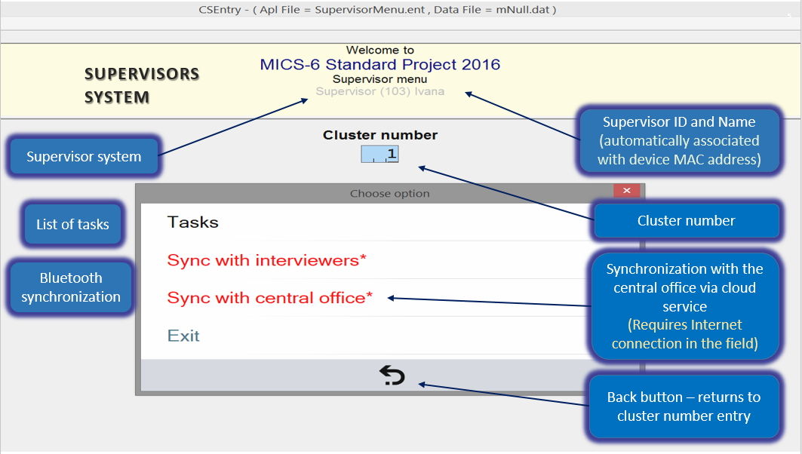

Before starting supervisor activities, the tablet needs information on the cluster in which the team is working. The supervisor should be careful when entering the cluster number and verify if work is implemented in correct enumeration area.

The very first screen that will appear upon launching the supervisor’s menu will allow the supervisor to enter cluster number. Supervisor can use the numeric keypad (that will automatically be displayed on the screen), as shown on the picture below; or launch “Touch keyboard” to enter values. Cluster number area on the screen automatically fills leading zeros. Supervisors can enter “1”, “01” or “001”.

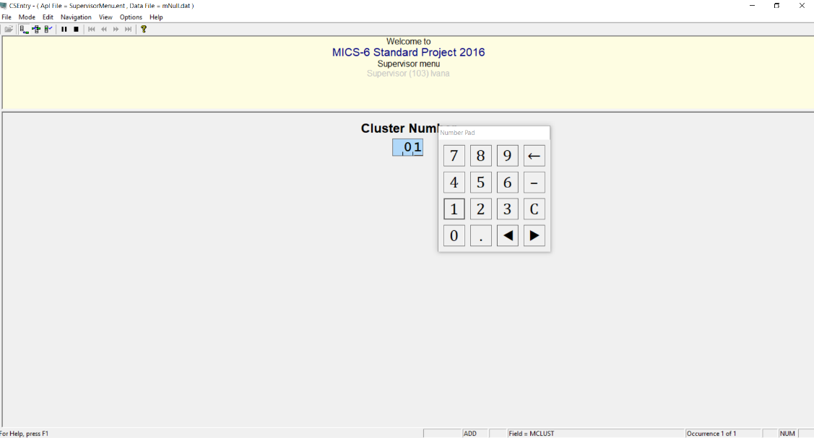

In case the supervisor records an invalid cluster number (e.g. Cluster number 743 is not in the sampling file), the following message will appear:

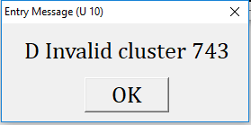

By selecting the “OK” button, the supervisor will return to the main menu, where s/he can enter correct cluster value.

Upon entering cluster number, the system will enquire if the supervisor wishes to “Open the cluster”. This message only appears when work in the new cluster is starting. Once the cluster is open for processing, this message will not appear again.

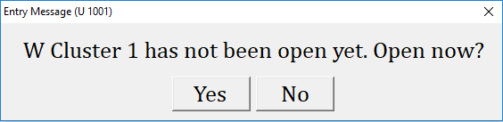

Once the cluster is open, the following menu will be displayed (see picture below):

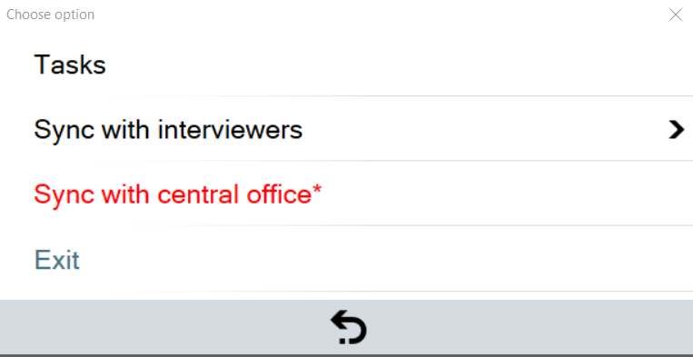

Option “Tasks” allows the supervisor to perform activities to control the sample, review data collected by the interviewers and perform other cluster operations. Each of these options is described in detail in sections below.

Options “Sync with interviewers” and “Sync with central office” allow the supervisor to synchronize data with interviewers in her/his team, and to send collected data to the central office.

Options marked in red and with additional “*” marked next to the text, are to inform the supervisor that a certain operation can now take place, and that it has not been completed. In the example above, option marked in red “Sync with central office*” is alerting the supervisor that there are new data that could be sent to the central office.

Option “Tasks”

This option leads to a sub-menu offering 3 options detailed below:
- Assign households
- Review data
- Cluster operations
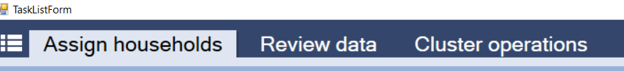
Return to main menu (back button sign on the bottom of the screen)

- Assign households

Once this option is selected, the tablet will present the list of households selected in the sample, as well as household assignment status: “not assigned” or “assigned to a particular interviewer in the team”.

All the households listed in a newly opened cluster is in white color. By selecting a household, the supervisor will be presented by the list of interviewers in her/his team and will have an option to select one of the interviewers for each household (note that when the household is selected, and the list of interviewers is shown, household list turns into gray color to create a focus on the available interviewers – see the next figure). Household assignment doesn’t need to take place at the same time for all households in the sample. The supervisor can at any time assign a household that was not previously assigned to anyone or change household assignments if needed.

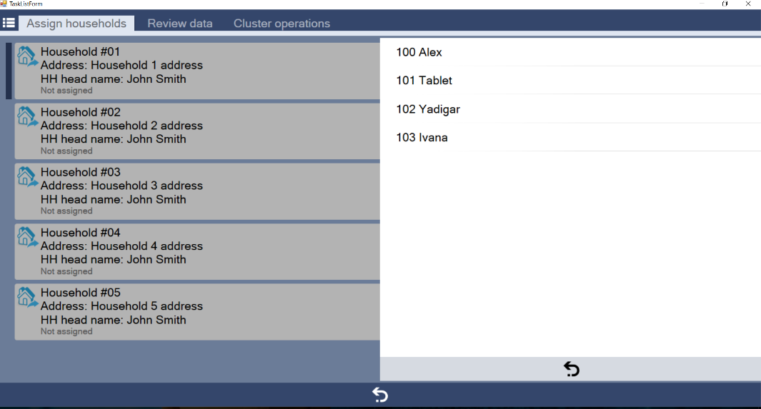

All the households in the recently opened cluster is in white color. Once a household is assigned to the interviewer, the color of the row for that particular household will change from white to Turquise, and the supervisor will see which interviewer the household was assigned to. In this example, Household #01 is assigned to Yadigar (interviewer no = 102).

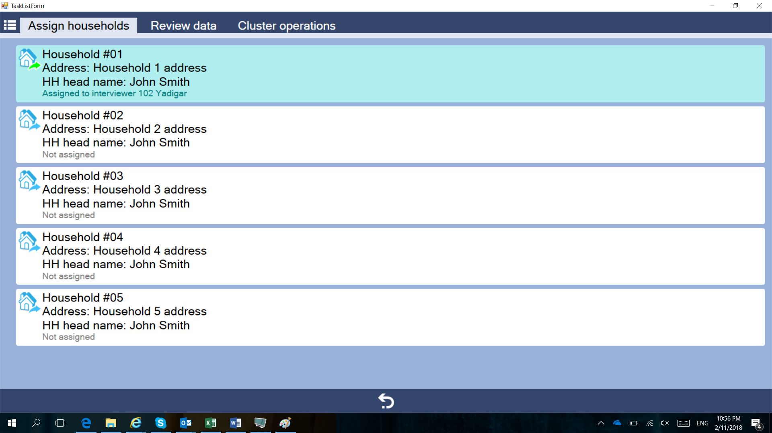

In case the supervisor wishes to change a household assignment, or add an additional household found to be living on the same address, s/he should mark the already assigned household, and the following sub-menu will appear:
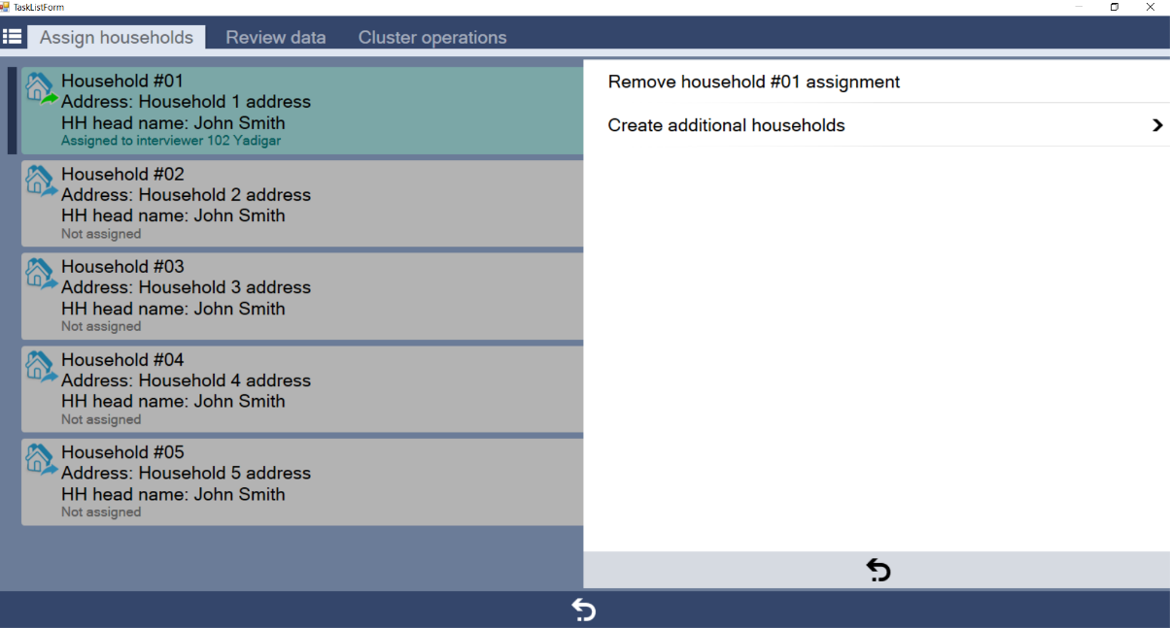

Note in the figure above, that when the household is selected, and the sub-menu is shown, all the households listed turn again into gray color. The sub-menu provides the possibility of removing an already completed assignment or create additional households in case there are more than one household found on the same address that were not listed at the time of the mapping and listing operation. In case of removing an already completed assignment, the color of the row for that particular household will change to white.

- Review data

This option allows the supervisor to review the data entered in a particular household or individual questionnaire. It executes the same program used by interviewers to collect the household and individual questionnaires but running this in modify mode. With this mode, supervisor can see the data already entered, but no changes in the data should be made by the supervisor because the data will not be saved. The supervisor should take note on a paper and all changes to the data in the questionnaire should be made on the tablet of the interviewer that collected the data for that questionnaire. The supervisor should discuss with the interviewer and instruct her/him to make necessary changes on her/his tablet by sitting together to be sure that the necessary changes are done in the right questionnaire. The interviewer will need to synchronize again with the supervisor to send the modified data.

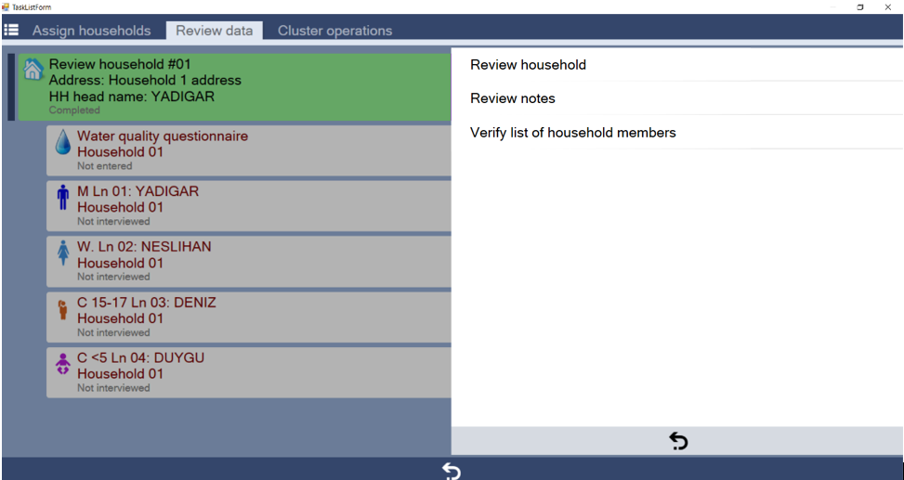

The “Review data” option further allows the supervisor to review notes associated to the particular household or individual questionnaire, as well as to re-interview a household and verify information from the list of household members.

Sub-option to “Verify list of household members”, executes the same programs used by interviewers to collect the household questionnaire.

After collecting the data for the list of household members, the summary of the list of household members collected by the interviewer and that on the supervisor’s tablet will be displayed, as shown below. If differences are spotted, the supervisor should instruct the interviewer to go back to the household and make necessary corrections. An important note is that data collection in one cluster is not considered completed if there is not at least one household in a cluster selected for and with completed verification. Although only one household verification is mandatory, it is recommended that the supervisors does it in more than one household. Please also note that the supervisor is encouraged to use the verification process to confirm other information collected.

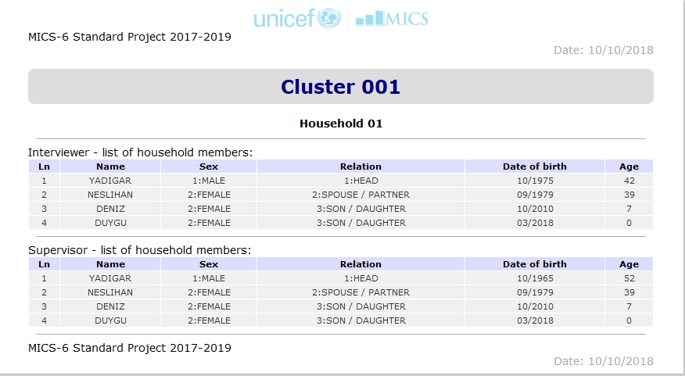

- Cluster operations

This option is used to check the data collected in one cluster and to complete the processing of the cluster once all data have been collected. It runs the program that creates a report which lists interviewer questionnaires, checks structural integrity of collected data, checks logical correctness of the data, and creates the file to send to the central office.

When the Close/List Cluster option is selected, the application produces a report which shows the status of the household and individual questionnaires. The report can be reviewed in 4 parts.
1. Cluster ID, where the cluster number is presented with additional information from the sampling file.
2. Errors: If there are errors in the cluster they are listed in this part.
3. Summary: Summary of the cluster questionnaires in terms of total number of questionnaires in details of their result codes.
4. Details: Each Household is presented here with the additional questionnaires and their result codes one by one.

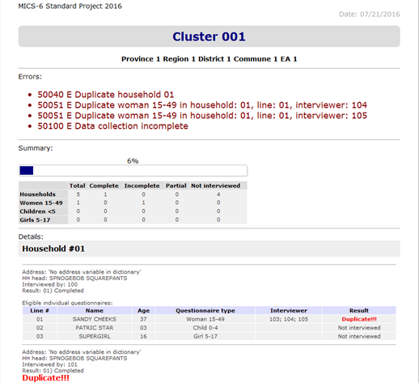

If all the questionnaires are finalized and at least one household member list is verified, the application successfully closes the cluster and prepares the file to be sent to the central office.

However, in case there are structural inconsistencies in the data, or data collection is incomplete, the following message will appear:

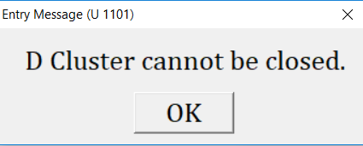

This alerts the supervisor that data collection in the cluster is still not complete and that the cluster cannot be considered finalized and closed.

- Return to main menu

Select the back-arrow button to return to the main menu.

Option “Sync with interviewers”

When selecting this option, the supervisor will be presented with the list of interviewers from her/his team. It is necessary to select the interviewer to whom the supervisor wishes to send household assignments, or from whom the supervisor wishes to receive data. There is no need to indicate the particular action; during the synchronization process all eligible actions will take place.

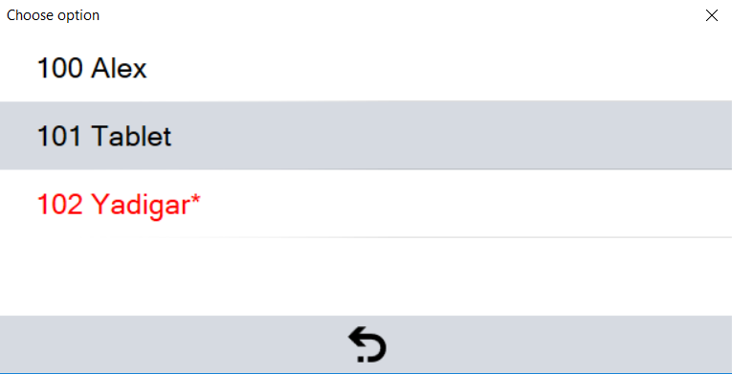

Once the interviewer is selected, this option will use Bluetooth to transfer data to or from an interviewer’s tablet to the supervisor’s tablet. The supervisor should prepare his/her tablet for synchronization, and simultaneously the interviewer should also choose the option “Sync with the supervisor” on his/her tablet. During this process interviewer and supervisor should be next to each other, to allow for Bluetooth connection to take place.

Once the synchronization process starts the following screen will appear:

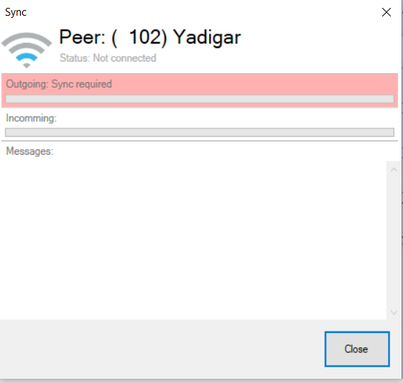

Upon successful synchronization the system will alert both supervisor and interviewer that data were transferred, and the interviewer will be able to see household assignments, while the supervisor will have collected data in copy to her/his tablet.

For interviewers to start work in a cluster, the supervisor should make sure to synchronize data with the interviewer upon household assignment. In case the supervisor deletes an assignment, synchronization will not automatically remove the assignment from the interviewer’s tablet. If changes to assignments are made, it is therefore important that the interviewer removes a previously assigned household on her/his tablet.

Option “Sync with central office”

At the end of each day, or depending on internet availability, the supervisor should sync collected data with the central office.
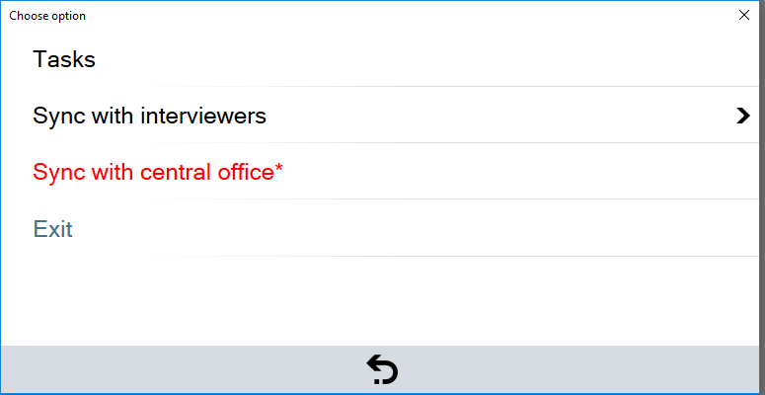

Once this option is selected, the following screen will appear, warning the supervisor to check internet connection.

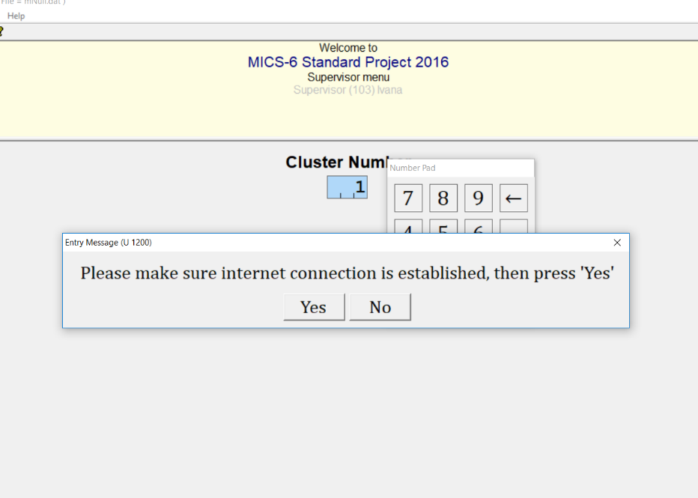

If the supervisor is sure that the tablet is connected to the internet, the system will alert the supervisor that the system will restart during synchronization, which means that it will close and automatically start running again, without the need to re-launch it manually.

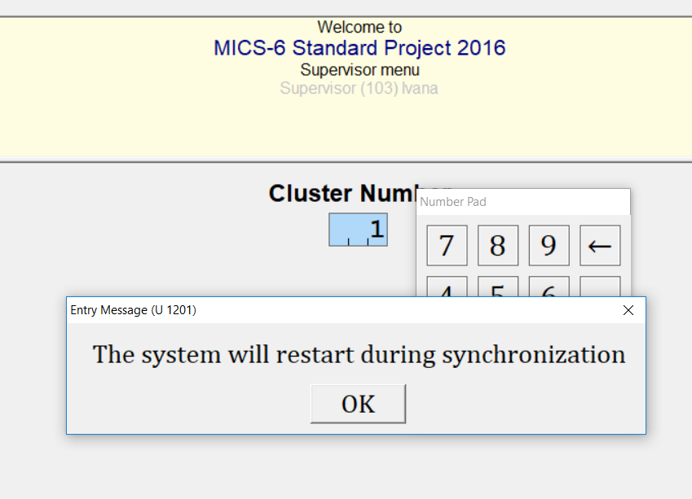

The automatic synchronization process will start, and all the data on the supervisor tablet will be copied to the central office using the internet connection. Although supervisor selects one cluster number to enter the menu, all data will be synchronized regardless of the indicated cluster number.

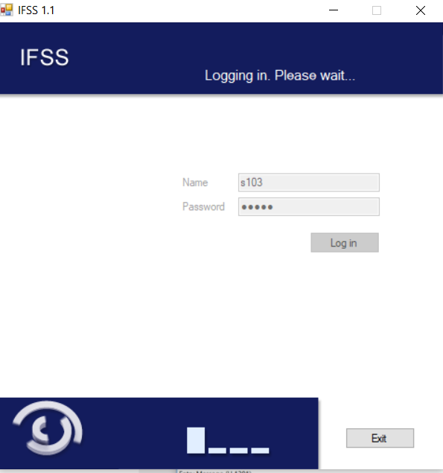

Option “Exit”

This option quits from the Supervisor’s menu system and returns to Windows.

